Nursery home challenges W/B 22-06-2020
Hi everyone, I hope that you are all keeping safe, well and happy. Please find this week’s home learning below…
- Sports
In a normal situation at school we would be currently preparing for our school sports day. I thought we would take this opportunity this week to ‘get sporty’!
It would be lovely to see you all taking part in some sporty activities. Here are a few ideas…
- Running/racing
- Jumping (counting the jumps)
- Hopping (counting the hops)
- Throwing beanbag/objects into a bucket.
- Skipping
- Dribbling a football
- Dancing to your favourite music.
- Homemade obstacle courses.
Take part in as many as you like! Please feel free to think of your own activities too!

- My Daddy.
It has recently been Father’s Day.
I would like you to engage your child in a conversation about their Daddy or special role model in their lives.
Job 1- Ask your child the following questions…
What does your Daddy do to make you laugh?
What is your Daddy’s favourite food?
What do you love about your Daddy?
What is your favourite thing to do with Daddy?
I can remember when my Daddy…
Job 2- Draw a picture of you and your Daddy/special role-model.

- The beach
Moving onto our next topic about ‘the beach’ I would like you to read the story ‘Kippers Beach Ball’. There are many versions of this on YouTube.
When you have read the story to your child, please take time to chat about what the story was about. The main characters and in particular the setting of the story (the beach).

Next, I would like you to talk to your child about beaches.
What would you see at the beach?
What could you do at the beach?
What does the beach look like?
I would then like you to ask your child to imagine that they were going to the beach and prepare a list of items that they might need to take. (reinforce what a list looks like)

Child to create the list and parents to write the list.
Your child is very welcome to try and copy the words if they want to. (This is optional, as some children are not ready for this stage).

If you want to find out more information about snails, this would be fantastic!
- Revisiting shapes.
Feed the shape monsters with the correct shapes. https://www.topmarks.co.uk/early-years/shape-monsters

Talk about the properties of the shapes.
- Square – 4 sides, 4 corners, all sides are the same length.
- Rectangle- 4 sides, 4 corners, 2 longer sides, 2 shorter sides .
- Triangle- 3 corners, 3 sides.
- Circle- 1 side, 0 corners.
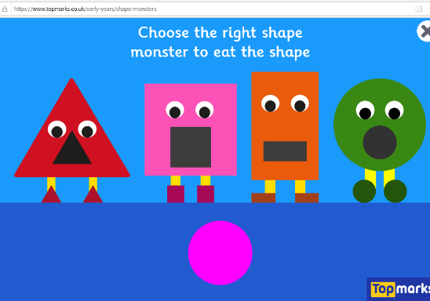

- The sound ‘s’.
Show your child an image of a snail (can use a real snail).
- Ask your child if they know what it is.
- Ask- ‘what sound can you hear at the beginning of ‘snail’?
- If they do not identify the initial sound, tell them- ‘we can hear the sound S’.
- Collect a selection of items in a bag that begin with the sound s, t, & a.
- Allow your child to choose items from the bag.
- Ask -What have you found? (encourage them to say the name of the item).
- Can they identify the initial sound of each item?
- The aim of this activity is to hear the initial sound ONLY. It does not matter at this point if your child cannot recognise what the letters look like. This activity is focussing on ‘tuning into initial sounds’.

Extension (optional).

