Reception Home Learning
Dear Parents,
I have compiled a list of suggested, mainly practical, activities that can be done throughout the day, every day. The most important thing that your child can do each day is share a story with an adult. We would also like your child to focus on accurately forming each letter of the alphabet, ensuring that they start at the top of each letter.
Kind regards,
Mrs Moore
LITERACY
Reading
Share lots of stories every day!
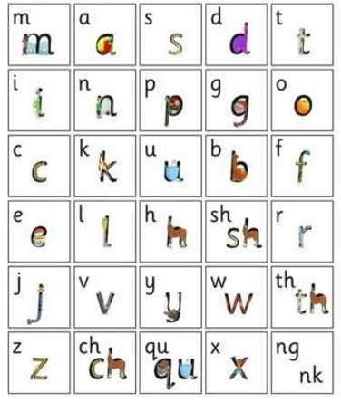
Writing
Each child has been writing the alphabet this week under adult supervision. If any letters were not formed accurately, the adult has highlighted them on their individual sheet in pink. A copy of this can be found in your child’s book bag. These are the letters that your child needs to practise daily to ensure that their letter formation is accurate. This will have a knock on effect all through school if they can get the basics right from the start. The red dot on the alphabet below shows the starting point for each letter. Most letters should start at the top. We are trying hard in Reception to get our writing to sit on the lines too.
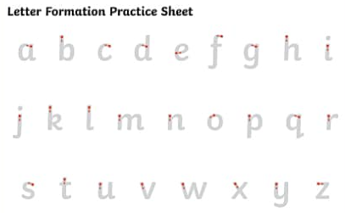

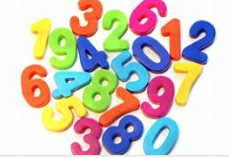  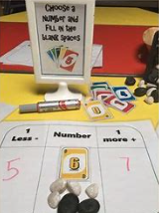  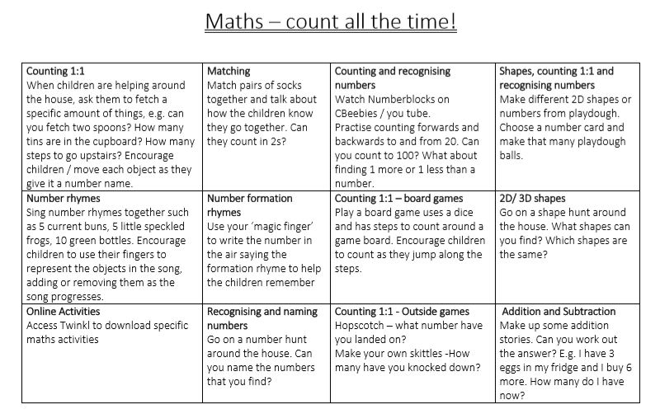 |  | Other suggested activities:  - Go for a walk  - Build something from a cardboard box  - Bake something  - Make a card for someone in your community  - Growing/ planting bulbs  - Make a homemade board game  - Do something kind for someone  - Lego building  - Drawing, colouring or painting  - Painting with water outside if it is a dry day  - Make a weather chart  - Jigsaws  - Games such as snap or bingo
THEME  Watch appropriate TV Shows / find out using the internet Cbeebies iPlayer has a range of documentaries that are suitable for young children that cover a wide range of topics such as Down on the Farm.  Down on the Farm – a lovely series of films about farming and farm life. https://www.bbc.co.uk/iplayer/episodes/b0798kz4/down-on-the-farm | Useful websites/apps-  www.topmarks.co.uk/maths-games/earlyyears  Hairy Letters app  www.teachyourmonstertoread.com (this costs £4.99 therefore it is optional)  Twinkl – enter the code UKTWINKLHELPS for 1 months’ ultimate membership free access. www.twinkl.co.uk/offer  Numberblocks – short programmes teaching basic mathematical concepts https://www.bbc.co.uk/iplayer/episodes/b08bzfnh/numberblocks  Cbeebies Bedtime Stories https://www.bbc.co.uk/iplayer/episodes/b00jdlm2/cbeebies-bedtime-stories  ABC Does – a EYFS consultant who has collected ideas from EYFS teachers (click on ‘Home Learning’ to access the activities https://abcdoes.com/home-learning/

