Reception Home Learning 1.6.20
Hi everyone,
Hope you have all had a lovely half term break and enjoyed some sunshine! This week staff will be in school planning for the phased return to school. More information will be shared about the Reception date based on the uptake of the year groups that come before us in the Government outline.
In the meantime, please continue with the home learning suggestions to keep the children engaged with some structure each day if possible.
Kind regards,
Mrs Moore
Suggested breakdown for 1 hour per day
Phonics  (30 mins) | Ruth Miskin phonics You Tube videos (live)  9.30- Set 1 sounds  10am- Set 2 sounds (red and green- please note red group are only starting out on these sounds so this will be challenging)  There are lots of phonics online games available on Classroom Secrets- phase 3
Story  (5-10 mins) | Storytime with an adult. At some point this week, please share the stories of Billy’s Bucket and Lucy and Tom at the Seaside via You Tube. Children enjoy repetition so these could be used more than once during the week.
Letter and Number formation  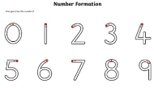  (5 mins) | By now the children have had lots of practise of accurate letter and number formation. This week ask them to write out the alphabet one day and the numbers to 10 another day. Identify any letters or numbers that still need further rehearsal and practise these to make the formation secure.  Remember the majority of letters and numbers start at the top!
Writing  (10 mins max) | Ask your child to retell what happened in one of the above stories. They should be able to pick out the key events in the correct sequence.  For this week’s writing, they can choose a story from the box above and draw a picture and write a couple of sentences about the story.  E.g. I want a bucket. Dad said have a bike etc
Maths  (10 mins)  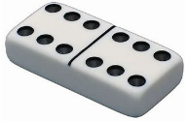 | This week we will be focusing on doubling- children will learn that doubling means ‘twice as many’. To begin with they could watch BBC Number blocks series 2 episode 9- double trouble. There is also a story called This is the story called Alison Hubble by Allan Ahlberg via You Tube which links to doubling.  Allow the children to explore different ways of building doubles using real objects e.g. stones, pasta etc.  Play doubles- if you have dice, take turns to roll 2 dice, they score a point if they roll a double. The first to reach 3 points wins the game.  If you have dominoes at home, ask your child to find the doubles and look at the doubles they make as they play.  There are useful games on Classroom Secrets and Topmarks which would support these objectives too. The username is: 240085 followed by your child’s first name (no space) and the password is: 123
Visit to the beach  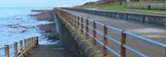 | This week we are beginning a seaside/ summer/ beach theme! If possible, visit the shore and talk about what you find at the beach in Maryport. Your child could take a sandwich bag with them and collect little shells and pebbles which they could use for doubling.  Share any photos via Tapestry, it would be great to see!
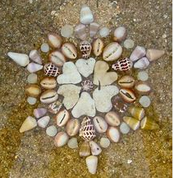  Design Technology | Andy Goldsworthy is a famous artist who creates sculptures using natural materials.  Examples of his work can be found via Google Images.  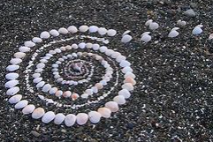  Your child could have a go at creating a sculpture using pebbles and shells following his style.  e.g.

Doubling (online games)

Hit the Button via Google (please choose a suitable level for your child’s ability)
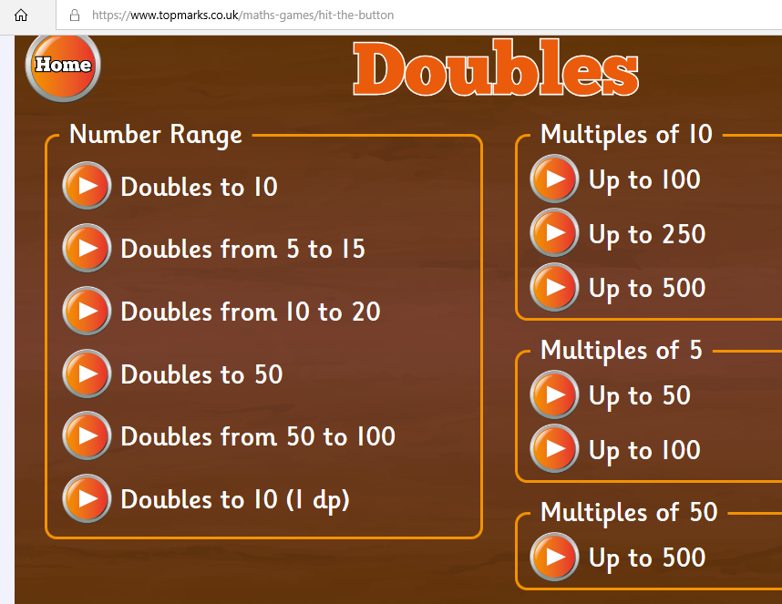

Classroom Secrets- search Reception doubling in the search bar at the top
