Reception Home Learning 11.5.20
Hi everyone,
I hope that you have enjoyed the sunshine over the bank holiday weekend. We will be doing our fortnightly ‘check in’ with you all during this week to see how things are going and if we can be of any help at all.
As part of this week’s home learning it would be lovely if some of our children could contribute to the painted rocks path in the Memorial Gardens. Their aim is to make a trail of painted rocks around the path to mark the lockdown.
Kind regards,
Mrs Moore
Suggested breakdown for 1 hour per day
Phonics  (30 mins) | Ruth Miskin phonics You Tube videos (live)  9.30- Set 1 sounds  10am- Set 2 sounds (red and green- please note red group are only starting out on these sounds so this will be challenging)
Story  (5-10 mins) | Storytime with an adult. At some point this week, please share the stories of Jim and the Beanstalk (as an alternative to Jack and the Beanstalk) and Oliver’s Vegetables - via You Tube. Children enjoy repetition so these could be used more than once during the week.
Number formation  (5 mins) | This week practise writing the numbers 1-10 (ensuring that your child begins at the top of each number.  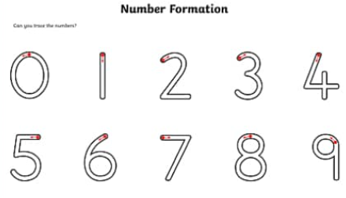
Writing  (10 mins max) | This week the children could write about their experience of VE day or something that they have enjoyed this weekend and draw a picture to illustrate it.
Maths  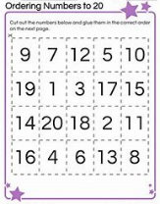  (10 mins) | This week we will be focusing on ordering numbers (particularly numbers 11-20) in preparation for Year 1.  Practise counting forwards and backwards to 20 regularly.  There are two Number Blocks videos which are brilliant for this-‘In your head’ and ‘I can count to 20’ – both are available via You Tube.  If an adult could write two numbers e.g. 13, 14, …. The child could write which number comes next.  There are useful games on Classroom Secrets and Topmarks which would support this objective too. The username is: 240085 followed by your child’s first name (no space) and the password is: 123
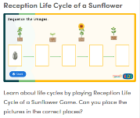  Science | There are numerous life cycle sequencing games linked to the sunflower, frog, chicken and butterfly available under the EYFS then Understanding the World tab on Classroom Secrets kids. The log in is just above.
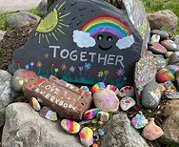  Art | Painted rocks- if you can please contribute to the Maryport painted rocks path in the Memorial Gardens. These could be taken down as part of daily exercise.

Ordering numbers (online games)

Topmarks- Ordering numbers (if your child is working with numbers beyond 10, please choose an appropriate level from the menu)
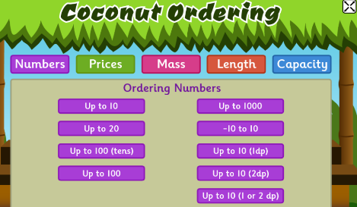
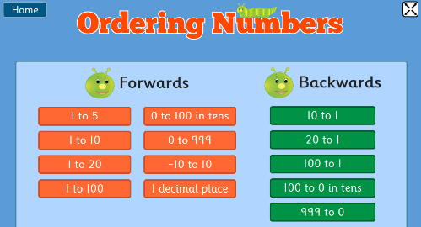

Remember to order backwards as well as forwards
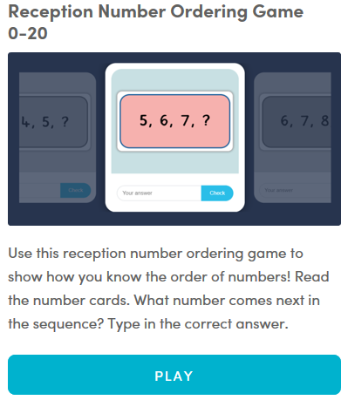
Classroom Secrets

