Reception Home Learning 13.7.20
Hi everyone,
This is the final ‘school’ week and the last push before the summer holidays. I hope you all have a wonderful time while we are off school and I’m genuinely thrilled to be involved with this year group once again next year. I would love to see any family activities posted on Tapestry during the holidays to see what you are all getting on with.
I can’t wait to get going again in September when the children are in Year 1. We have lots of plans in place already!
Kind regards,
Mrs Moore
Suggested breakdown for 1 hour per day
Phonics  (20 mins) | The children in school will be continuing with the set 1 and 2 phonics videos every morning.
Story  (5-10 mins)  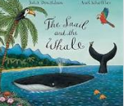 | Storytime with an adult. At some point this week, please share the story of The Snail and the Whale and Somebody Swallowed Stanley via You Tube. These link well with our Under the Sea theme. Children enjoy repetition so these could be used more than once during the week.
Writing  (10 mins) | Ask your child to write out the alphabet…check on accurate letter formation. Revise any letters which are not formed correctly- remember most letters begin at the top.  Make a list of things that should be found in the ocean and a list of things that shouldn’t be found in the ocean- draw pictures beside each item in the list.
Maths  (10 mins)  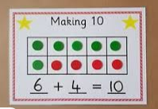 | This week the focus will be on revising number bonds to secure this knowledge in preparation for Year 1.  Give your child 10 objects e.g. crayons. How many different ways can you find the number bonds to 10? Encourage your child to be methodical: start with 1 and 9, then 2 and 8 etc. How many different pairs of numbers do you know which make 10? Have you found them all? How do you know?  If your child is already confident with this, show them the number bonds to 20 and 100 following the same pattern e.g. 11+9=20, 10 + 90 = 100.  This can be followed up by playing games e.g. pairs using number cards or saying a number and your child could say its pair to make 10. Hold up 3 fingers- your child can show using their fingers how many more would be needed to make 10.
Science  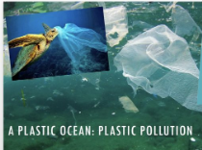 | Find out about plastic pollution in our oceans and how It is affecting the animals who live in the sea. Talk about what your family can do to reduce plastic waste.
Art  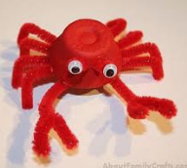 | Egg box ocean life  e.g.  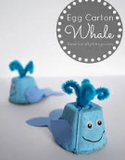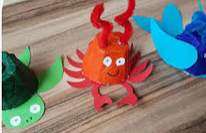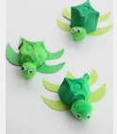
Extension for maths activity:
https://www.nctm.org/Classroom-Resources/Illuminations/Interactives/Ten-Frame/
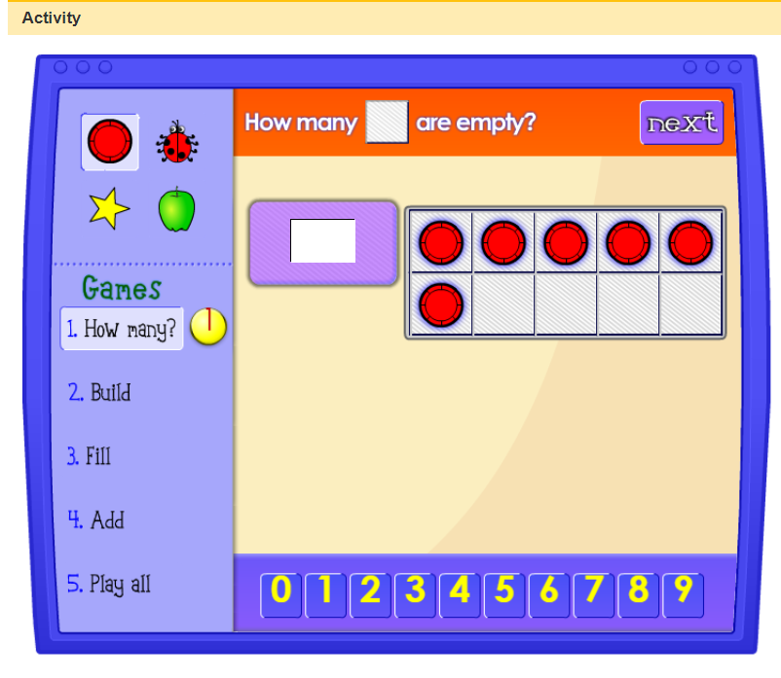
Hit the button via Topmarks
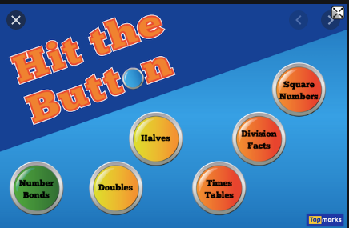
Classroom Secrets kids
