Reception Home Learning 15.6.20
Hi everyone,
We will be in touch shortly to confirm a date and time for the 12 Reception children starting back with us.
In the meantime, thank you for your continued support with the home learning activities. I understand that this is becoming much tougher as the weeks progress. Please just fit in what you can, as and when.
Kind regards,
Mrs Moore
Suggested breakdown for 1 hour per day
Phonics  (30 mins) | Ruth Miskin phonics You Tube videos (live)  9.30- Set 1 sounds  10am- Set 2 sounds (red and green- please note red group are only starting out on these sounds so this will be challenging)  There are lots of phonics online games available on Classroom Secrets- phase 3
Story  (5-10 mins) | Storytime with an adult. At some point this week, please share the story of The Lighthouse Keeper’s Lunch by Ronda and David Armitage via You Tube. Children enjoy repetition so these could be used more than once during the week.
Letter and Number formation  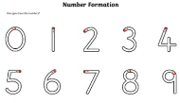  (5 mins) | Please recap any remaining letters that are not correctly formed.
Writing  (10 mins) | Make a list of the items that floated and the items that sunk (based on the science activity) To extend this, they could draw pictures of each item.
Maths  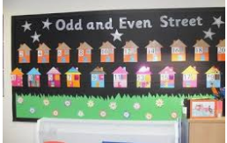  (10 mins) | This week we will be focusing on odd and even numbers. The children need to understand that quantities which can be shared into 2 equal groups with no items left over are even. Those which have one left over when they are shared into two equal groups are odd. They could explore this by grouping objects- pairing socks is a great starting point!  Numberblocks video- series 2 episode 11- odds and evens.  Sorting- provide items eg crayons, buttons, pasta etc (up to 10 pieces)- ask the children to count the items e.g. 8 and decide if it is odd or even by grouping the objects into pairs.  If possible, when you are out point out the house numbers on a nearby street. What do they notice? Talk about how odd and even numbers are mostly on opposite sides of the street.  There are lots of activities accessible via Twinkl too.  There are useful games on Classroom Secrets and Topmarks which would support these objectives too. The username is: 240085 followed by your child’s first name (no space) and the password is: 123
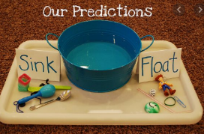  Science | Floating and sinking recap from earlier in the year  Gather objects from around the house. Fill a bowl with some water. Can they predict if the item will float or sink? Can they explain why the item floats or sinks? Talk about the different materials that you find.
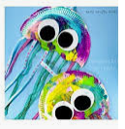  Art | Jelly fish craft  Use paper plates and strands of wool/ribbon to create fun jelly fish!

Odd and even (online game)

Hit the Button via Google (please choose a suitable level for your child’s ability)
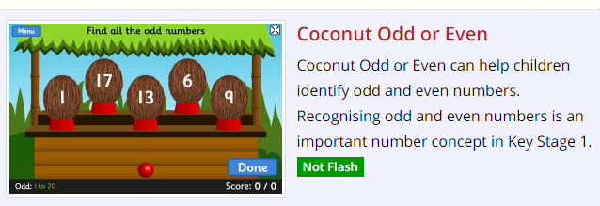

Classroom Secrets- search Reception odd and even in the search bar at the top
