Reception Home Learning 18.5.20
Hi everyone,
Thank you for all the lovely sentence writing about VE day and also the Tapestry posts showing children painting rocks and displaying them in the collection at the Memorial Gardens. I have been down to see them and I have spotted some of ours!
This is the final week before the Whit half term holiday, keep up the good work everyone!
Kind regards,
Mrs Moore
Suggested breakdown for 1 hour per day
Phonics  (30 mins) | Ruth Miskin phonics You Tube videos (live)  9.30- Set 1 sounds  10am- Set 2 sounds (red and green- please note red group are only starting out on these sounds so this will be challenging)  There are lots of phonics online games available on Classroom Secrets- phase 3
Story  (5-10 mins) | Storytime with an adult. At some point this week, please share the stories of Titch by Pat Hutchins and You’ll soon grow into them Titch - via You Tube. Children enjoy repetition so these could be used more than once during the week.
Number formation  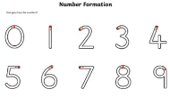  (5 mins) | To consolidate last week’s learning, ask the children to write the numbers 1-10 (or 20 if they can) in the correct order, using the correct number formation, taking care to start at the top of each number each time.
Writing  (10 mins max) | The children could orally say what happened in the story of Titch and write a few sentences to retell the story. E.g. Pete had a big saw…
Maths  (10 mins) | This week we will be focusing on 2D and 3D shape names. You could try a shape hunt when you are out and about e.g. road signs or the children could do a shape hunt in the kitchen cupboards and then follow this up with a conversation about the name of the shape and words to describe it e.g curved.  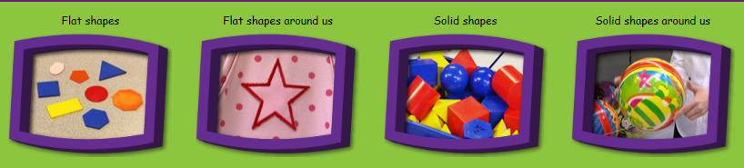  If you google Espresso Primary and log in using the username: student9704 and the password: maryport and click on the foundation tab then maths, then shape there are a number of useful videos.  There are useful games on Classroom Secrets and Topmarks which would support these objectives too. The username is: 240085 followed by your child’s first name (no space) and the password is: 123
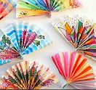  Design Technology | If we were at school this week, the adult focus activity would be to model how to create zig zag folds by folding some paper back and forward to make what looks like a fan or an accordion. This skill takes children a bit of practise but is excellent to develop their fine motor skills. If you can show your child how to do this and then they can have a try themselves using scraps of newspaper or strips cut from a magazine.  Once they are confident with this, they could make a fan for the warm weather!
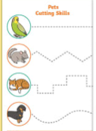  Cutting skills | Developing children’s cutting skills brings many benefits including: improving their focus and attention, strengthening hand muscles and improving hand-eye coordination. It is a skill that needs lots of repetition and practise.  Play doh is useful to cut through at the beginning. Children can progress onto free cutting of straight lines, zig zag lines, wavy lines. An adult could draw some of these on a piece of paper for the child to cut.  Alternatively, if you have access to a printer, Twinkl offers lots of different sheets to promote children’s growth in cutting skills.

2D and 3D shape (online games)
Topmarks-
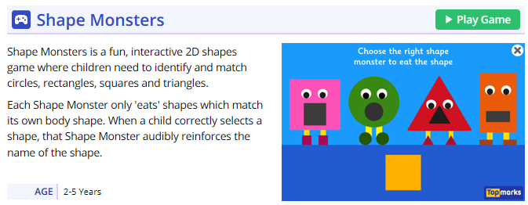
Classroom Secrets- search Reception shape games