Reception Home Learning 22.6.20
Hi everyone,
We are aiming to welcome Reception back into school on Monday 29th June. Mrs Ormond will be in touch to confirm the details with you all, staggered start and finish times will be sent out individually via text message. We will be based in the nursery room and the outdoor area. We have followed the early years risk assessments and removed the sand, play doh and wooden toys. Books will be split into 4 boxes, one for each day of the week and quarantined after use for 72 hours. Social distancing is not expected for early years children however we will be promoting and ensuring regular hand washing throughout the day.
We can provide school packed lunches (which would need to be ordered in the usual way (on Sundays via Lunch Shop) or alternatively your child can bring their own packed lunches. These would need to be disposable so that they can go in the bin afterwards (no plastic containers).
Kind regards,

Mrs Moore
Suggested breakdown for 1 hour per day
Phonics  (30 mins) | If possible, please continue to view the Ruth Miskin videos- the children who have been watching these regularly are getting a lot of benefit from them.
Story  (5-10 mins) | Storytime with an adult. At some point this week, please share the story of Winnie at the Seaside via You Tube. Children enjoy repetition so these could be used more than once during the week.
Writing  (10 mins) | Following on from the science videos, choose a sea creature and write a couple of sentences about it and draw a picture.
Maths  (10 mins)  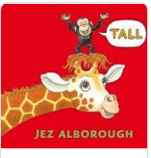 | This week the focus will be on length- to introduce this new theme the story called Tall by Jez Alborough is a good starting point via You Tube.  Children will begin by making direct comparisons e.g. the tree is tall, the pencil is short. The two words that we need to introduce are longer and shorter. Once the child can do this they can progress onto measuring objects.  There are multiple ways for children to explore length- a few suggestions are:  - Building towers with blocks (pointing out which is the shortest/ longest  - Making worms out of play doh and comparing them saying which is the shortest and longest  - Talk that arises naturally- comparing heights in the family, heights of sunflowers, size of foot prints etc  There is no expectation that Reception children need to use a tape measure or a ruler to measure lengths but if a adult could model how to use these, the child would enjoy exploring. Please see an alternative extension activity on the next page.  There are useful games on Classroom Secrets and Topmarks which would support these objectives too. The username is: 240085 followed by your child’s first name (no space) and the password is: 123
Science  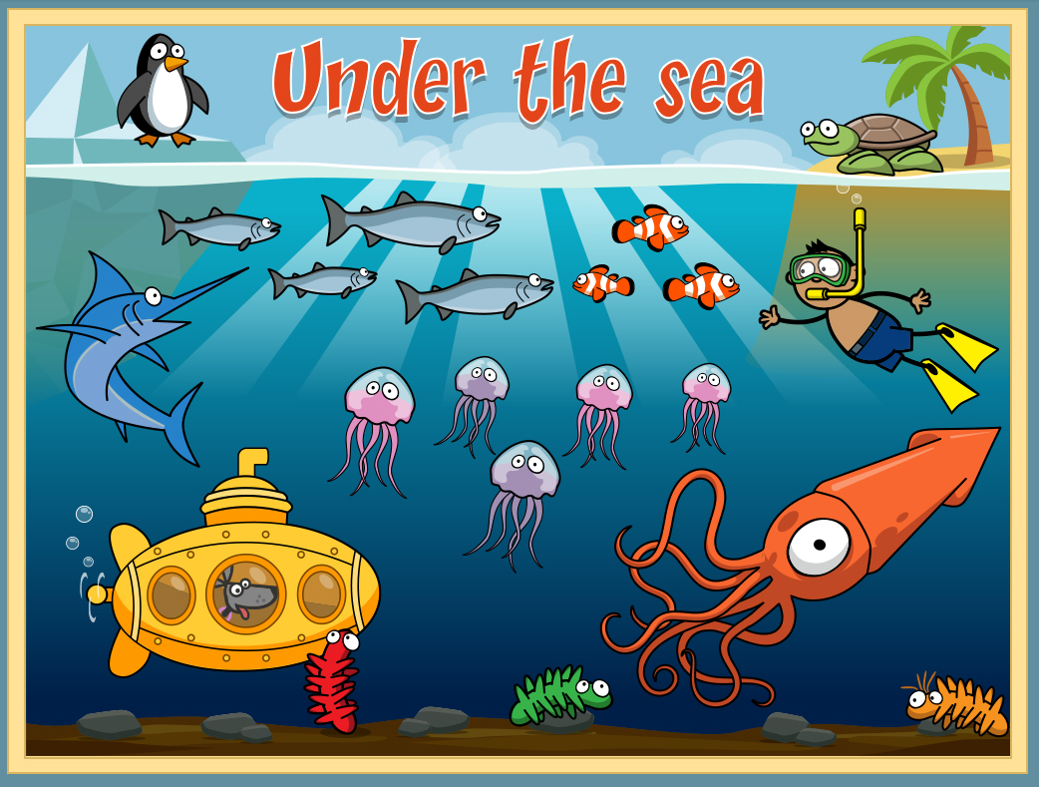 | Sea creatures  There is lots of videos and online activities available about Under the Sea at Espresso Primary. The username is: student9704 and the password is maryport (no capital).Once you are on the site, if you search for under the sea you will find them.  It’s such a shame that the aquarium is closed as this would have been a perfect place to visit!
Art  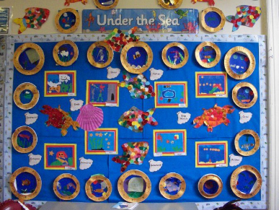 | Making a port hole out of a paper plate  Discuss what portholes are- if you are around the docks, see if the children can point out portholes on the boats- discuss what they are used for.  Talk about what they might see if they look through a porthole and make a sea creatures scene behind it.
Extension for maths activity:
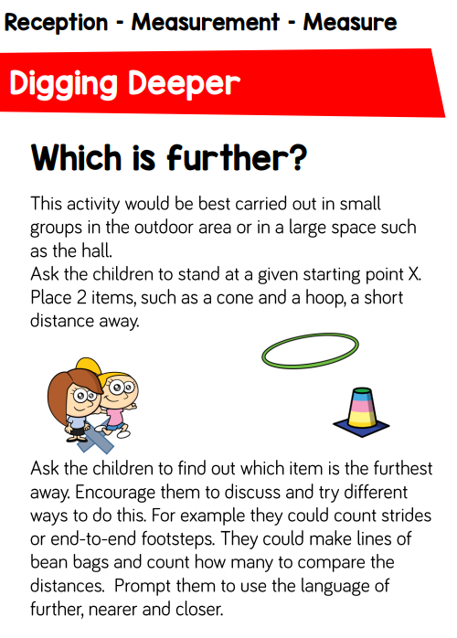

Length (online game)
Topmarks- Let’s compare
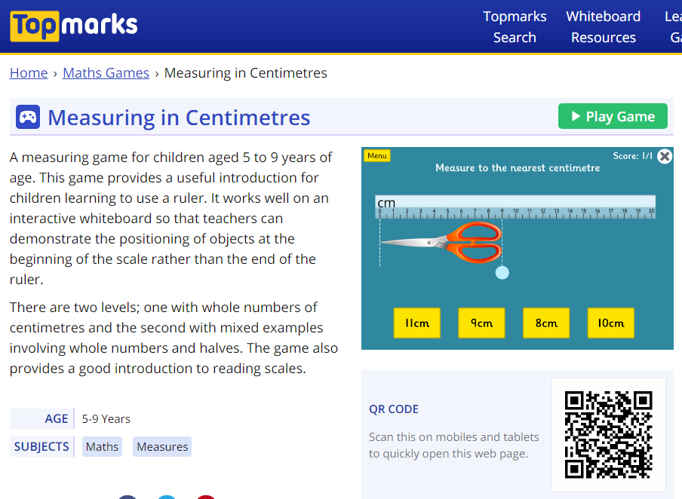
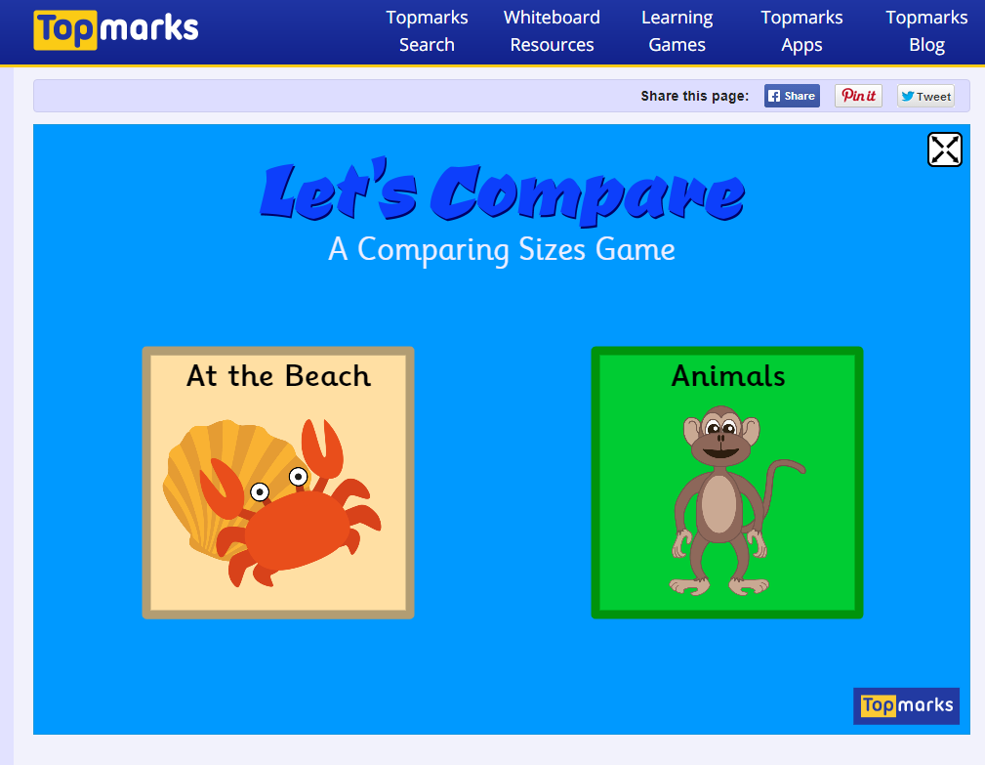

Extension activity (if required)

