Reception Home Learning 29.6.20
Hi everyone,
Today we welcome back some of our Reception children. We will be following this format for learning at school to make it the same for those at home.
Please continue to share your experiences and activities via Tapestry.
Kind regards,
Mrs Moore
Suggested breakdown for 1 hour per day
Phonics  (30 mins) | If possible, please continue to view the Ruth Miskin videos- the children who have been watching these regularly are getting a lot of benefit from them. These will continue to be available online to help children keep pace with their phonics.
Story  (5-10 mins) | Storytime with an adult. At some point this week, please share the story of Commotion in the Ocean via You Tube. This links very well with our seaside theme. Children enjoy repetition so these could be used more than once during the week.
Writing  (10 mins) | Recap last week’s science first. Following on from the Commotion in the Ocean story- create a fact file about a sea creature of their choice with name, drawing, food, where it lives etc.
Maths  (10 mins)  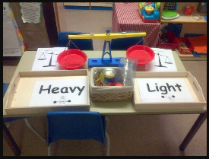 | This week the focus will be on weight. Who sank the boat? By Pamela Allen is a good introduction to this maths topic. To begin with the children should start by making direct comparisons between the weight of objects- being able to identify which is the lightest and which is the heaviest. This can be repeated with different objects- they can show using their arms which one weighs more by making a human balance scale. Include some small heavy items as children tend to think that heavy items are big.  The third step for Reception would be to give them an object e.g. apple and ask the child to find objects which are lighter than the apple and heavier than the apple.  Language to use: heavy/ heavier/heaviest and light/ lighter/ lightest.  To take this further- the children could role play using weight in real life- e.g. a fruit and veg shop, post office (weighing parcels) or an airport check in with luggage.
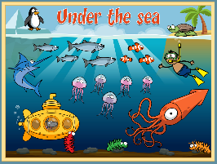  Science | Sea creatures (continuation from last week)  There are lots of videos and online activities available about Under the Sea at Espresso Primary. Please revisit these from last week as this will help your child create the fact file for the writing activity above.  The username is: student9704 and the password is maryport (no capital). Once you are on the site, if you search for under the sea you will find them.  It’s such a shame that the aquarium is closed as this would have been a perfect place to visit!
Art | Shoe box under the ocean scene or paper plate aquarium  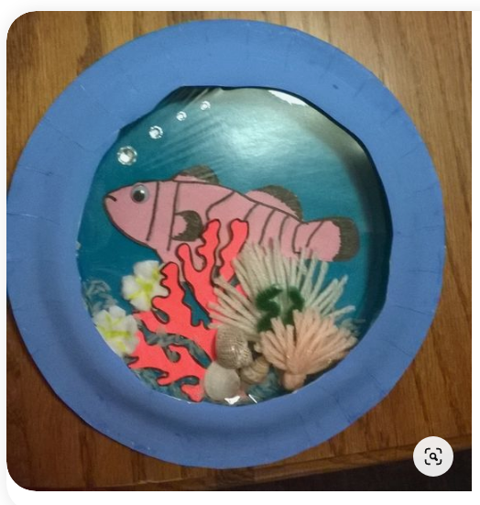  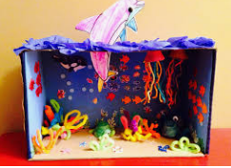

Extension for maths activity:
