Reception Home Learning 6.7.20
Hi everyone,
We have two weeks left now before the end of term and the start of the summer holidays. With this in mind, please continue to support our home learning. It is most appreciated and gives children a bridge into Year 1.
Kind regards,
Mrs Moore
Suggested breakdown for 1 hour per day
Phonics  (20 mins) | The children in school will be continuing with the set 1 and 2 phonics videos every morning.
Story  (5-10 mins) | Storytime with an adult. At some point this week, please share the story of The Rainbow Fish and The Big Book of the Blue via You Tube. These link well with our Under the Sea theme. Children enjoy repetition so these could be used more than once during the week.
Writing  (10 mins) | The Rainbow Fish gave away his most prized possession- his scales- talk about what prized possessions are. Draw a picture of it and write a sentence to say why it is special.
Maths  (10 mins)  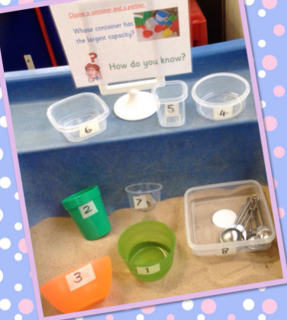 | This week the focus will be on capacity.  - Understanding full and empty using containers  - Extend their understanding to half full, nearly full, nearly empty. This can be carried out practically using water, juice, bath water, cereal etc  - Take this further by using different shaped containers to investigate e.g. tall, thin, narrow, wide and shallow.  - Once the children have got this, progress onto measuring capacity of containers. How many cup fulls does the vimto bottle hold etc? What about the shampoo bottle? Which holds the most? Which holds the least?
Art | Choose from these ideas linked to the story of The Rainbow Fish:  - Make a rainbow fish collage  - Use a big piece of card or a roll of old wall paper to create a big ‘Under the Sea’ themed picture  - Printing using the end of a celery stick to make some fish pictures  - Bubble printing to create a watery background for fish  - Wax resist- drawing a seaside picture using wax crayons and painting over with paint.  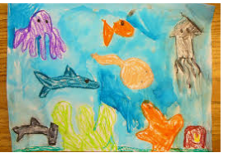  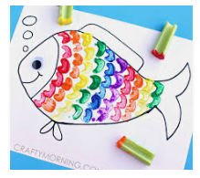  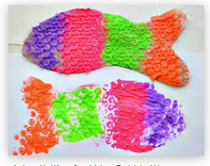  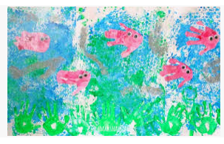  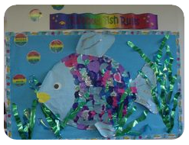

Extension for maths activity:
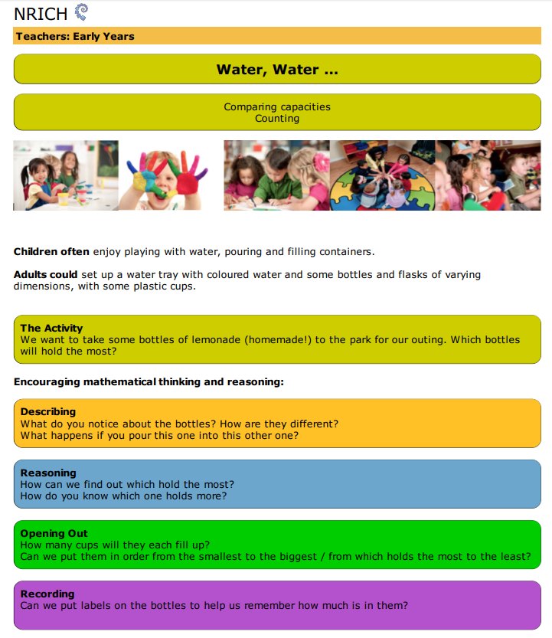

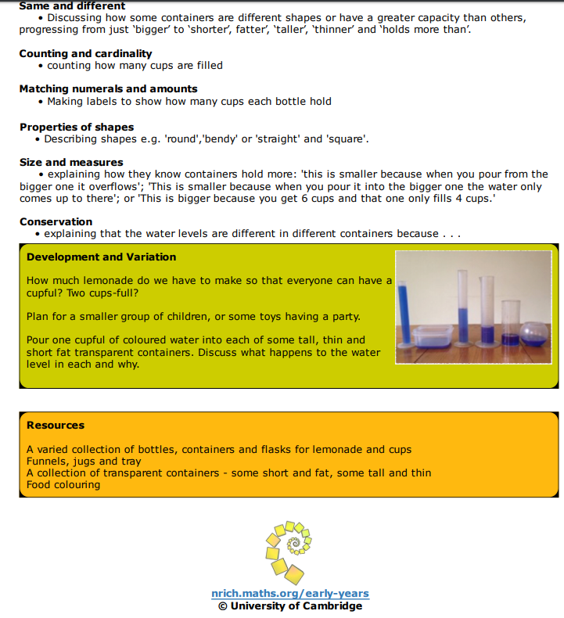

Online game- Classroom Secrets

