Reception Home Learning 8.6.20
Hi everyone,
Last week, I managed to speak with the majority of Reception parents to plan our phased return to school. At present we have about 11 children who have expressed interest in starting back once the Reception window opens.
If your circumstances change in the next few weeks due to work or family commitments, please let us know by ringing school and we can offer your child a place.
Kind regards,
Mrs Moore
Suggested breakdown for 1 hour per day
Phonics  (30 mins) | Ruth Miskin phonics You Tube videos (live)  9.30- Set 1 sounds  10am- Set 2 sounds (red and green- please note red group are only starting out on these sounds so this will be challenging)  There are lots of phonics online games available on Classroom Secrets- phase 3
Story  (5-10 mins) | Storytime with an adult. At some point this week, please share the story of Sharing a Shell by Julia Donaldson via You Tube. Children enjoy repetition so these could be used more than once during the week.
Letter and Number formation  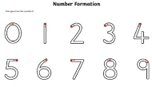  (5 mins) | Please recap any remaining letters that are not correctly formed.
Writing  (10 mins max) | This week I would like the children to write a few sentences about their visit to the rock pool and what they could see.
Maths  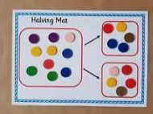  (10 mins) | This week we will be focusing on the opposite of doubling- halving. This is best introduced usually through food! E.g. finding half a pizza or a bar of chocolate and talking about 2 halves making one whole one.  Children can halve quantities by sharing them into two equal groups. An adult could model sharing a packet of sweets into 2 equal groups- ask the child to check if it is fair? This could be repeated for different objects such as strawberries.  During the course of the week, provide quantities of food that they will need to share onto plates e.g. a box of raisins, a handful of crackers. Alternatively, you could have a teddy bears picnic with two bears to pretend.  You could also talk about this when filling up the bath or pouring drinks.  There are useful games on Classroom Secrets and Topmarks which would support these objectives too. The username is: 240085 followed by your child’s first name (no space) and the password is: 123
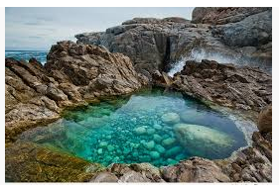  Science | Who lives in a rock pool?  If possible, visit the shore again and this time focus on the rock pools. Look at what can be seen in the rock pools. Collect shells, pebbles and driftwood in freezer bags.  Count and sort what they find.
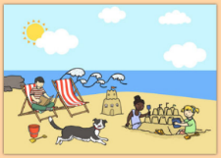  Art | Paint or draw a seaside picture- talk about what would need to be included

Halving (online games)

Hit the Button via Google (please choose a suitable level for your child’s ability)
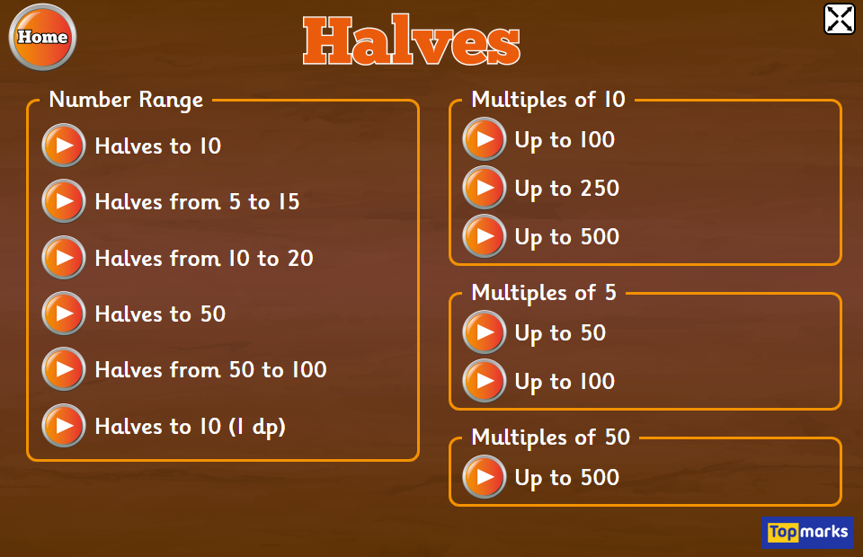

Classroom Secrets- search Reception halving in the search bar at the top

