Reception Home Learning 20.4.20
Hi everyone,
Hope everything is okay! We have enjoyed seeing lots of things that Reception have been up to over the last week. You have all been busy from planting to making obstacle courses and baking! Everyone seems to be making the most of a difficult situation.
Last week we made contact with all of our families. It was nice to hear how things are going. As always if you have any queries, we are available through Tapestry so please just get in touch and we will be happy to help you.
This week, I want the activities to remain largely unchanged as they are what the children need to continue with. I have highlighted the changes in green below.
If we were in school this week, we would have been planting seeds such as sunflowers and cress. If at all possible, it would be great if the children could do this at home. It would be a nice activity to do in the sun! As part of this the children need to know about what makes plants grow so an adult could talk to them about the basic needs of plants.
Kind regards,
Mrs Moore
Suggested breakdown for 1 hour per day
Phonics  (30 mins) | Ruth Miskin phonics You Tube videos (live)  9.30- Set 1 sounds  10am- Set 2 sounds (red and green- please note red group are only starting out on these sounds so this will be challenging)
Story  (5-10 mins) | Storytime with an adult. At some point this week, please share the story of Jack and the Beanstalk- there are several videos available via You Tube. Children enjoy repetition so this could be used more than once during the week.
Letter formation  (5 mins) | Please continue to use the sheet from your child’s book bag to see which letters to practise (highlighted in pink)
Writing  (10 mins max) | In the summer term, we would be placing a high emphasis on writing in preparation for Year 1. The focus would be on the children sounding out a sentence and writing it from their ‘sound talk’ and using finger spaces between words. E.g. The cat sat in the sun.  Each day your child could write a simple sentence and draw a picture – it could be about anything- something that they have done that day might be a good starting point.
Maths  (10 mins) | This week we will focus on the children understanding adding two single digit numbers and counting on to find the answer. This can be done practically to combine two groups of objects e.g 5 pieces of pasta add 3 pieces of pasta = 8 pieces of pasta. They will need help at first counting on from the largest number. There are useful games on Classroom Secrets and Topmarks which would support this objective too. The username is: 240085 followed by your child’s first name (no space) and the password is: 123
Science | Growing seeds
PE  (as and when) | Throwing and catching skills using a large ball.

Adding two single digit numbers (online games)

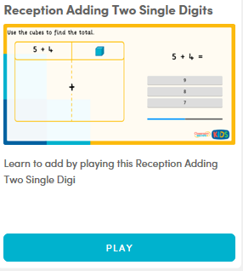
Classroom Secrets (see log in details on the previous page)

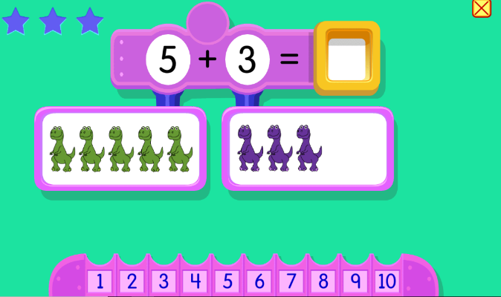
Topmarks- Addition to 10 game

There are also lots of other addition games available from Topmarks. If your child would like more challenging numbers to work with there are plenty to choose from such as: Alien Addition, Funky Mummy and Blast Off.

