Reception Home Learning 27.4.20
Hi everyone,
We are going to check in with everyone again this week to see how things are going. If you have any queries, we will be happy to help you over the phone.
This week we are continuing with our theme of growing and planting and the timetable is largely unchanged. I hope the children are finding it accessible in short bursts.
Kind regards,
Mrs Moore
Suggested breakdown for 1 hour per day
Phonics  (30 mins) | Ruth Miskin phonics You Tube videos (live)  9.30- Set 1 sounds  10am- Set 2 sounds (red and green- please note red group are only starting out on these sounds so this will be challenging)
Story  (5-10 mins) | Storytime with an adult. At some point this week, please share the story of Jasper’s Beanstalk- again, there are several videos available via You Tube. Children enjoy repetition so this could be used more than once during the week.
Letter formation  (5 mins) | Please continue to use the sheet from your child’s book bag to see which letters to practise (highlighted in pink)
Writing  (10 mins max) | In the summer term, we would be placing a high emphasis on writing in preparation for Year 1. The focus would be on the children sounding out a sentence and writing it from their ‘sound talk’ and using finger spaces between words. E.g. The cat sat in the sun.  Each day your child could write a simple sentence and draw a picture – it could be about anything- something that they have done that day might be a good starting point.
Maths  (10 mins) | This week we will continue to focus on addition and ways of making 10. This is something that we have covered before so the children should be familiar with this already. This could be done practically using objects such as 10 pieces of lego, 10 buttons or 10 pens etc so they can find all the different combinations. They could also play a simple pairs game- if the adult could write all the numbers to 10 on separate pieces of paper, the children could turn two over and say if they make 10, continuing until they can find all the possibilities.  There are useful games on Classroom Secrets and Topmarks which would support this objective too. The username is: 240085 followed by your child’s first name (no space) and the password is: 123
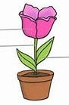  Science | Labelling a plant- roots, stem, flower, petal, leaf
Art | Paper tearing- create a snail in the style of Matisse’s work  e.g.  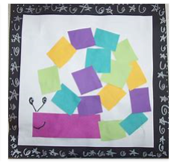

Number bonds to 10 (online games)
If your child knows these by heart, extend this to numbers bonds to 100 (show the pattern of adding a 0 or number bonds to 20)

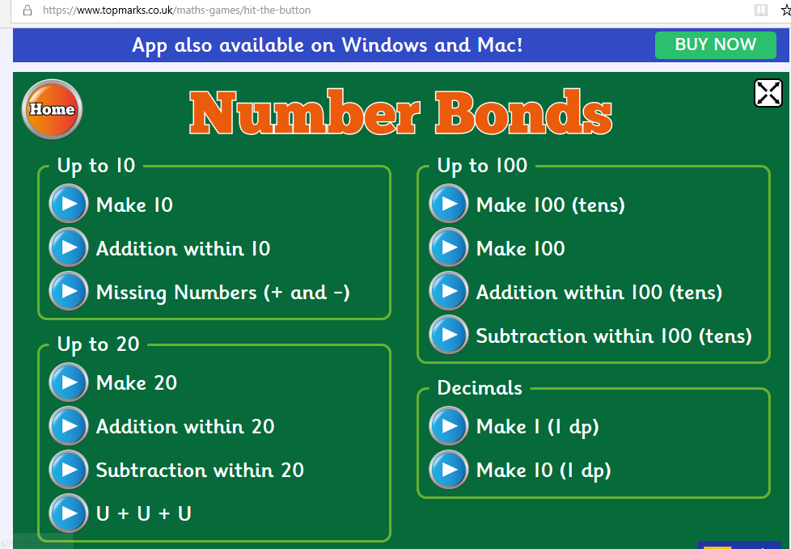
Hit the button

Classroom Secrets NCTM_ Tens Frame
