Reception Home Learning 4.5.20
Hi everyone,
Thank you for keeping up bits and pieces of structure for the children at this time. We truly appreciate that everyone’s circumstances are different and everyone is trying their best. The safety and emotional well-being of all members of the family are most important so please just do what you can.
I am trying to only vary parts of the timetable deliberately so that the children are familiar with what activities they are doing.
Kind regards,
Mrs Moore
Suggested breakdown for 1 hour per day
Phonics  (30 mins) | Ruth Miskin phonics You Tube videos (live)  9.30- Set 1 sounds  10am- Set 2 sounds (red and green- please note red group are only starting out on these sounds so this will be challenging)
Story  (5-10 mins) | Storytime with an adult. At some point this week, please share the stories of Yucky Worms by Vivian French and The Very Tiny Seed by Eric Carle - via You Tube. Children enjoy repetition so these could be used more than once during the week.
Letter formation  (5 mins) | Please continue to use the sheet from your child’s book bag to see which letters to practise (highlighted in pink)
Writing  (10 mins max) | In the summer term, we would be placing a high emphasis on writing in preparation for Year 1. The focus would be on the children sounding out a sentence and writing it from their ‘sound talk’ and using finger spaces between words. E.g. The cat sat in the sun.  Each day your child could write a simple sentence and draw a picture – it could be about anything- something that they have done that day might be a good starting point.
Maths  (10 mins)  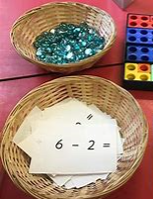 | This week we will be focusing on subtraction (children find this more difficult than addition) E.g. 7- 3 = 4 (single digit – single digit). This can be explored practically first of all using objects such as pens, tins or pasta then the children can build up to answering take away questions using their fingers/ as part of a number sentence (8-4 =4)  There are useful games on Classroom Secrets and Topmarks which would support this objective too. The username is: 240085 followed by your child’s first name (no space) and the password is: 123
History | VE Day Celebrations  On Friday we will celebrate VE day- marking 75 years since the end of WW2. This week we would like the children to make their own party decorations such as bunting, flags or posters to decorate a window at home with a red, white and blue theme.  Please send any photos to Tapestry so that we can share the celebrations together via Facebook.
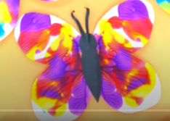  Art | Symmetrical folding- butterfly paper (if you have paint at home)  You Tube video- Symmetrical Butterfly Painting | Caitie's Classroom | Learning Videos For Kids

Subtraction (online games)

Topmarks- subtraction grids (if your child is working with numbers beyond 10, please choose an appropriate level from the menu)
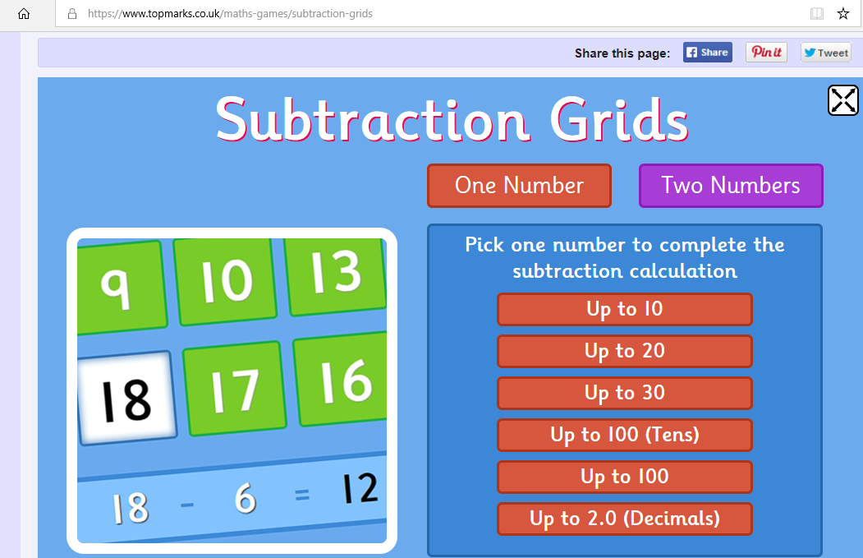

Classroom Secrets
