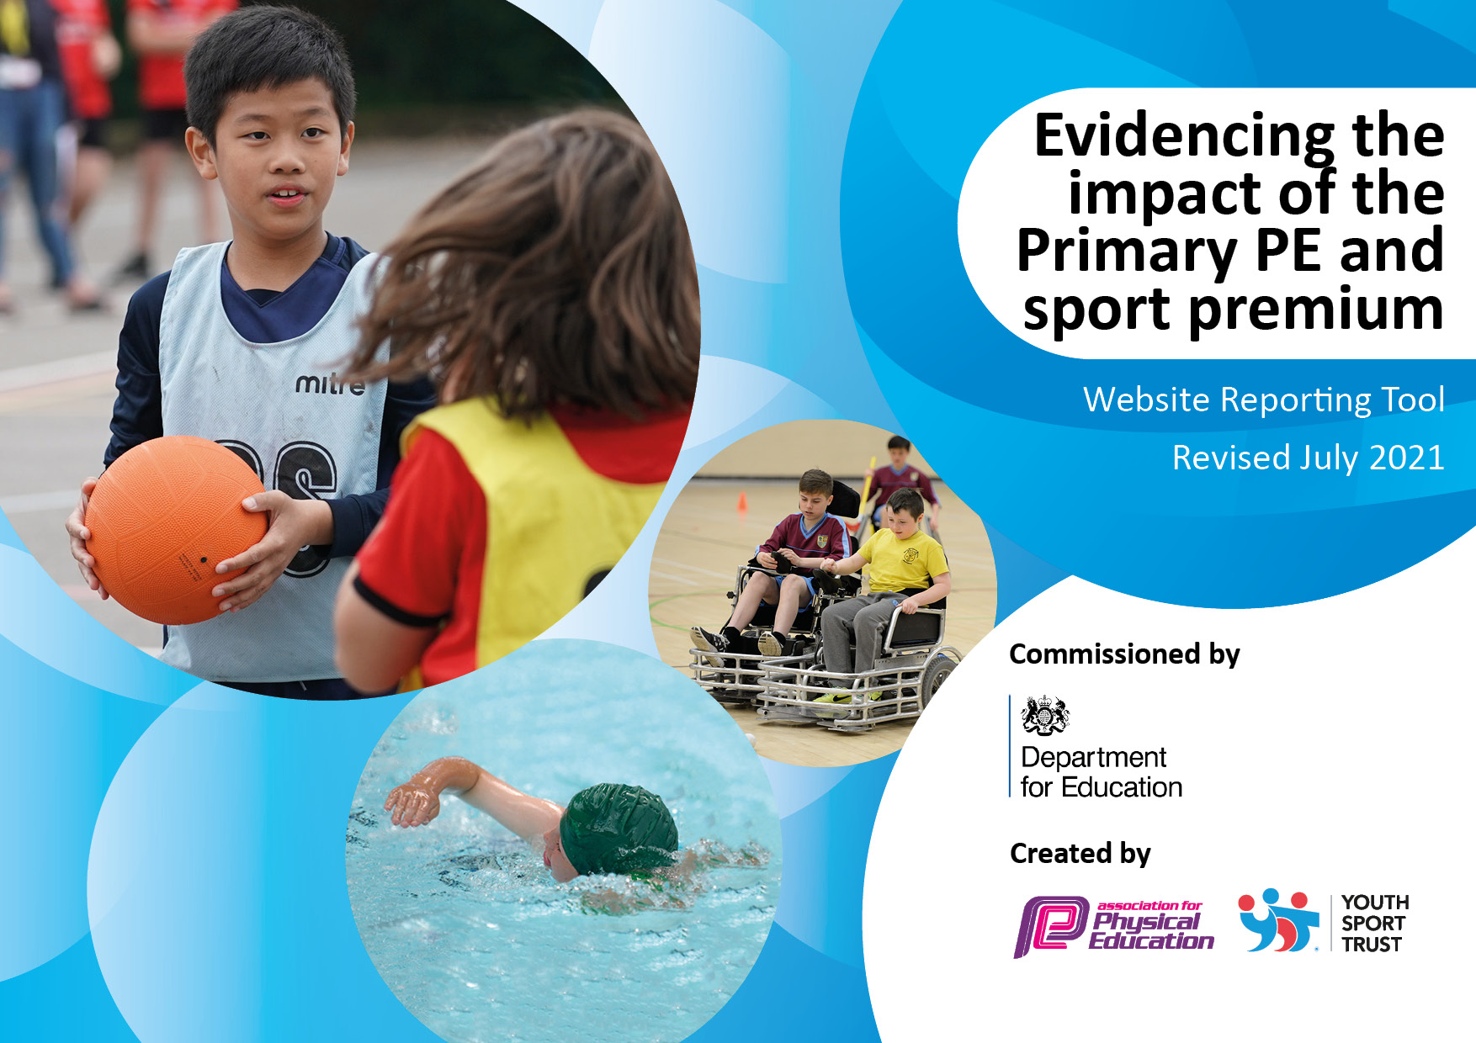
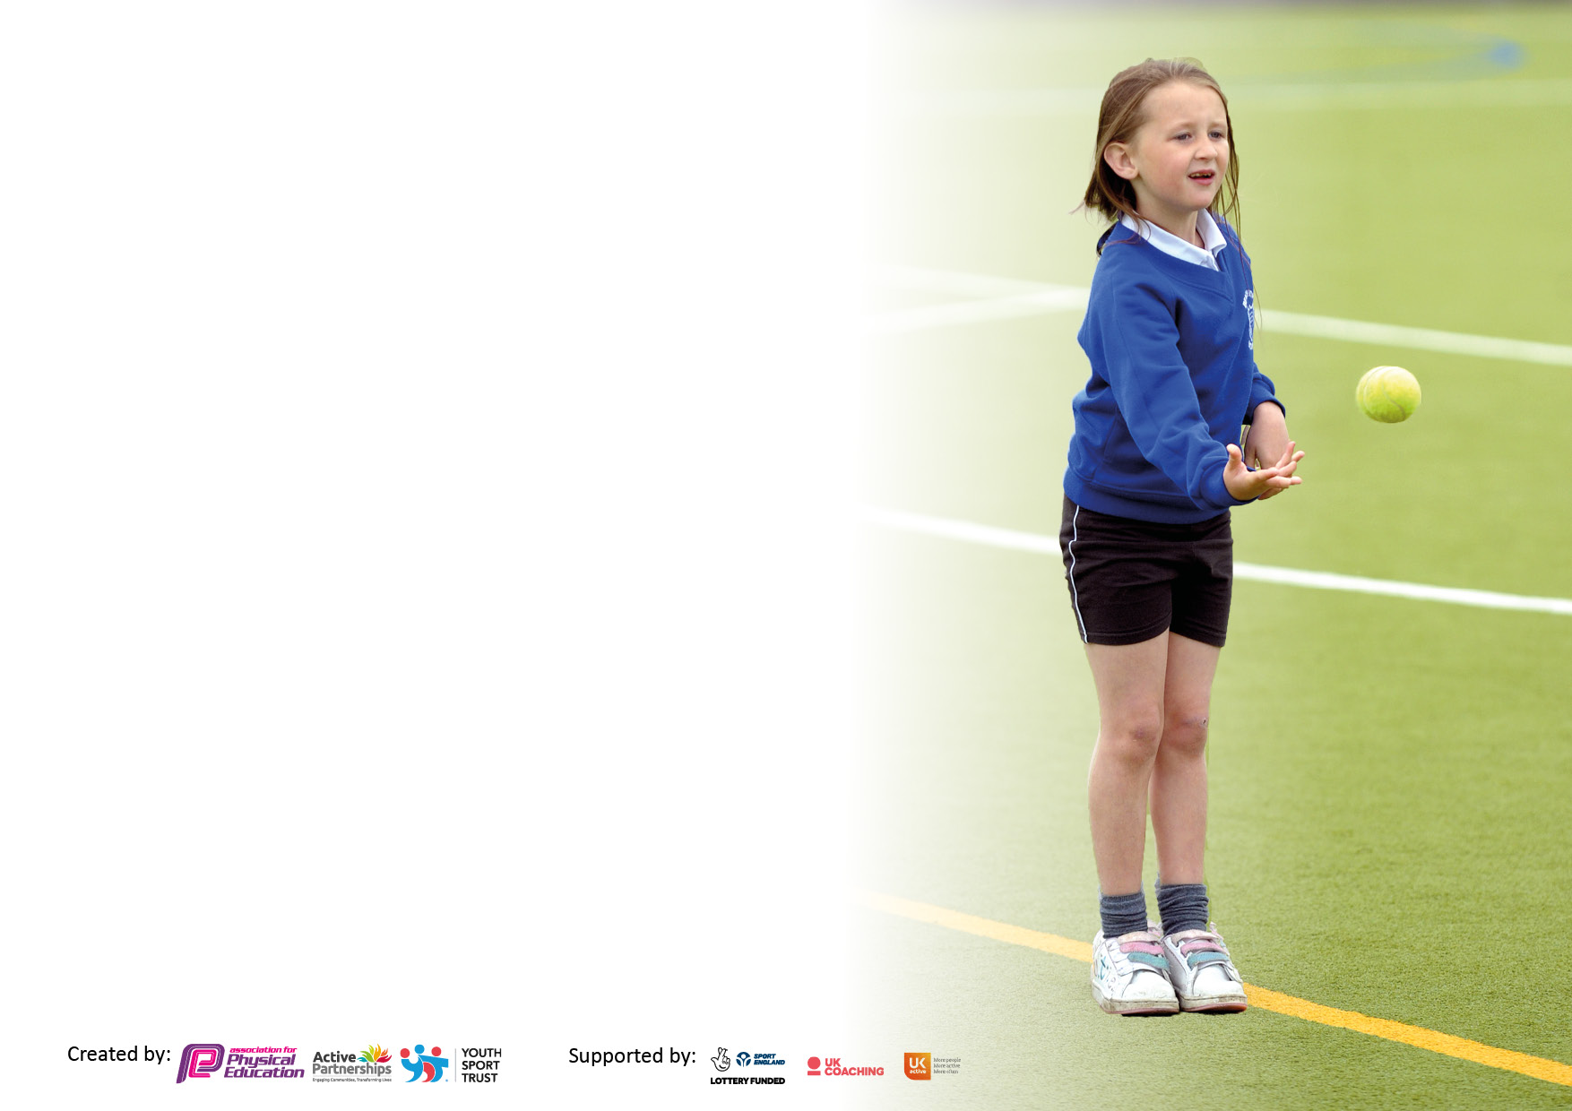

It is important that your grant is used effectively and based on school need. The Education Inspection Framework makes clear there will be a focus on ‘whether leaders and those responsible for governors all understand their respective roles and perform these in a way that enhances the effectiveness of the school’.

Under the Quality of Education Ofsted inspectors consider:
Intent - Curriculum design, coverage and appropriateness
Implementation - Curriculum delivery, Teaching (pedagogy) and Assessment
Impact - Attainment and progress

To assist schools with common transferable language this template has been developed to utilise the same three headings which should make your plans easily transferable between working documents.

Schools must use the funding to make additional and sustainable improvements to the quality of Physical Education, School Sport and Physical Activity (PESSPA) they offer. This means that you should use the Primary PE and sport premium to:

- Develop or add to the PESSPA activities that your school already offer
- Build capacity and capability within the school to ensure that improvements made now will benefit pupils joining the school in future years
- The Primary PE and sport premium should not be used to fund capital spend projects; the school’s budget should fund these.

Pleasevisitgov.ukfortherevisedDfEguidanceincludingthe5keyindicatorsacrosswhichschoolsshoulddemonstrate animprovement.Thisdocumentwillhelpyoutoreviewyourprovisionandtoreportyourspend.DfEencouragesschools to use this template as an effective way of meeting the reporting requirements of the Primary PE and sport premium.

We recommend you start by reflecting on the impact of current provision and reviewing the previous spend.

Schools are required to publish details of how they spend this funding, including any under-spend from 2019/2020, as well as on the impact it has on pupils’ PE and sport participation and attainment. All funding must be spent by 31st July 2022.

We recommend regularly updating the table and publishing it on your website throughout the year. This evidences your ongoing self-evaluation of how you are using the funding to secure maximum, sustainable impact. Final copy must be posted on your website by the end of the academic year and no later than the 31st July 2021. To see an example of how to complete the table please click HERE.
Created by: Supported by:

Details with regard to funding
Please complete the table below.

Total amount carried over from 2019/20 | £
Total amount allocated for 2020/21 | £18,030
How much (if any) do you intend to carry over from this total fund into 2021/22? | £14,998
Total amount allocated for 2021/22 | £18,210
Total amount of funding for 2021/22. To be spent and reported on by 31st July 2022. | £33208
Swimming Data
Please report on your Swimming Data below.

Meeting national curriculum requirements for swimming and water safety.

N.B. Complete this section to your best ability. For example you might have practised safe self-rescue techniques on dry land which you can then transfer to the pool when school swimming restarts.
Due to exceptional circumstances priority should be given to ensuring that pupils can perform safe self rescue even if they do not fully meet the first two requirements of the NC programme of study
What percentage of your current Year 6 cohort swim competently, confidently and proficiently over a distance of at least 25 metres?  N.B. Even though your pupils may swim in another year please report on their attainment on leaving primary school at the end of the summer term 2021.  Please see note above | 62%
What percentage of your current Year 6 cohort use a range of strokes effectively [for example, front crawl, backstroke and breaststroke]?  Please see note above | 62%
What percentage of your current Year 6 cohort perform safe self-rescue in different water-based situations? | 62%
Schools can choose to use the Primary PE and sport premium to provide additional provision for swimming but this must be for activity over and above the national curriculum requirements. Have you used it in this way? | No

Action Plan and Budget Tracking
Capture your intended annual spend against the 5 key indicators. Clarify the success criteria and evidence of impact that you intend to measure to evaluate for pupils today and for the future.

Academic Year: 2021/22 | Total fund allocated: £33208 | Date Updated: 31st July 2022
Key indicator 1: The engagement of all pupils in regular physical activity – Chief Medical Officers guidelines recommend that primary school pupils undertake at least 30 minutes of physical activity a day in school |  |  |  | Percentage of total allocation:
 |  |  |  | 34%
Intent | Implementation |  | Impact
Your school focus should be clear what you want the pupils to know and be able to do and about  what they need to learn and to  consolidate through practice: | Make sure your actions to achieve are linked to your intentions: | Funding allocated: | Evidence of impact: what do pupils now know and what can they now do? What has changed?: | Sustainability and suggested next steps:
Educate a team of children to deliver activities that will increase activity levels during break and lunch times. | Play leader training for year 5 children (Spring term). Booked using ASSP. | £675 | Children more knowledgeable and can suggest activities for others to play. | Schedule next year’s training
Engage children in more physical activity/play during lunch times. | Buy into OPAL play and roll this out throughout the school. | £1,740 | Children are now exposed to a variety of play opportunities at lunch times. | Ensure all staff understand how OPAL play will be implemented through sufficient training and continue to collect play resources from the community. Equipment to be checked regularly to ensure it is suitable for use.
Increase in the quality of sporting equipment around school. | Purchased basketball posts, football nets, infant benches, infant play equipment and sheds. | £8,906 | Children have high quality equipment to use during their PE sessions. | Ensure the equipment is well looked after and check regularly for its suitably for use.
Key indicator 2: The profile of PESSPA being raised across the school as a tool for whole school improvement |  |  |  | Percentage of total allocation:
 |  |  |  | 28%
Intent | Implementation |  | Impact
Your school focus should be clear what you want the pupils to know and be able to do and about  what they need to learn and to  consolidate through practice: | Make sure your actions to achieve are linked to your intentions: | Funding allocated: | Evidence of impact: what do pupils now know and what can they now do? What has changed?: | Sustainability and suggested next steps:
Recognising the achievements of the children (inside and outside of school). | Children’s PE, school sport and community achievements celebrated in Celebration Assembly. Achievements added to Facebook and to their class Seesaw. | N/A | Motivates other children to succeed and share their achievements. Children can now share achievements with staff members and know they will be celebrated. | Continued.
PE to have a high profile across the school and it to be visible to children. | Created a PE display board visible to all which includes information on: curriculum PE, clubs, competitions and a healthy lifestyle. | N/A | Sports, clubs and competitions visible to children which can inspire them to get involved. | Keep updating the display board with new information/photographs.
Pupils taught that sport and well-being are interlinked. | Wright Sports Services to deliver a 3 week healthy ways workshop to year 3.  Coach delivering yoga. | See costs below  £300 | Children will be more educated on the benefits on sport and physical activity and will approach it in a way that will be beneficial to their wellbeing. | Book this workshop for next year.

Key indicator 3: Increased confidence, knowledge and skills of all staff in teaching PE and sport |  |  |  | Percentage of total allocation:
 |  |  |  | 1.5%
Intent | Implementation |  | Impact
Your school focus should be clear | Make sure your actions to | Funding | Evidence of impact: what do | Sustainability and suggested
what you want the pupils to know | achieve are linked to your | allocated: | pupils now know and what | next steps:
and be able to do and about | intentions: |  | can they now do? What has
what they need to learn and to |  |  | changed?:
consolidate through practice:
To provide a broad range of activities for all children during curriculum PE. | iPep PE planner subscription | £500 | Videos allow children to have access to high quality examples/modelling. The differentiated activities allow all children to achieve the learning objective. Gives teachers confidence to stretch and challenge the children. | Renew iPep subscription.  Allow teachers to observe coaches/other teachers to increase confidence, knowledge and skills of sports they are less confident teaching.
Key indicator 4: Broader experience of a range of sports and activities offered to all pupils |  |  |  | Percentage of total allocation:
 |  |  |  | 36.5%
Intent | Implementation |  | Impact
Your school focus should be clear | Make sure your actions to | Funding | Evidence of impact: what do | Sustainability and suggested
what you want the pupils to know | achieve are linked to your | allocated: | pupils now know and what | next steps:
and be able to do and about | intentions: |  | can they now do? What has
what they need to learn and to |  |  | changed?:
consolidate through practice:
Children are given the opportunity to experience a wider range of sports/activities such a ten pin bowling, panathlon, escape rooms festival and boccia/table top cricket. | Some SEN children were given the opportunity to go ten pin bowling in Carlisle.  Some SEN children participated in a panathlon event.  Year 6 children attended an escape rooms festival linked to the Commonwealth Games.  Some SEN children participated in a boccia/table top cricket. | £3,600 | Pupils experience a wider variety of sports than are on offer in our local area and develop the positive attitude to towards sports in general. | Continue to provide a wider range of sports/activities to children.
Curriculum planning includes all School Games sports.  PE curriculum leader release time to support, monitor and evaluate | iPEP PE Planner subscription Schemes of work in place. | £3446 | Multiple successes at the competitions attended.  Curriculum planning in place for all year groups | Continue iPep subscription and entering competitions.
Children are given the opportunity to experience outdoor adventurous learning through Forest School experience. | Forest School leader employed 0.1 per week to deliver sessions. | £5252 | Pupils develop outdoor and adventure skills throughout the year.

Key indicator 5: Increased participation in competitive sport |  |  |  | Percentage of total allocation:
 |  |  |  | 28%
Intent | Implementation |  | Impact
Your school focus should be clear | Make sure your actions to | Funding | Evidence of impact: what do | Sustainability and suggested
what you want the pupils to know | achieve are linked to your | allocated: | pupils now know and what | next steps:
and be able to do and about | intentions: |  | can they now do? What has
what they need to learn and to |  |  | changed?:
consolidate through practice:
Increased participation in competitive sport | Purchase of the Wright Sports Services 5s Programme.  Attended every competition offered by Netherhall:  - Netball  - Boccia/Table Top Cricket  - Multiskills  - Football  - Cross Country  - Athletics  Year 6 rounders competition against Richmond Hill Primary School.  Carlisle Football Tournament | £8,874  £490 | Development of stamina, speed, strength, skill and suppleness whilst competing against children.  Enjoyment of competing against other schools.  . | Wider competition calendar.

Signed off by
Head Teacher:
Date:
Subject Leader:
Date:
Governor:
Date:

