Science week 3
How can we see things?
Previously we learnt that light travels into our eyes and enables us to see objects which is why you cannot see things in the dark.
Websites to look at
https://www.bbc.co.uk/bitesize/topics/zbssgk7/articles/zp7f8mn
https://www.bbc.co.uk/bitesize/clips/zf9c87h
Activity1 : Use the template to label the parts of the eye

Can you label the different parts of the eye?
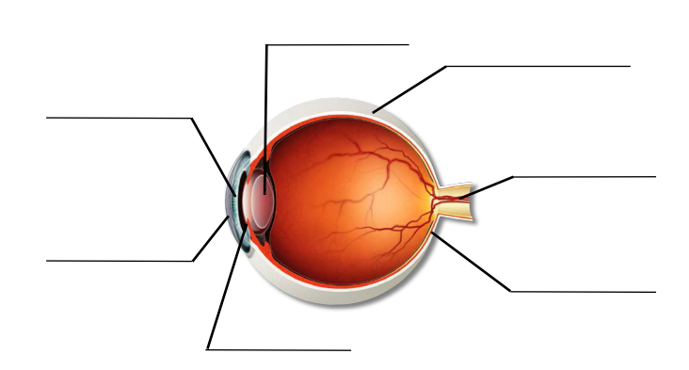

*Now we understand that the light travels into our eyes, not from our eyes.

Activity 2: Now have a close look at someone’s eye
. Can you see the cornea (the transparent film over the front of the eye)?
. Can you see the iris (the colourful part of the eye)? What colours can you see?
. Can you see the pupil (the black part of the eye)?
. Can you see the sclera (the white part of the eye)?

