The Romans
Year 4 Home Learning Projects
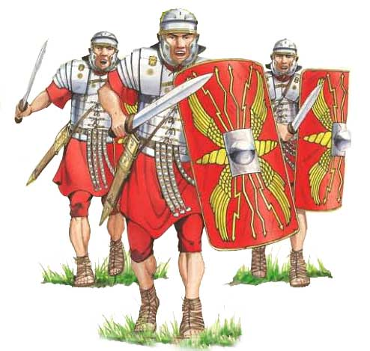

Please see below for a list of Roman activities you can complete at home. You can do as many of these as you like and can share pictures of your work on Seesaw when you are finished.

Useful websites:
http://www.primaryhomeworkhelp.co.uk/Romans.html
https://www.bbc.co.uk/teach/school-radio/history-ks2-romans-index/zvgk47h
https://www.bbc.co.uk/bitesize/topics/zwmpfg8
https://www.bbc.co.uk/bitesize/topics/zwmpfg8/articles/z2sm6sg
https://www.bbc.co.uk/bitesize/topics/zqtf34j/articles/z9j4kqt

Activities

- Make a list of objects that we would use now that the Romans used and one of objects we don't use now

- Create a Roman timeline

- Draw/paint a picture of something from Romans times e.g. a Roman banquet, or chariot racing. Write a caption to go with it.

- Write a secret message in Roman numerals (with an alphabet key)

- Create a poster advertising a Roman museum collection. (This can be done on the computer)

- Write a short newspaper report announcing the invasion of Britain (you will need to decide whether you’re a Roman or British newspaper first and don’t forget to include a catchy headline!)

- Write a diary entry from someone in a British village which gets taken over by the Romans.

- Write a diary entry from someone working in a Roman Villa in Britain

- Dress up as someone from Roman times. Have your photo taken and write a caption to go with it.

- Create a leaflet about a Roman exhibit for a museum.

- Find an interesting paragraph about Roman life in a book. Make notes and write about it in your own words. Don’t forget to write title of book.

- Design a Roman maze using reflective symmetry.

- Mint your own Roman coins

- Design and make a Roman outfit for a slave and/ or a rich person

- Create an outdoor game for Roman children to play

- Plan a trip across UK visiting only Roman towns and using as many Roman roads as possible.

- Play a game imagining the Romans invading - how would you feel as a Roman? How were the Romans organised? How would you feel as a Celt?

- Research the Roman Gods and design your own God
Make a 3D model of an item from Roman times

- Write a food diary for one day if you were member of a Roman household, see if you can try to do the same for a British person during the same period.

- Find a Roman recipe. Create this recipe and take a photo to show your creation. (Write the recipe to go with your photo in case others would like to have a go)

- Design a job advert for someone to work as a servant in a Roman villa

- Write your own Roman poem.

- Create a maths work sheet for Roman children, making sure you use Roman numerals in your calculations.
- Write a description about arriving at one of the Roman Vilas to work for an important Roman leader. (It was dark as I arrived. I was nervous but also excited as I approached the Villa as it looked so different to my own home. I looked up in awe at the building before me and I couldn’t help but wonder, what would my life bring...)

- Imagine you are a member of a Roman leader’s household. Write a letter home to your family.
- Write a report on Caesar’s Invasion

- Get someone to pretend they were a Roman military leader or you could be this person. Conduct an interview. Write out the questions and answers.

- With permission, watch a film with a Roman theme. Write a film review.

- Write a story with a Roman theme, maybe something linked to an object. This could be present day set in museum or linked to an artefact in your home.

- Research and learn a Roman song or dance

- Find as many countries as possible that the Romans invaded. Draw their flags and write a sentence to go with each flag.

- Make a 3D model of a Roman Villa and/or a Celtic round house from Britain.

- Make a Roman shield out of cardboard - research the style and colours carefully

- Make some Roman armour and a helmet.

- Write a Roman play and video it for the class.

