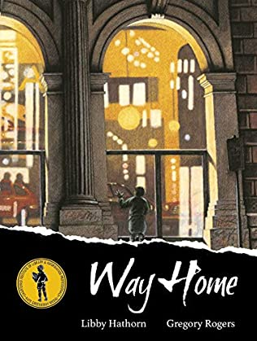

Questions to think about

* Who is the person in the picture?
* Where did they come from?
* Where are they going?
* Are they lost?
* How old is the person?
* Who do they live with?
* What is the building in the background?
* Do you think this person is the main character? Are we going to meet other characters? Who?
* What is the story going to be about?