Week 2
Focus: The water cycle

Activity 1:
As a little recap, visit the following links to refresh your understanding of what the water cycle is. You can make some notes linked to the key words as you watch. These links are from www.espresso.com you will need to use the log in - student9704 and password maryport

Read the water cycle book -
https://central.espresso.co.uk/espresso/modules/e2_big_books/flash/water_cycle/mfnp.html?source=search-all-all-all-all&source-keywords=water%20cycle

Watch the water cycle video clips –
https://central.espresso.co.uk/espresso/modules/t2_comp_model/water_supply/video_cycle.html?source=search-all-all-all-all&source-keywords=water%20cycle
https://central.espresso.co.uk/espresso/primary_uk/subject/module/video/item1207022/grade2/module1196044/index.html?source=search-all-all-all-all&source-keywords=water%20cycle

And you can even sing along to the water cycle song! –
https://www.youtube.com/watch?v=TWb4KlM2vts

Activity 2 –
Complete the worksheet by adding in the missing words.
Can you draw your own water cycle diagram? I would like you to use the key words outlined on the activity sheet. Then please upload to Seesaw.

Activity 3 –
Read the book, ‘The Drop in My Drink’ this has been uploaded to your Seesaw. As you are reading this book I would like to you to think carefully about the journey of the water droplet –
What places does it visit?
What can it see?
What can it smell?
What can it hear?
Makes notes along the way as this will help you with your next activity.

Activity 4 –
I would like you to create a word class poem based on the journey of the water droplet from the story.
Each line within your poem will include an adjective, noun, verb and an adverb. The structure for the poem has been uploaded along with some examples. Once you have used the structure to help generate your poem I would like you to present it either handwritten, using an app or computer based program and then upload it to Seesaw. You may also add a voice note of you reading your poem out loud ☺

If you have enjoyed this activity you may also like to create your own free verse poem based on the water droplets journey.

Activity 5 –
From your previous task you will have generated lots of language based around the water droplets journey. I would now like you to create a short first person story based around this.
You will pretend that you are the water droplet. As you go on the journey think about all the things you will see, smell, and hear along the way. Will you change state (for example into ice?) How will this make you feel?
Will you remain happy throughout your journey? Or will there be moments where you are scared? Make sure that the language that you choose reflects these emotions.
Remember this is just a short story, but I would like you to carefully choose the language and sentence types that you use.
I can’t wait to read these!

Science
Our Science topic this term is Light and How We See.
Look at the picture in your activities folder on SeeSaw – Click on Respond to activity and let me know what you think? Which child is right? Can you explain why?
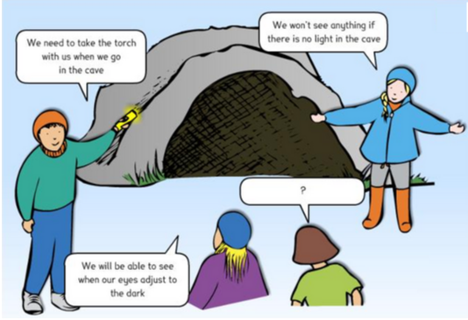

Also remember we have a TimesTableRockstar challenge against Year 5! Keep up your work on Spelling Shed and Reading Plus too!

Keep working hard!
Mrs Hurst & Miss Dover

