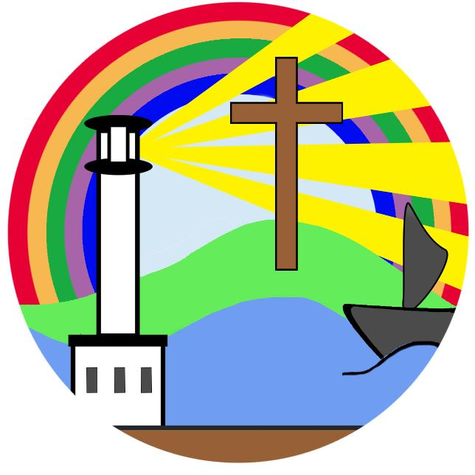

Curriculum Overview - Year 2

|  | Autumn 1 | Autumn 2 | Spring 1 | Spring 2 | Summer 1 | Summer 2 |
| --- | --- | --- | --- | --- | --- | --- |
| Christian value - year 1 | Courage | Peace | Perseverance | Friendship | Compassion | Truth |
| Christian value - year 2 | Hope | Responsibility | Thankfulness | Forgiveness | Respect | Trust |
| Enrichment opportunities | Forest school  Roman museum  Sponsored walk  Book bus | Christmas play  Christmas pantomime  Library visit  Phunky Foods Workshop | Forest school  Castle trip/Tullie House  Islam workshop | Litter pick  Easter activities | Forest school  Local walk  Stocks Wood Outdoor Centre | Sports day  Residential  Bowling club |
| Whole class story | Dr Suess collection stories  By Theodore Suess | The owl who was afraid of the dark  By Jill Tomlinson | Matilda  By Roald Dahl | A bear called Paddington  By Michael Bond | Precious and the monkeys  By Alexander McCal  Smith | The Worst Witch  By Jill Murphy |
| English - Reading | Read Write Inc. group focus | Fairy tales  Remembrance Day  Antarctica  Habitats  Homes  Christmas  Poetry focus (to read and study): a tiny burning flame | Famous artists  Castles  Changes through time  Materials  Recycling  Festivals  Poetry focus (to read and study): Cobwebs - Unknown | Springtime  Where our food comes from  Homes  Weather patterns  Changes through time  Antarctica  Poetry focus (to perform): Daddy Fell into The Pond –  Alfred Noyes | Nature  Growing plants  Lice cycles  Henry VIII  British monarchy  Poetry focus (to read and study): My Lonely Garden from Take oﬀ  Your Brave  – Nadim (aged 4) | Product design  Religion  Looking after ourselves  Continents  Countries  Bible stories  Poetry focus (to perform): Cats Sleep Anywhere –  Eleanor Farjeon |
| English - Writing Book | Journey home | The Goldilocks Project | The bear under the stairs  The bear and the piano | Grandad’s  campervan  If all the world were… | Lizzy and the cloud  Toys in space | Rosie Revere Engineer |
| English - Writing outcomes | **Main:**  Persuasive letter  **Other:**  Posters  Lists  Postcard  Information text | **Main:**  Sequel stories  **Other:**  Wanted poster  Letter  Retellings  List of rules  Character descriptions | **Main:**  Information text  Own narrative about bravery  **Other:**  Letters  Retellings of stories  Newspaper report  Information poster | **Main:**  Sequel narrative  Non-narrative poem  **Other:**  Labels  Memory poem  Interview  Captions  Postcards  Writing in role  Diary entry  Short explanation text | **Main:**  Guidebook  Own fantasy narrative  **Other:**  Adverts  Pitch  Letter of advice  Posters  Diary entry  Invitation  Descriptive settings | **Main:**  Explanation text  **Other:**  Advert  Letter  School report  Invention description |
| SPAG | Nouns  Vowels and consonants  Demarcating sentences  Forming nouns using ‘-ness’  Punctuating sentences | Adjectives  Compound words  Adjectives with ‘-er’ and ‘-est’  Subordination  Statements and exclamations | Noun phrases  Homophones  Forming adjectives using ‘-ful’ and ‘-ness’  Questions and commands  Sentence writing | Verbs  Singular and plural  Adverbs with ‘-ly’  Commas in lists  Changing adjectives into adverbs | Adverbs  Word clauses  Coordination  Apostrophes for possession  Past and present tense | Recapping pronouns  Forming nouns using ‘-er’  Progressive tense  Apostrophes for contractions  Uplevelling sentences |
| Maths | Place value  Addition and subtraction | Addition and subtraction  Shape | Money  Multiplication and division | Length and height  Mass, capacity and temperature | Fractions  Time | Statistics  Position and direction  Consolidation |
| Science | Living things and their habitats | Animals including humans | Use of everyday materials | Use of everyday materials continued | Plants | Living things and their habitats (minibeasts) |
| RE | Understanding Christianity: God | Understanding Christianity: Incarnation | Understanding Christianity: Gospel | Understanding Christianity: Salvation | Understanding Christianity: Creation | Multi-Faith  Islam |
| Geography |  | Why don’t penguins need to fly? |  | Why does it matter where my food comes from? |  | How does the geography of the Kampong Ayer compare with where I live? |
| History | Romans (empire and civilisation) |  | Castles and the Bayeux Tapestry (monarchy and power) |  | Kings and Queens – Comparing Queen Elizabeth II and Queen Victoria (monarchy and power) |  |
| Art | Craft and design: Map it out |  | Painting and mixed media: Life in colour |  | Mechanisms: Fairground wheel |  |
| Design and Technology |  | Structures: Baby bears chair |  | Mechanisms: Making a moving monster |  | Sculpture and 3D: Clay houses |
| Music | Tony chestnut | Carnival of the animals  Composing music inspired by birdsong | Grandma rap | Orawa  Trains | Swimg-a-long with Shostakovich  Charlie Chaplin | Tanczymy labada |
| PE | Throwing and catching | Gym – balance and agility | Dance – fictional characters ‘traditional tales’ | Balance and control – striking | Athletics – fundamentals | Partner games |
| Computing | IT around us | Word processing | Robot algorithms | Programming quizzes using scratch Jr | Making music | Stop motion |
| PHSE | Me and my relationships | Valuing difference | Keeping safe | Right and respect | Being my best | Growing and changing |