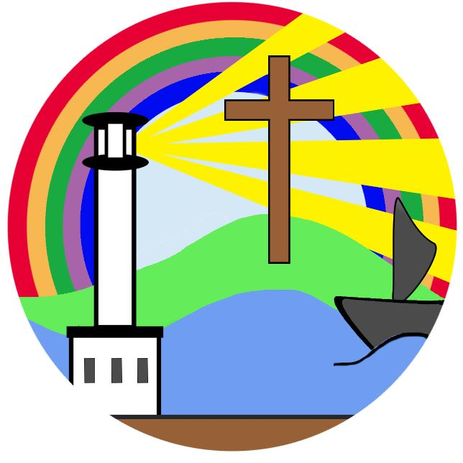
Curriculum Overview - Year 3/4 Cycle A

 | Autumn 1 | Autumn 2 | Spring 1 | Spring 2 | Summer 1 | Summer 2
Christian value - year 1 | Courage | Peace | Perseverance | Friendship | Compassion | Truth
Christian value - year 2 | Hope | Responsibility | Thankfulness | Forgiveness | Respect | Trust
Enrichment opportunities | Topic/artifact boxes  Macmillan Walk  Book bus  Forest school  Stocks Wood Stone Age Day | Astral circus workshop  Christmas crafts  Nativity performance  Church visit | Tullie House  Water workshops  First aid workshop | Easter crafts  Easter performance  Play in a day  Swimming | Residential  Local area walks | Sports day  Maryport Bowling club visit  Residential
Whole class story | The Iron Man | George’s Marvellous Medicine | Egyptian Cinderella | The Great Food Bank Heist | Toys Go Out | Nims Island
English - Reading | Materials  Rocks and fossils  Prehistoric Britain  Robots  From a railway carriage  Halloween spiders  Iron Man  Pebble in my Pocket | Gunpowder plot  Isaac Newton  Forces  Castles  Angry earth  Christmas  Incredible book eating boy  Walking with my iguana  Leon and The Place between | Ancient Egypt  Light and shadows  Fairy tales  E-safety  Egyptian Cinderella  Mummy!  Flat Stanley | Weather  Keeping healthy  Rocks and fossils  International women’s day  Here we are  Be glad your nose is on your face  The secret of black rock | The sound collector  Fairy tales  Deaf awareness week  Towns, cities and villages  Growing plants  Fairy tales  The sound collector | Coasts  Poetry performance  Nature  Colours  Malala Yousafzai’s birthday  The day the crayons quit  Matilda who told lies and was burned to death
English - Writing | Stone Age Boy – Adventure Story  Skara Brae – Holiday brochure  Witches Fingers – Instruction writing | Leon and the Place Between – Fantasy story  Christmas – Letter to Santa / speech | Flat Stanley – Postcard writing  Tullie House - Recount | The Secret of Black Rock – Narrative  Skeletons and muscles – explanation text  Earthquakes – information text  List poem | Wolves in the walls – Suspense story  Our school – non chronological report  Summer show – speech | Blue Umbrella – Romance story  Plants – iMovie explanation text / speech  Clerihew poem
Maths | Number: Place Value  Number: Addition and Subtraction | Number: Addition and Subtraction  Measurement: Area  Number: Multiplication and Division | Number: Multiplication and Division  Measurement: Length and Perimeter | Number: Fractions and decimals  Measurement: Mass and Capacity | Number: Fractions  Measurement: Money  Measurement: Time | Geometry: Shape  Statistics  Geometry: Position and direction
Science | Rocks | Forces and magnets | Light | Animals, including humans | Plants
RE | Creation and fall  People of God | Buddhism  Incarnation/God: What is the trinity  Advent | Gospel: What kind of world did Jesus want?  Salvation: Why do Christians call the day Jesus died good Friday? | Kingdom of God  Pentecost | Islam | Multi faith  Humanism
Geography |  | Beyond the Magic Kingdom: What the sunshine state was really like? |  | Earthquakes: Why do some earthquakes cause more damage? | Local area: How and why is my local area changing?
History | Stone age to Iron Age |  | Ancient Egypt |  | Local area
Art | Painting and mixed media - Prehistoric art |  | Craft and design - Egyptian scrolls |  | Drawing - Growing artists | Sculpture and 3D – Abstract shape and space
Design and Technology |  | Structures - constructing a castle | Textiles – Egyptian collars | Eating seasonally - Making and tasting a selection of foods using seasonal produce | Mechanical systems - Making a pneumatic toy | Electrical systems - Build an electrostatic game
Music |  | African drums  Rhythm patterns  Christmas music and songs |  | Earthquakes  Instrumental colour expression |  | Carnival of the animals  Composing instrumental music
PE | Football and basketball | Gym – symmetrical shapes | Dance history – Ancient Egypt | Over the net | Being an athlete | Strike and field  Thinking aloud (outdoor  Adventure)
Computing | Computer systems and networks: connecting computers | Creating media: desktop publishing | Programming: sequence in music | Programming: events and actions | Creating media: creating a movie | Databases: Top Trumps
PHSE | Me and my relationships | Valuing difference | Keeping safe | Rights and responsibilities | Being my best | Growing and changing
Spanish | Greetings | Seasons | Animals | Musical instruments | Vegetables | Ice creams

