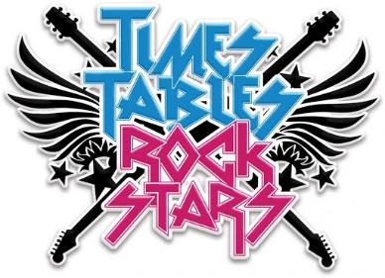
TTRS Battle of the Bands
Lime JW vs Lime RH
Starts: 9am on 20th April Ends: 15.30 on 24th April
Let the battle commence…

Please see below for more information regarding this week’s suggested tasks. Pictures of completed activities can be sent to either Miss Huddart or Mr Ward on Seesaw.

Science- Light and Shadow
Light Sources
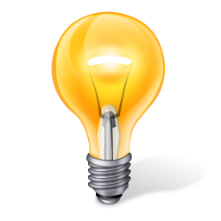
Task 1
- Watch the introduction to light sources clips below:
https://www.bbc.co.uk/bitesize/clips/zjkc87h
https://www.bbc.co.uk/bitesize/topics/zbssgk7/articles/z2s4xfr
- Activity
How many light sources can you find around the house? Remember, a light source makes its own light. List each one you find in a table like the one below and draw a picture. When you have done that, think of other light sources you didn’t see around the house and draw and list as many as you can in the table too.
Light sources around the house | Other light sources

Night and Day
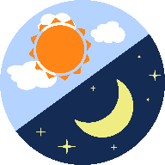
Task 2
Watch the video clips below:
https://www.bbc.co.uk/bitesize/clips/z9fpyrd
https://www.bbc.co.uk/bitesize/clips/z6fnvcw
Day: | Night:
- Draw a picture of somewhere you know well on a bright, sunny day. It could be your school, your house, the park or anywhere else. Then, draw a picture of the same place at night-time.
- Why are the two pictures different? Explain in as much detail as you can.
- What is day time?
- When does day time start and end?
- What is night time?
- When does night time start and end?

What are shadows and how are they formed?
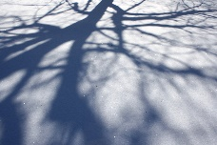
Task 3
Watch the video clip below:
https://www.bbc.co.uk/bitesize/clips/zg6r82p
Have a look at some different objects/ materials around your house. Some are transparent, some are opaque and some are translucent. Can you find out which is which by studying the shadows each object creates?
OPAQUE: the light cannot pass through the object so it casts a DARK SHADOW
TRANSPARENT: the light can pass through the object so it casts NO SHADOW
TRANSLUCENT: the light can partially pass through the object so it casts a LIGHT SHADOW

Object or material | Tick one of the following boxes to show what kind of shadow each object created. |  |  | This means the object is: opaque, transparent or translucent?
 | Dark Shadow | Light Shadow | No Shadow

Shadow Stick Investigation
Task 4
https://www.bbc.co.uk/bitesize/clips/z6fnvcw
https://www.bbc.co.uk/bitesize/clips/z8vfb9q
- Set up a shadow stick in a sunny spot to see what happens to the shadow throughout the day.
For example:
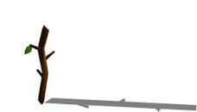
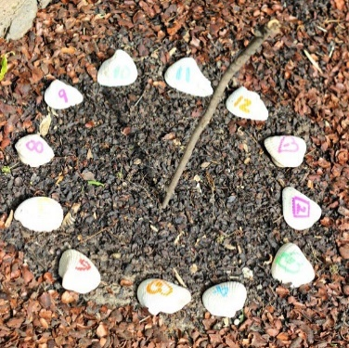
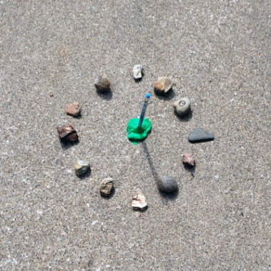
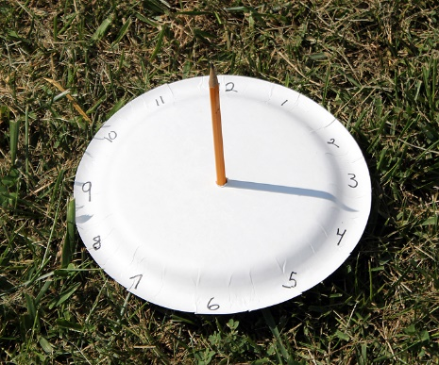

https://www.youtube.com/watch?v=oSMsX7cwzjk- How to make a sundial clip
- Record your results in a table like the one below:
Questions
- At what time of the day was the shadow shortest?
- Why do you think it was shortest at this time?
- At what time of the day was the shadow longest?
- Why do you think it was longest at this time?
- What do your results tell you about the length of shadows?

Time | Length of Shadow in (cm)

Make your own Shadow Puppets

Fun with Light and Dark
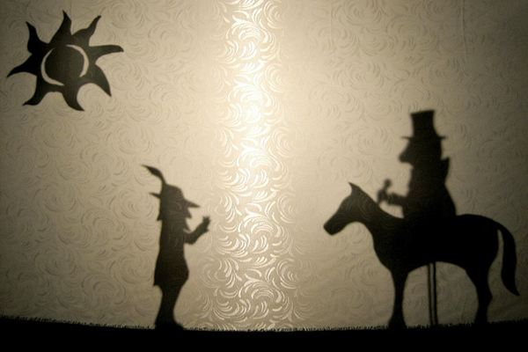
Task 5
Watch the following video clips:
https://www.bbc.co.uk/bitesize/clips/z87jmp3
https://www.youtube.com/watch?v=OsdMqNIcrls
https://www.youtube.com/watch?v=-hL28SkHf1g
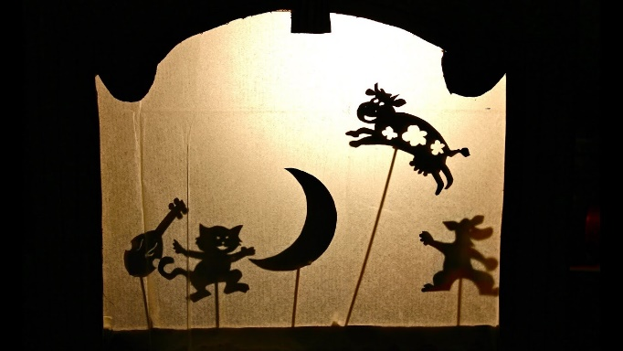
What you need:
- Lamp/ torch
- Cardboard
- Sellotape
- Pencil
- Scissors
- Wooden skewers or sticks
- White wall
How to:
- Choose what type of puppets you want. How about your favourite animal? Or your friends and family? Or a scary ghost?
- Draw outlines for your puppets on the cardboard and cut them out.
- Use sellotape to attach a skewer to the back of each of your puppets.
- Put the lamp or torch on the floor or on a table. Point it at the wall and turn it on. Turn off other lights and close the curtains.
- Hold your puppets between the light and the wall. Can you see a shadow on the wall? Move the puppets between the light and the wall to make the shadow different sizes.

Reflections
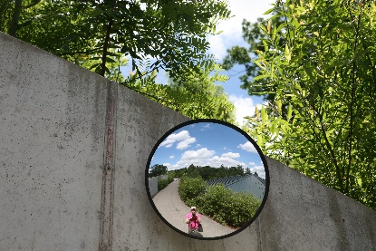
Task 6
Watch the following video clips:
https://www.bbc.co.uk/bitesize/clips/zf9c87h
https://www.bbc.co.uk/bitesize/clips/ztcg9j6
Have a go at each of the following challenges

Shadow Drawing- A Light and Shadow Experiment

Task 7

Equipment

- Several toys/ objects
- Paper
- Pen or pencil

Instructions

1. Choose a time to do this experiment. Do this in early morning or late afternoon.
2. Put sun cream on and wear sunglasses.
- Place the toys on the paper.
- Using a pen or pencil, trace the outline of the shadows on to the paper.

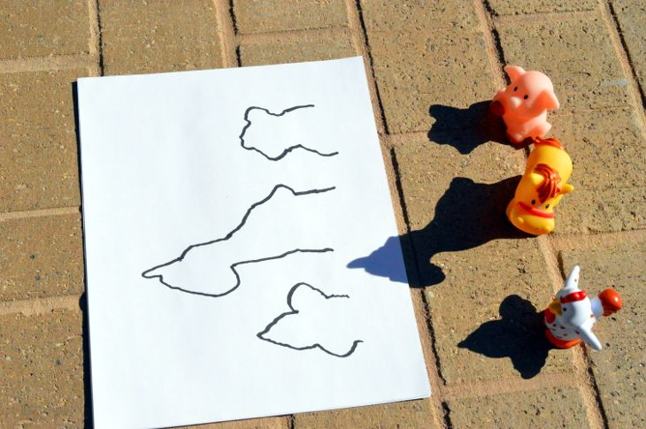
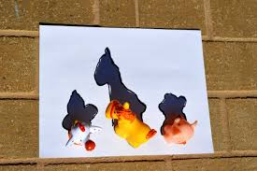

Observations/ points for discussion:
- Do the shadow stay the same? How do they change with time?
- Are the shadows larger, the same size or smaller than the toys?
- When you rotate the toys, what happens to the shadows?

