TTRS Battle of the Bands
Year 3 Boys vs Year 3 Girls
Starts: 9am on 4th May Ends: 15.30 on 7th May
Let the battle commence…

Please see below for more information regarding this week’s suggested tasks. Pictures of completed activities can be sent to either Miss Huddart or Mr Ward on Seesaw, thank you.

VE DAY
May Day is traditionally held on the first Monday in May, but this year it has been put back to Friday 8th May in order to help celebrate the 75th anniversary of VE Day. The holiday will form part of a three-day weekend of commemorative events.
VE Day - or 'Victory in Europe Day' - marks the day towards the end of World War Two (WW2) when fighting against Nazi Germany in Europe came to an end.
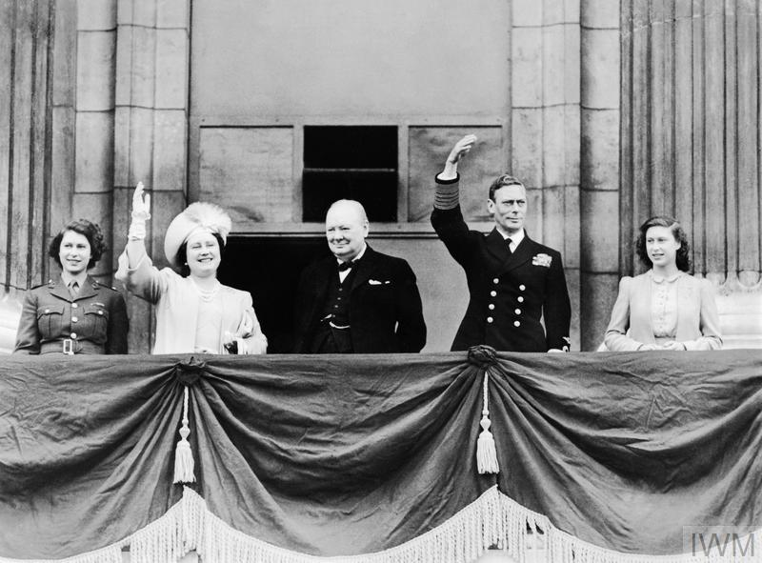
On 8 May 1945, Prime Minister Winston Churchill made an announcement on the radio at 3pm that the war in Europe had come to an end, following Germany's surrender the day before. This resulted in a nation rejoicing with men, women and children throwing parties and ringing bells. In London, people gathered in front of Buckingham Palace to see Prime Minister Winston Churchill and the royal family. The skies were also full of planes marking victory high above them.
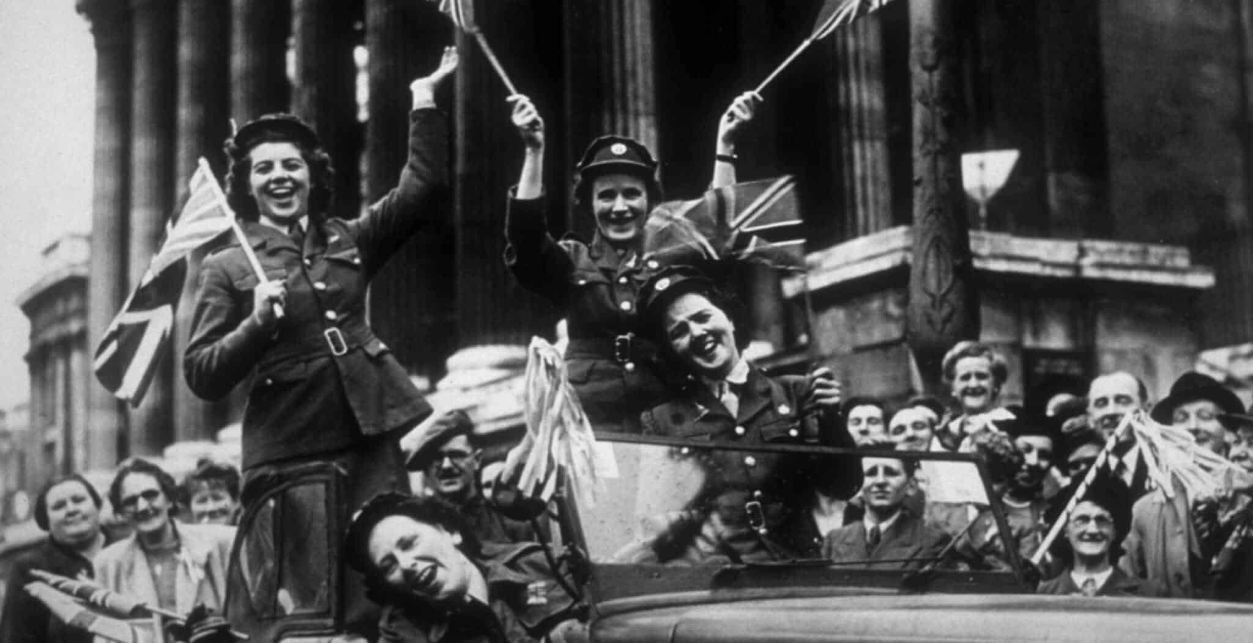
To find out more about VE day and to listen to Winston Churchill’s historic announcement, follow the links below:
https://www.bbc.co.uk/newsround/48201749
https://www.bbc.com/historyofthebbc/anniversaries/may/ve-day-broadcasts
https://www.bbc.co.uk/teach/class-clips-video/history-ks2-ve-day/z7xtmfr

Horrible Histories
https://www.youtube.com/watch?v=OROsPVqMeBs
Suggested Tasks
There are plenty of celebrations planned to mark this anniversary and there is no reason your household should feel left out! Here are a few of our top suggestions to get your children thinking about the end of the war and how it was marked.

- Talk the talk’ of a great man.
Act out Winston Churchill’s iconic speech for your family. You can find the transcript by following the link below:
https://winstonchurchill.org/resources/speeches/1941-1945-war-leader/to-v-e-crowds/

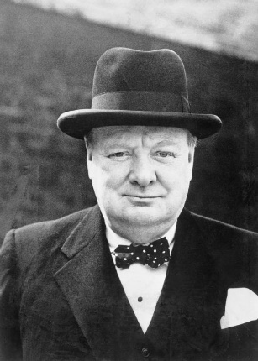

- A taste of war time?
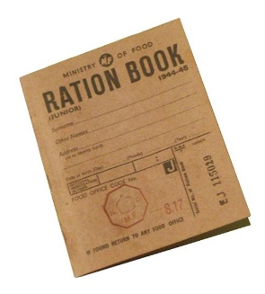
- Try making some war time recipes such as a cake or lemonade.
- Which kitchen utensils do we have not that wouldn’t have existed in 1945? For an extra challenge try to make your recipes using a 1945 method.
- Find out which foods were rationed and plan a party menu fit for VE Day
- Please see the following link for a range of 1940’s wartime recipes:
https://the1940sexperiment.com/100-wartime-recipes/
- Some example recipes are provided on the last page.

- Step back in time and throw a party!
Recreate the nationwide celebrations of 1945 in your home.
Why not have a picnic and play some war time tunes. You could even dress in 1940s style clothes or practice some 1940 dance moves like the Lindy Hop.

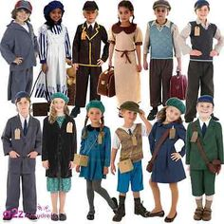
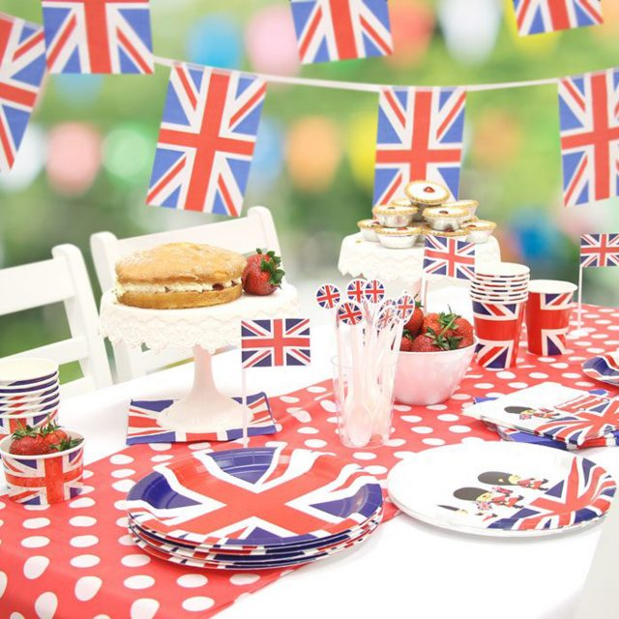

- Share some stories of VE Day or WW2
Read aloud a poem, short story or a chapter of a longer book relevant to VE Day. Alternatively, share some ‘real life’ stories from the war. Do you know anyone in your family who remembers WW2 and could share their stories with you?

Two Poems about VE Night - Then and Now by Iris Bruce:

https://www.bbc.co.uk/history/ww2peopleswar/stories/98/a4024298.shtml

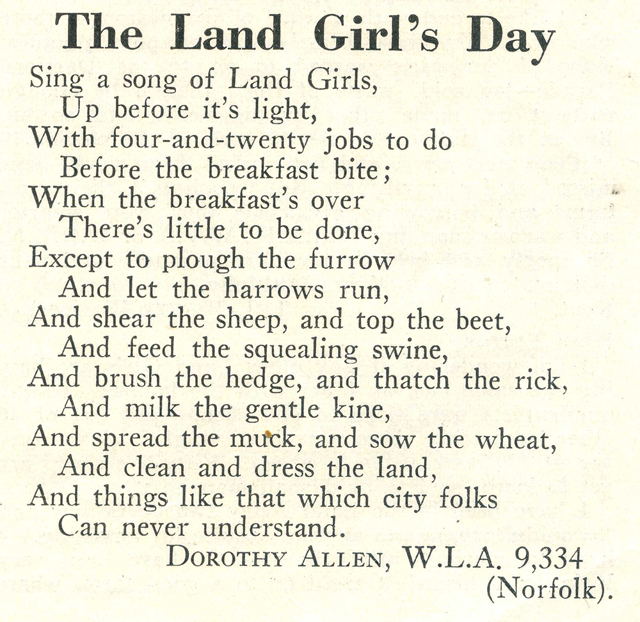

- Create a peace display
How can we remember the past and build a peaceful future together?
Create a peace poster or display somewhere in your house to remind people to be kind to each other.

- Decorate your house for VE Day.
Why not make some bunting to hang up around your house, decorate an entire window or make a smaller stained glass decoration?
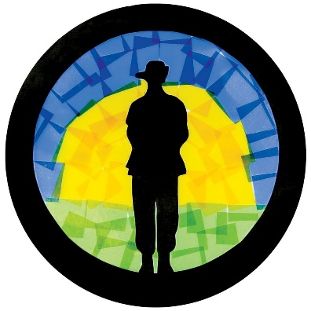

Free printable Union Jack flags and bunting templates available at:
https://www.primarytreasurechest.com/teachingresources/category/world-war-two-teaching-resources.html

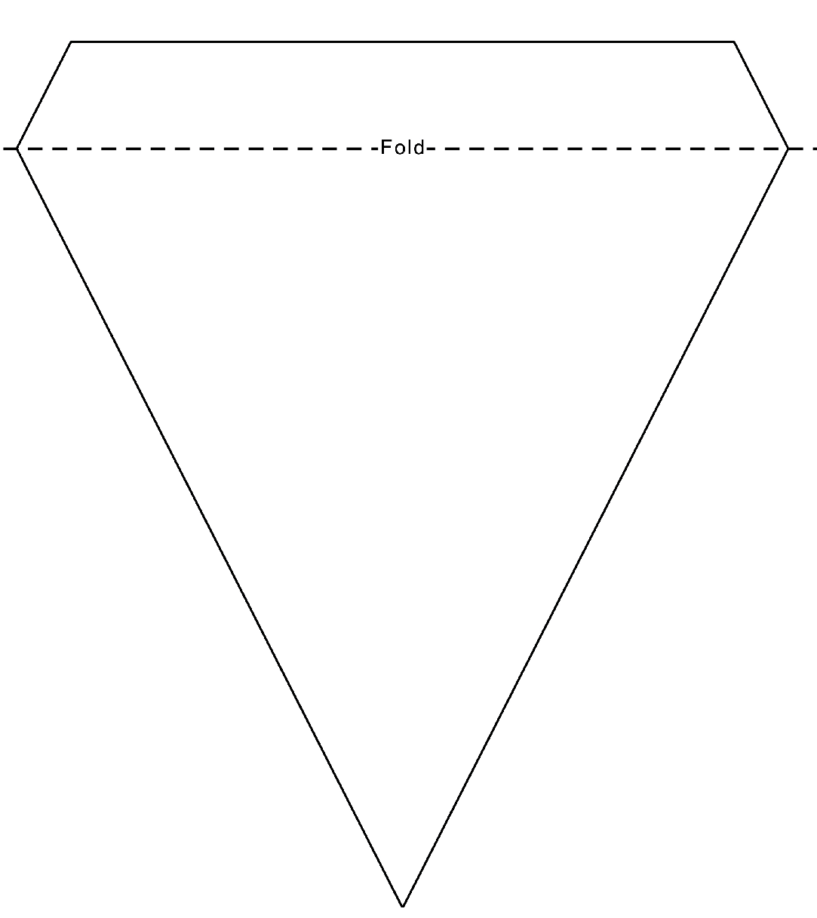
Free blank template below:
- Make a newspaper front page
Which stories should be included? Would you include the personal stories from people in the UK or would you stick to politicians? The BBC has some great archive on news footage taken from that day to get you inspired. Template provided on next page.

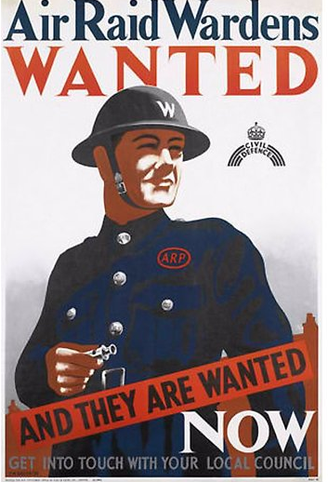
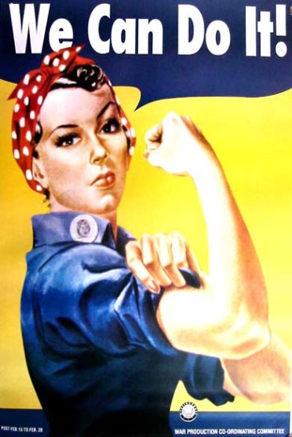
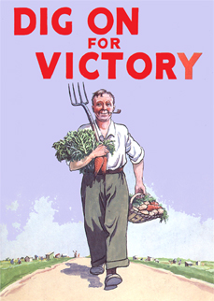
- Design your own WW2 poster.
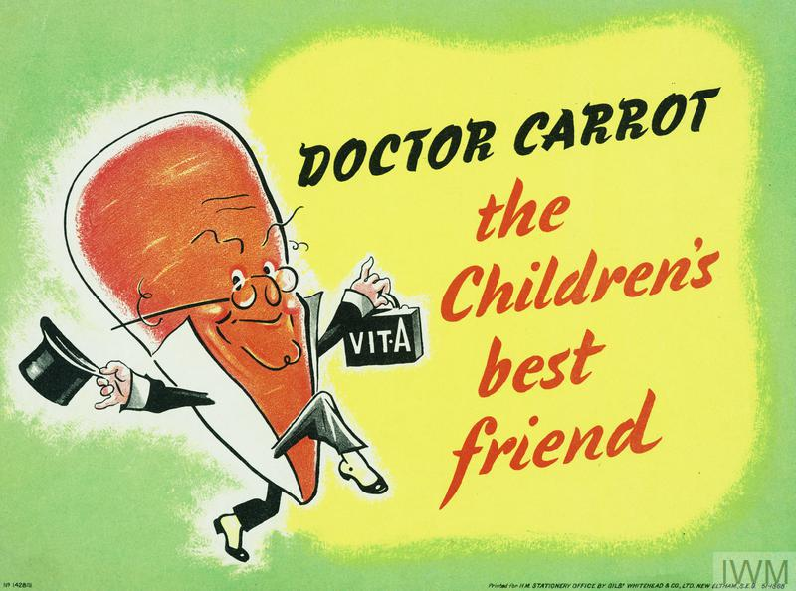
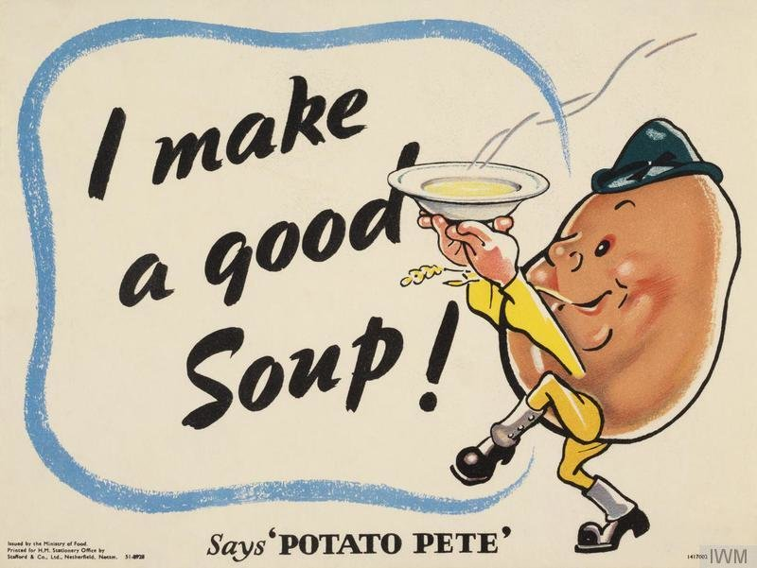

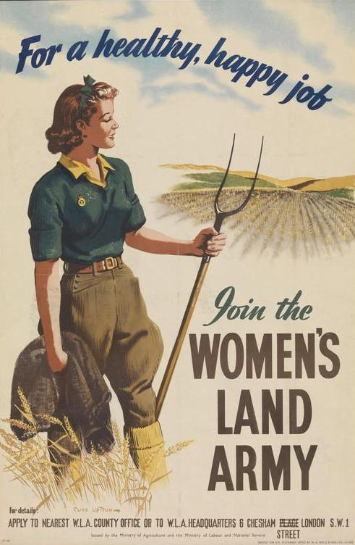
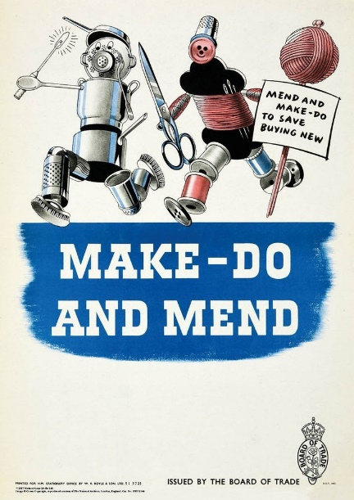
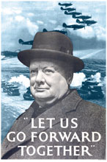

- Create an information poster, leaflet, power point presentation, piece of art work or model based on WW2 and VE Day. You may want to use the following questions to help you if you are doing research:

- Which country started World War 2?
- What year did World War 2 begin?
- How many countries were involved in World War 2?
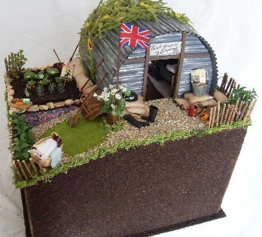
- Name 2 things World War 2 was the first war to ever involve?
- Who was the leader of Germany?
- Who was the leader of Britain?
- Name 2 countries that Germany invaded in 1939:
- Why did Germany invade these countries?
- Why did Hitler order thousands of German bomber planes to drop bombs on British cities? What was this called?
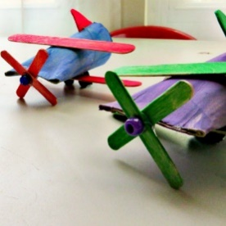
- When did WW2 end?
- How did people in Britain celebrate the end of WW2?

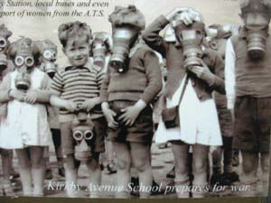
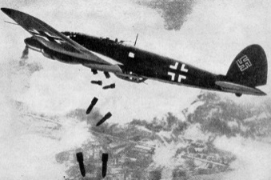

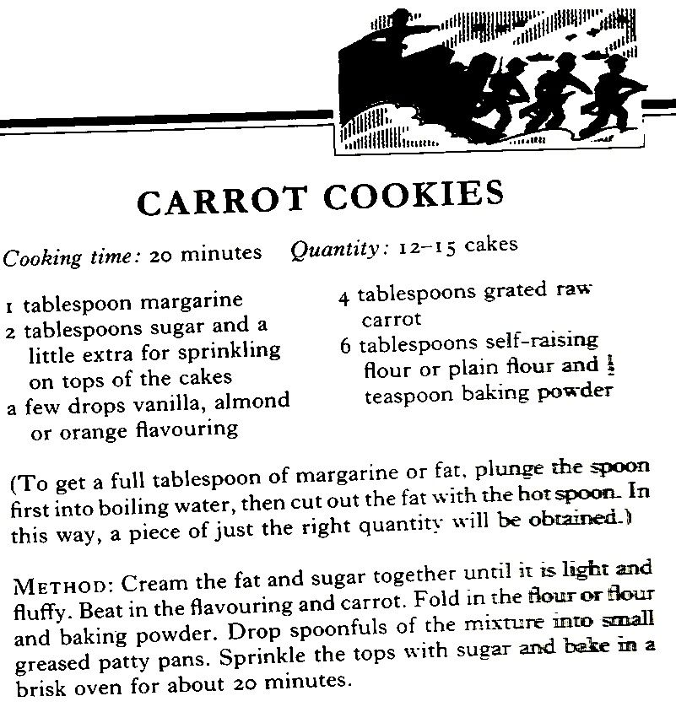
WW2 Recipes

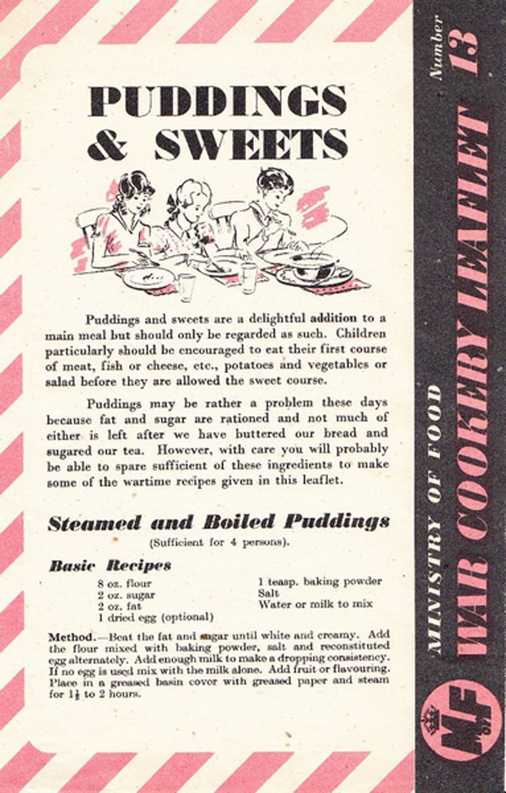
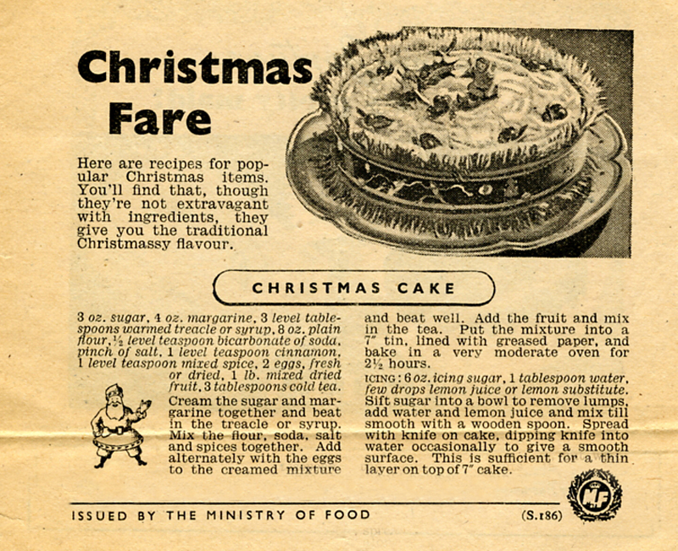

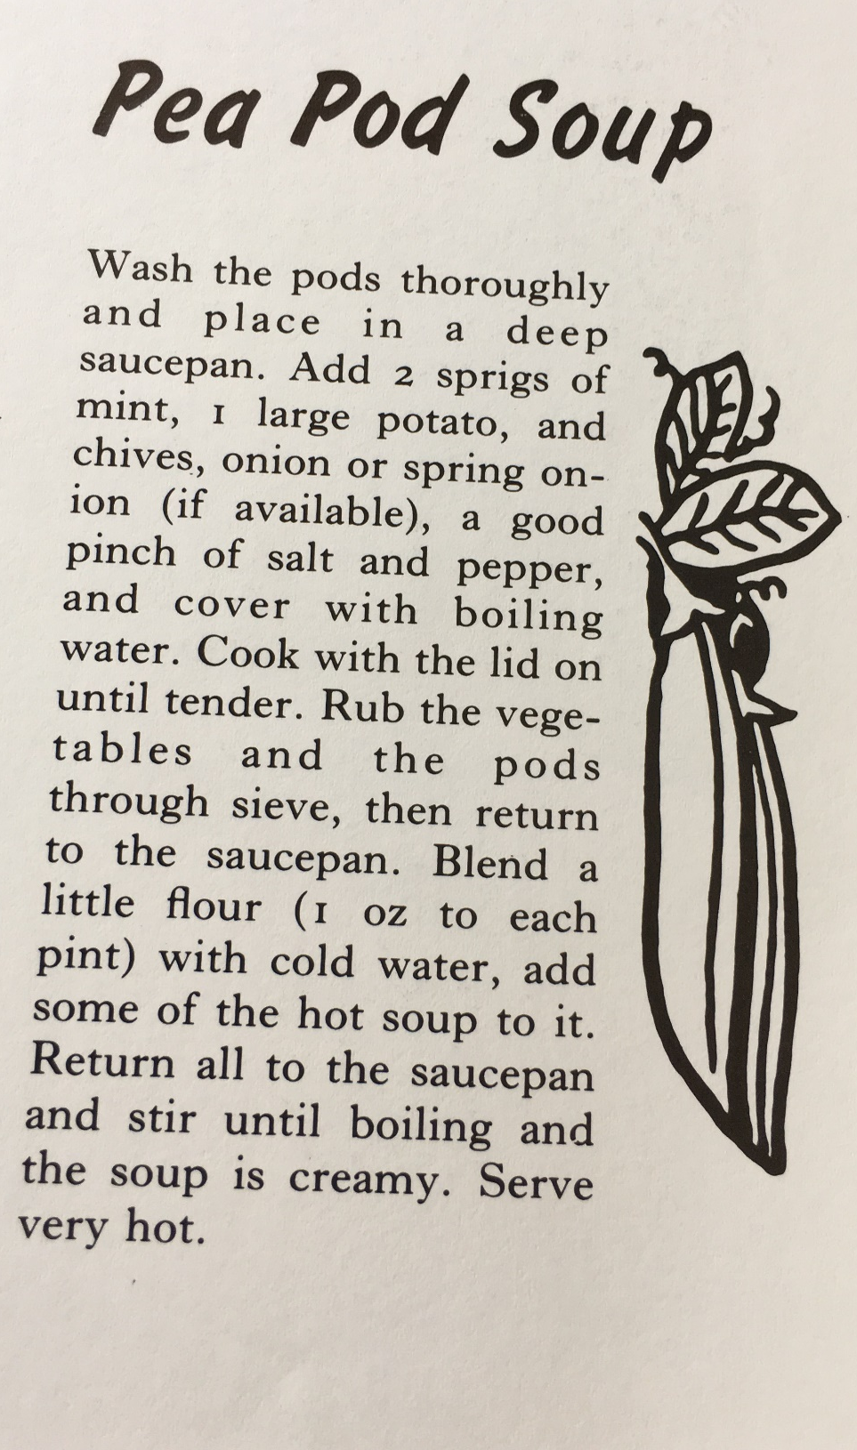

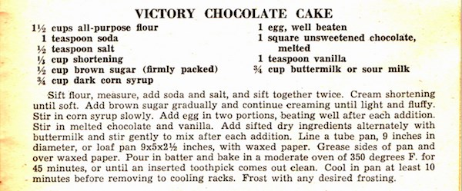
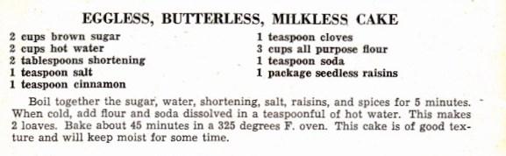

Lemon Cheese Curd
1 cup sugar (teacup size)
3oz marge/butter
2 eggs
Rind of 1 and juice of 2 lemons
Put butter, sugar, lemon rind and juice in a saucepan or basin.
Beat eggs, put into saucepan or basin and stir quickly when butter has melted.
Cook for 20-30 minutes.

Wartime Salad Cream or Mayonnaise
1/2 time Milk
1/4pt vinegar
1 egg yolk
1 tbsp sugar
1 tsp celery salt
1 tsp pepper
1 dessert spoon mustard
MIX: Mustard, pepper, salt, sugar into egg yolk, add milk then vinegar drop by drop. Put in double saucepan and boil until it thickens (tip: a bit of grated horseradish makes a nice flavour).

