Numeracy | Literacy | RE
- TT Rock stars battle  - Maths 10 activity sheet  - BBC Bitesize have daily lessons with videos and online games too  https://www.bbc.co.uk/bitesize  - White Rose Maths - https://whiterosemaths.com/homelearning/year-4/  There are daily lessons on here to work through.  Worksheets will be uploaded to Seesaw  (Answers on Friday)  - Classroom secrets - https://kids.classroomsecrets.co.uk/category/year-4/year-4-maths/  There are a range of activities on here to work through.  Roman numerals  Create a clock face showing all the Roman numerals from 1 to 12 (I – XII) using sticks.  _______________________________________________  Geography  Wind energy is one type of renewable resource.  Can you design your very own wind turbine on paper?  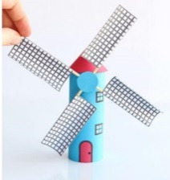  Alternatively, you could have a go at making a wind turbine using resources in your house. Can you make the blades on your wind turbine spin?  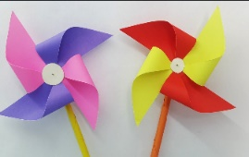 | Reading activity  Complete at least 5 activities on Read Theory.  Reading Quiz  The accelerated reading link will be published on Facebook so you can quiz on the books you are reading at home.  Spellings  Continue to challenge yourself on Spelling shed!  Use the spelling ideas on See-Saw to help you practise your spellings.  Classroom Secrets  Complete the editing and writing game.  https://kids.classroomsecrets.co.uk/resource/year-4-editing-writing-game/  Jane Considine Sentence stackers  We have been working hard learning some exciting ways to teach writing whilst we have been off. There is a fabulous lady called Jane Considine – she is hosting sentence stacking lessons every day at 9.45. To find these lessons you need to search her name using Youtube. All you need is a pen and paper – different colours would be nice.  Remember to send us some examples of your writing! | Buddhist Celebrations  Last week, Buddhists celebratd Wesak – find out what this is and have a go at making a latern  https://www.bbc.co.uk/bitesize/topics/zh4mrj6/articles/zbsp92p
 |  | Memorial Garden Painted Rocks
 |  | Members of the town are wanting to make a trail of painted rocks around the path of the memorial garden – can you help?
 | PE | Key Worker Paper Dolls Project
 | #ThisIsPe  The Yorkshire Sports foundation have been busy creating a whole range of PE activities that can be done at home. We have attached a link to an example.  https://youtu.be/gRRnI3vB1WI | https://www.thekidstable.co.uk/paper-dolls-project  The Kids Table are inviting you to make key worker paper dolls – the above link shows you how to do this. Let us know where you display your dolls.
This is an example wind turbine made from a toilet roll tube, paper, wooden sticks and glue.

