Home Learning – W.B 13/04/2020

TTRS Battle of the Bands

Lime JW vs Lime RH

Starts: 15.30 on 13th April Ends: 15.30 on 17th April

Let the battle commence…

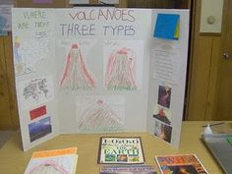

Here are this weeks suggested activities. Pictures of completed activities can be sent to either Mr Ward or Miss Huddart on Seesaw.

1. Research and present findings in your own words about different volcanoes/earthquakes.
2. Draw a picture of a volcano or an earthquake scene.
3. Write an A-Z list of words you could use to describe a volcano/earthquake.

Extra challenge

Create a board game inspired by volcanoes/earthquakes.

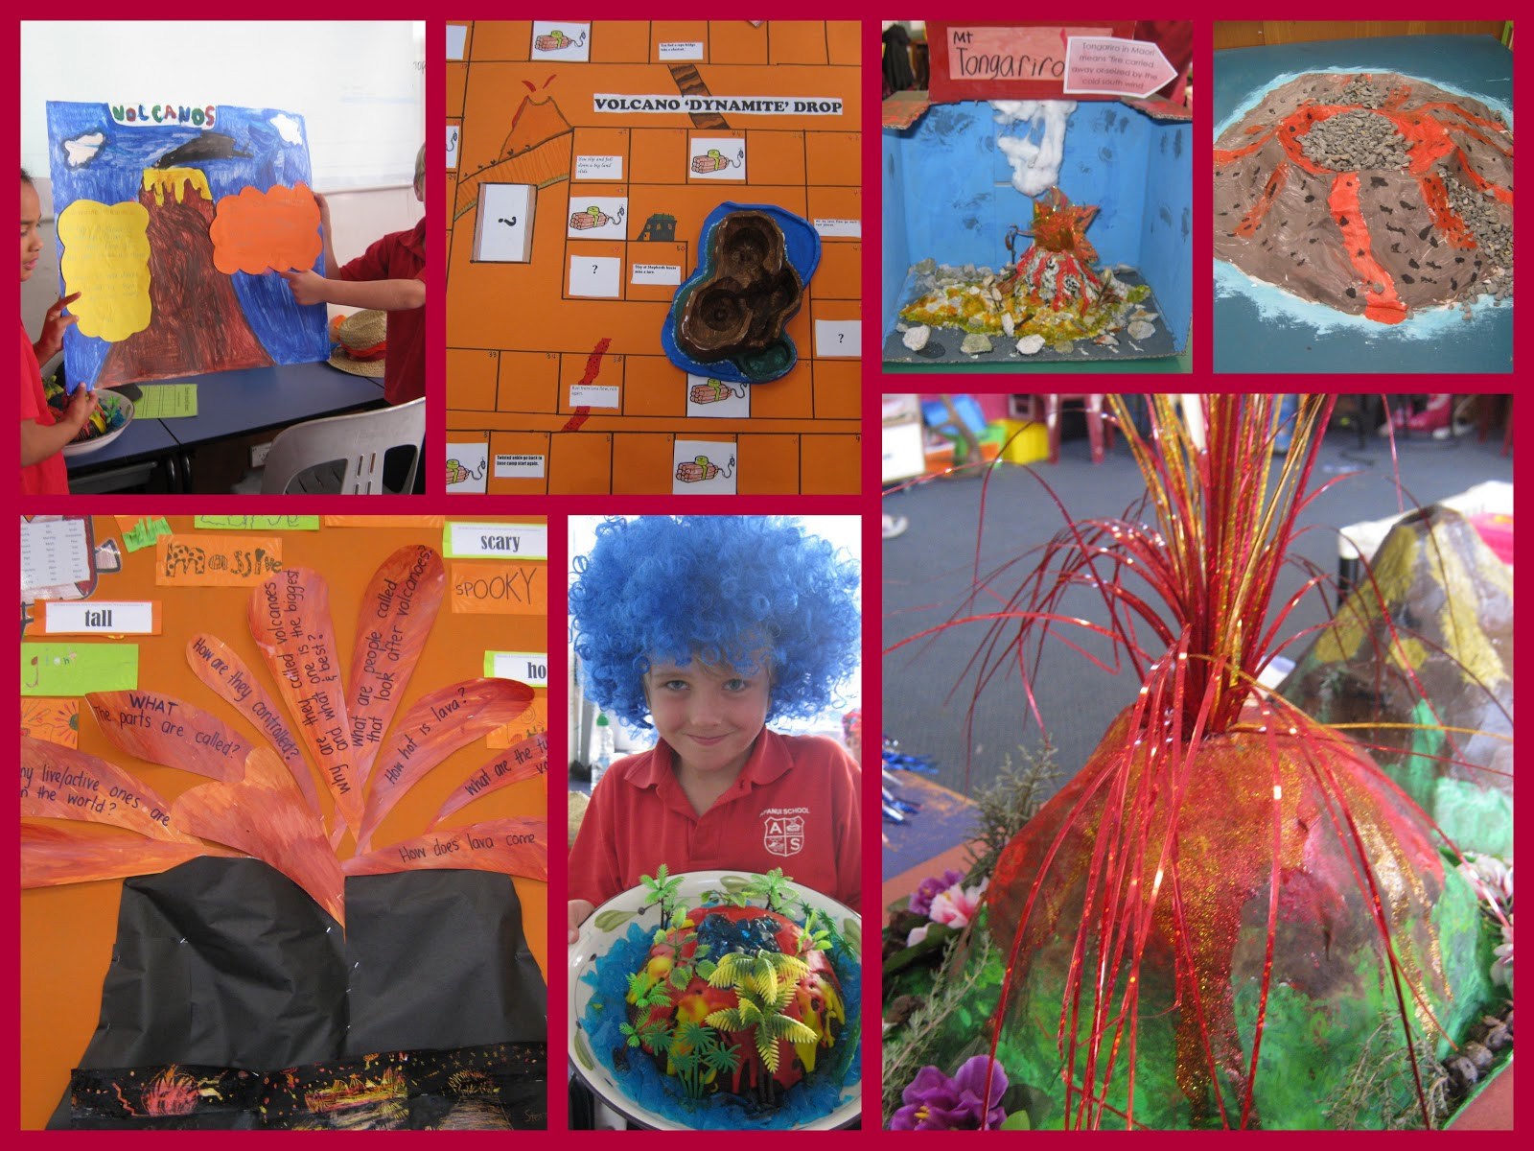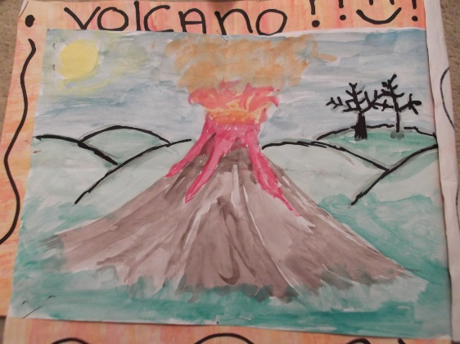

Details of further resources to support home learning can be found on the school website under our class page.