Pictures of completed activities can be sent to either Miss Huddart or Mr Ward on Seesaw.

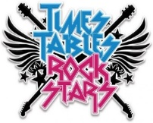

TTRS Battle of the Bands (Lime JW vs Lime RH)

Starts: 9.00am 13th July Ends: 3.00pm 16th July

Who will win the last battle of the year?

White Rose Maths

To access this week’s White Rose Maths home learning activities, please follow the link below:

<https://whiterosemaths.com/homelearning/year-3/>

A copy of this week’s worksheets can also be found on our school website.

Oak Academy English

Please follow the link below to access the Oak Academy online learning resources.

<https://classroom.thenational.academy/schedule-by-year/year-3>

They also provide learning materials for others subjects which you might like to try- just click on the ‘subjects’ tab in the top right-hand corner.

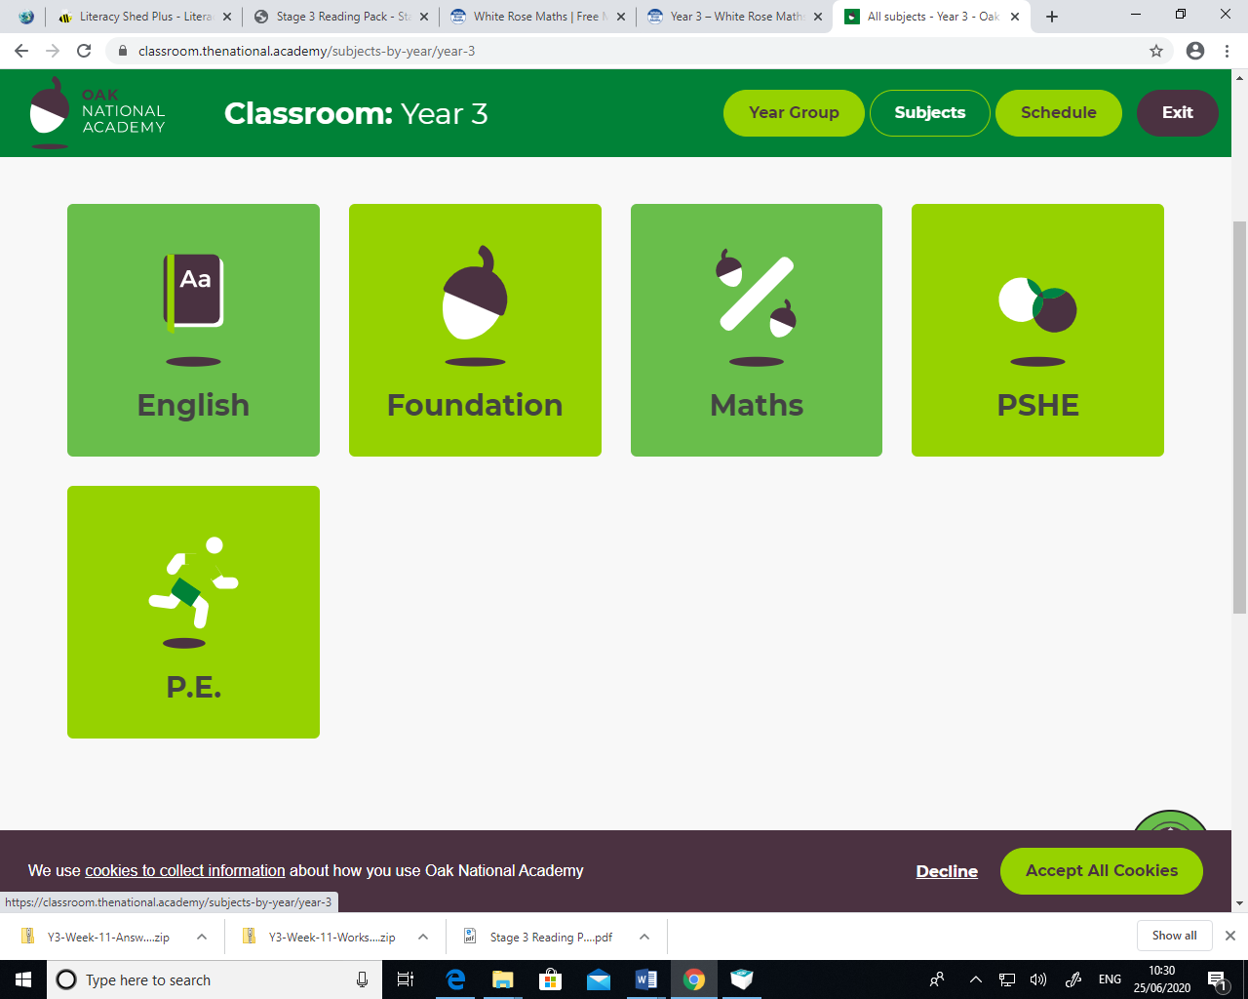

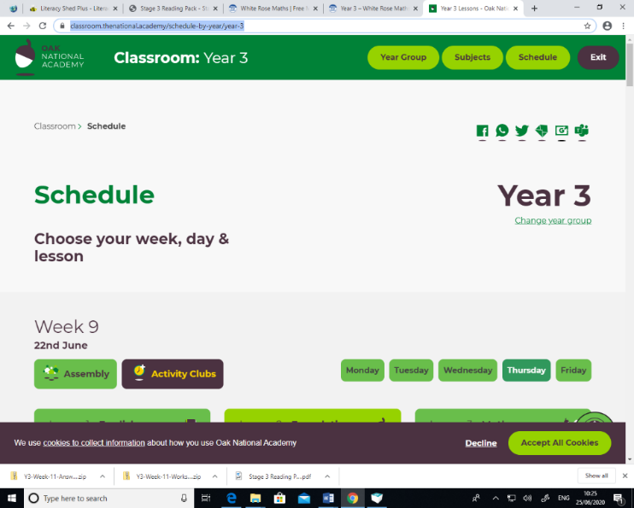

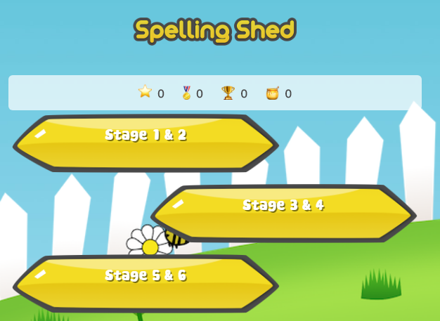

**Spelling Shed**

<https://play.edshed.com/login>

Login details – You should have received these on Seesaw. However, if you are unable to find them please get in touch with us.

Just a few minutes per day can make a huge impact on your child’s spelling.

Daily Reading

You could read a book you have at home or an e-book on

Collins Connect. The choice is yours. Once you’ve finished

your book, see if you can quiz on it using the Accelerated Reader link below.

E-book collection

<https://connect.collins.co.uk/school/teacherlogin.aspx>

Username: [parents@harpercollins.co.uk](mailto:parents@harpercollins.co.uk) Password: Parents20!

Accelerated Reader Quiz

Remember quizzing must be done using the link below as each school has a unique web address:

<https://ukhosted30.renlearn.co.uk/2235895>

Login details for this should be in your child’s diary along with their reading range.



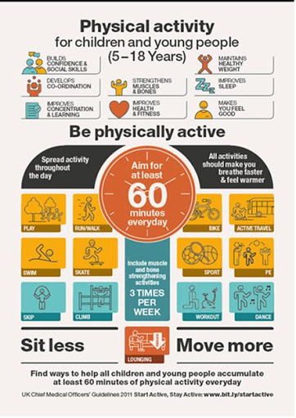The links below will give you some creative ways to achieve your active 60 minutes.

<https://www.bbc.co.uk/teach/supermovers>

<https://www.youthsporttrust.org/national-school-sport-week-resources-2020>

<https://www.youtube.com/user/WestYorkshireSport/videos>