Home Learning WB 15.6.20

White Rose Maths Week 8

To access this week’s White Rose Maths home learning videos, please follow the link below:

<https://whiterosemaths.com/homelearning/year-3/>

A copy of this week’s worksheets can also be found on our school website. If you don’t have access to a printer, do not worry, just grab a pencil and paper.

This week’s suggested activities will recap our study of ancient Egypt.

1. Make a pyramid model.

<https://www.dkfindout.com/uk/history/ancient-egypt/inside-great-pyramid/>

1. Create a biography for a famous Egyptian pharaoh e.g.Tutankhamun. (See ‘Features of a Biography’, ‘Word Mat’ and ‘Biography Example’ in the attached files.)

<https://www.dkfindout.com/uk/history/ancient-egypt/pharaohs/>

<https://www.bbc.co.uk/bitesize/topics/zg87xnb/articles/zvmkhbk/>

<https://www.ancient-egypt-online.com/ancient-egyptian-pharaohs.html>

1. Use hieroglyphs to write your name or a hidden a message.

<https://www.bbc.co.uk/bitesize/topics/zg87xnb/articles/zvw3mfr/>

1. Research the importance of the River Nile and how it was used. It is up to you how you present this information e.g. poster, PowerPoint, fact file or video.

https://www.dkfindout.com/uk/history/ancient-egypt/ancient-egyptian-boats/

<https://www.bbc.co.uk/bitesize/topics/zg87xnb/articles/zkkywty>

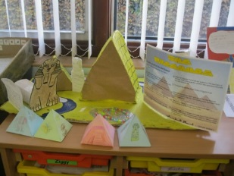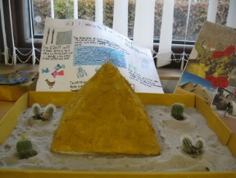



TTRS Battle of the Bands

Starts: 15thJune 9.00am Ends: 19th June 3.15pm

Just a few minutes per day can make a huge impact on your child’s recall.

Daily Reading

It is a good idea to keep up with your daily reading. This could be a book you have at home or an e-book on Collins Connect. The choice is yours. Once you’ve finished your book, why not see if you can quiz on it using the link below.

E-book collection

<https://connect.collins.co.uk/school/teacherlogin.aspx>

Username: [parents@harpercollins.co.uk](mailto:parents@harpercollins.co.uk) Password: Parents20!

The full list of books that can be quizzed on using Accelerated Reader can be found on Seesaw. If you are unsure where to find the list please get in touch and we can point you in the right direction.

Accelerated Reader Quiz

Remember quizzing must be done using the link below as each school has a unique web address:

<https://ukhosted30.renlearn.co.uk/2235895>

Login details for this should be in your child’s diary along with their reading range.



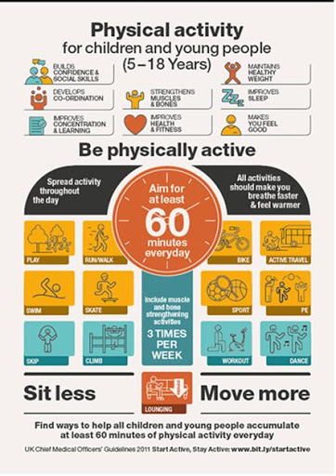

<https://www.youtube.com/user/WestYorkshireSport/videos>

Fun, free activities to entertain and educate at home.