Home Learning – W.B 27/04/2020



TTRS

25 Garage sessions (1 session=1minute)

Starts: 9.00 on 27th April Ends: 15.15 on 1st May

Spread these out across the week. Just a few minutes per day can make a huge impact on your child’s recall.

A counting stick (like the one below) is a great tool to support the development of your child’s times table knowledge. Why not make your own?

Counting sticks can be used during TTRS. As your child becomes more confident they will choose to use the stick less.

Who will be this week’s TTRS winner?

Children can practise counting forwards and backwards along the stick.

Cover up some of the multiples. Can they identify which ones are missing?

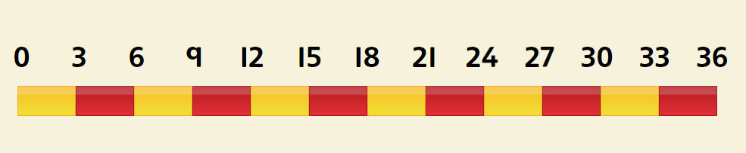

Details of further resources to support home learning can be found on the school website under our class page.

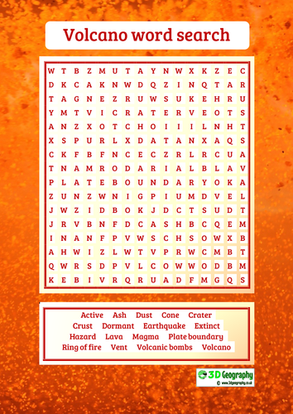

Here are this weeks suggested activities. Pictures of completed activities can be sent to either Mr Ward or Miss Huddart on Seesaw.

1. Create a word search using topic words.
2. Draw a map showing the location of earthquakes around the world.
3. Write an adventure story set around a volcanic eruption / earthquake.
4. Top Trump cards for volcanoes around the world. (You could use the headings height and last erupted)

Extra Challenge

Any other activity from the volcanoes PowerPoint (see school website). Alternatively make up your own activity.

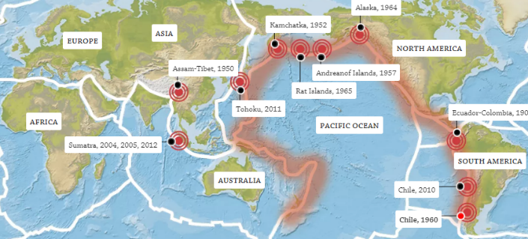

Useful web links

Map of Earth’s volcanoes. Click the volcano to find out more facts.

<https://www.dkfindout.com/uk/earth/volcanoes/where-are-earths-volcanoes/>

World map of earthquakes.

<https://www.dkfindout.com/uk/earth/earthquakes/where-do-earthquakes-happen/>

More information on volcanoes and earthquakes can be found here.

<https://www.bbc.co.uk/bitesize/topics/z849q6f>

