Home Learning WB 29.6.20



White Rose Maths Week 10

To access this week’s White Rose Maths home learning videos, please follow the link below:

<https://whiterosemaths.com/homelearning/year-3/>

A copy of this week’s questions can also be found on our school website. If you don’t have access to a printer, do not worry, just grab a pencil and paper or take a screenshot on your tablet.



TTRS Battle of the Bands (Boys vs Girls)

Starts: 9.00am 29th June Ends: 3.15pm 3rd July

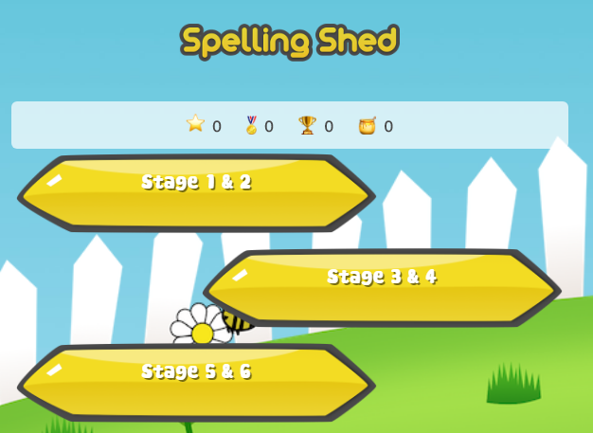

**Spelling Shed**

<https://play.edshed.com/login>

Login details – You should have received these on Seesaw. However, if you are unable to find them please get in touch with us.

Just a few minutes per day can make a huge impact on your child’s spelling.

Who will be this week’s super speller?





Extreme Reading Challenge

It is a good idea to keep up with your daily reading. This week your challenge is to get someone to take a picture of you reading in an unusual location. Then send it to Mr Ward or Miss Huddart on Seesaw. Here are a few suggestions.

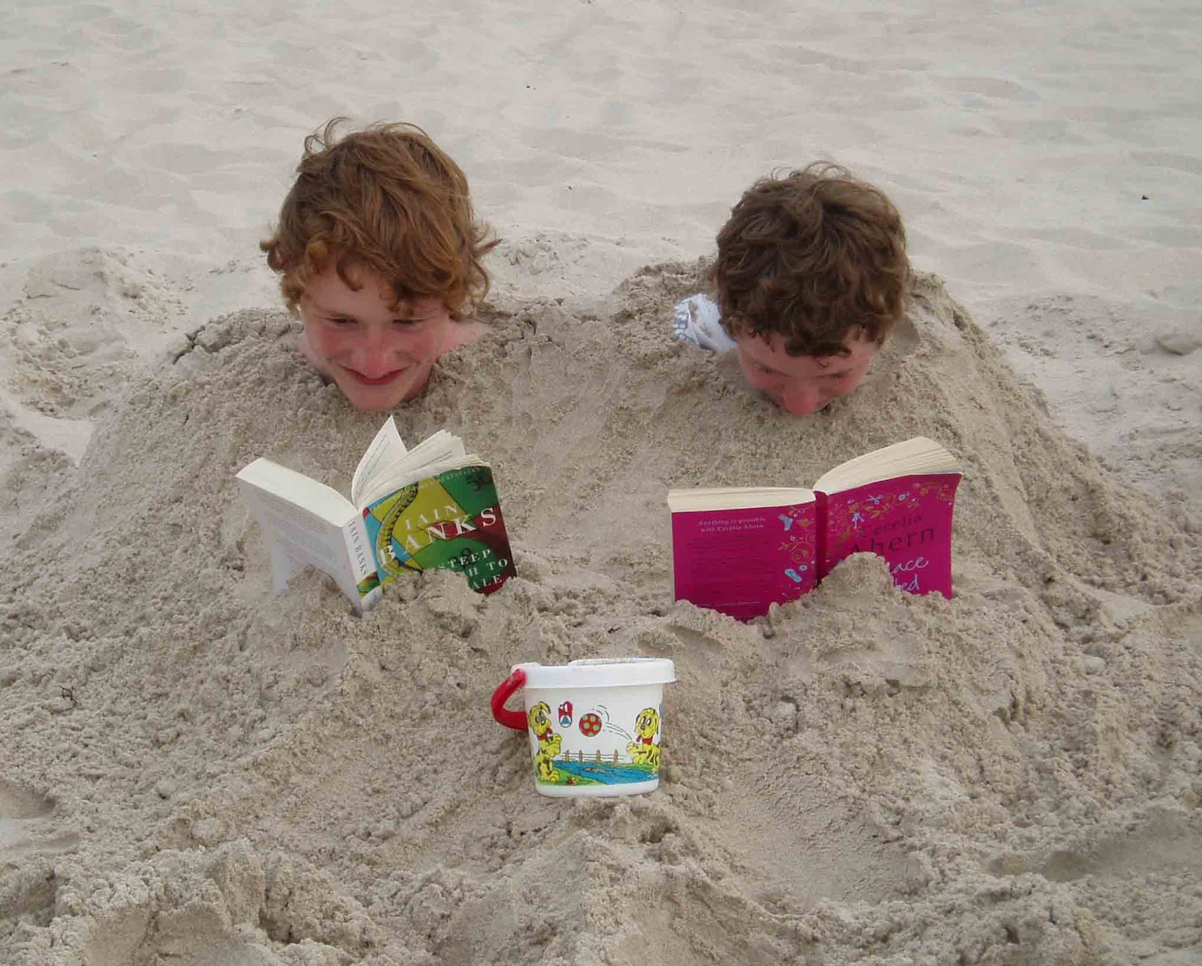 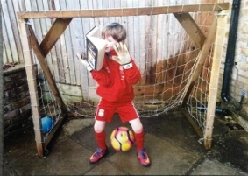 

You could read a book you have at home or an e-book on Collins Connect. The choice is yours. Once you’ve finished your book, see if you can quiz on it using the link below.

E-book collection

<https://connect.collins.co.uk/school/teacherlogin.aspx>

Username: [parents@harpercollins.co.uk](mailto:parents@harpercollins.co.uk) Password: Parents20!

The full list of books that can be quizzed on using Accelerated Reader can be found on Seesaw. If you are unsure where to find the list please get in touch and we can point you in the right direction.

Accelerated Reader Quiz

Remember quizzing must be done using the link below as each school has a unique web address:

<https://ukhosted30.renlearn.co.uk/2235895>

Login details for this should be in your child’s diary along with their reading range.

Oak National Academy

For any further resources please see the link below. This is a virtual school set up by the government to provide home learning resources.

<https://classroom.thenational.academy/schedule-by-year/year-3>

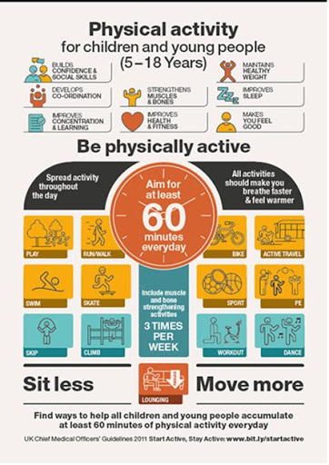

The links below will give you some creative ways to achieve your daily active 60 minutes.

<https://www.bbc.co.uk/teach/supermovers>

<https://www.youthsporttrust.org/national-school-sport-week-resources-2020>

<https://www.youtube.com/user/WestYorkshireSport/videos>