MATER ECCLESIAE CATHOLIC MULTI ACADEMY TRUST

One Family in Christ

CENTRAL OFFER
March 2023

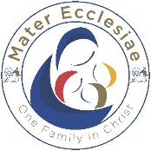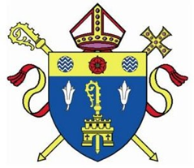

MATER ECCLESIAE

The Mater Ecclesiae Catholic Multi Academy Trust is a newly established trust serving the Preston and Rural Preston area in the Diocese of Lancaster.
The Trust currently consists of seven primary schools. These schools converted to Mater Ecclesiae Catholic Multi Academy Trust on 1st December 2022. Over the next three years, in line with the Bishop’s vison for academisation the Trust will grow to include 3 secondary schools and twenty primary schools.
The trust serves approximately 1,800 children and families and employs over 250 staff across the Trust.
The Trust works in partnership as one family of schools, whilst maintaining and celebrating the uniqueness of each individual school and the community it serves. Our vision is central to everything that we do within the individual schools and across the Trust.

Mater Ecclesiae Catholic Multi Academy Trust Vision
We are ‘One Family in Christ’ serving the family of Catholic schools in the Preston area, under the patronage of Mary the Mother of the church - Mater Ecclesiae.
Our vision is to work together to meet the needs of all and strive for excellence. Within our family, members of our community are loved and valued as unique individuals made in the image of God. They are respected and cherished and given every opportunity to grow together.
As ‘One Family in Christ’ we embrace, celebrate and inspire our diverse communities to achieve their full potential.

As Mater Ecclesiae we aim to:

Live as “one family in Christ” serving others
Shine a light on God’s presence in our lives and the lives of others
Nurture the Catholic faith of our communities
Be one family, sharing in the joys, sorrows, challenges and successes as one.
Strive for every decision and action to reflect the love of God in our community
To take our inspiration and desire to serve from Mary, Mother of the Church and her son Jesus Christ – the Servant King

Strive for excellence
Be inspirational, academically rigorous and innovative, achieving standards of excellence in all settings, supported by exceptionally caring staff who reflect the light of Christ.
Work together to provide excellent education that is relevant to the lives of our children and young people in each of our schools.
Enlighten the lives of our young people by providing a wider curriculum that gives opportunities for all to develop and build their self-belief and worth.

Support our children and young people to grow in virtue and make a positive contribution to our Mater Ecclesiae community and the wider local, national and global communities

Develop community and partnership

Strive to listen and respond to the voices and needs in our communities.
Ensure that we are a diverse, welcoming and compassionate community.
Celebrate the richness of diversity in our communities by recognising that we all are made in the image of God.
Nurture the personal integrity and faith development of pupils that also challenges them to know and understand communities around the world.

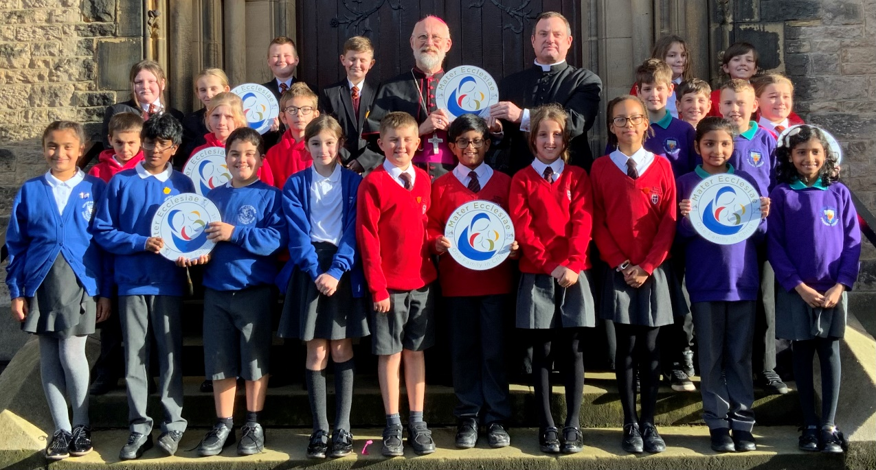

Our Trust Structure

Members | The Members protect the charitable and educational  objectives of the Trust
Directors | The board’s core function is to set the strategic direction of  the Trust
Local Governing Bodies | LGBs are responsible for setting the strategic direction of the individual academy and holding its leadership to  account
Executive Leadership  Team | This group consists of the Chief Executive Officer,  Headteachers and Chief Finance Officer
Central Team | The Central Team is responsible for delivering cost- effective and professional central services, compliance  and policy

Mater Ecclesiae offer
Our Central offer is developing as we grow. The support offered to our schools goes beyond the following areas and is constant and responsive. Some schools may have additional support or have a bespoke offer, dependent on need.

SCHOOL IMPROVEMENT
School improvement leaders’ focus is to challenge and support school leaders and local governing bodies to continue to develop the quality of provision within schools; to monitor, evaluate and report school effectiveness in line with the Trust’s vision and to ensure regular, open communication to enable the Board to meet its responsibilities.

The executive team (CEO and headteachers) work together to develop and deliver the Improvement Plans for the Trust so that all pupils are given the best opportunities to achieve educational, personal and spiritual growth and excellence. This will be achieved through ensuring high-quality teaching and learning of an ambitious and broad curriculum, enriched by a wide range of personal development and spiritually enriching opportunities. Leadership teams within our schools work together on specific partnership projects to share practice, knowledge and expertise.

School to school support is a great and growing strength of Mater Ecclesiae and is provided in a number of different ways including

Bespoke Individual support for schools dependent on need. This is particularly valuable for staff
- who are new to a year group/key stage
- ECTs
- Staff seeking professional development in specific areas
- New subject leaders
- New SENCOS

Joint training for school staff on identified areas for shared development. Recently this has included Supporting neurodiverse children in our schools, Midas training, Writing Moderation

Joint audits of current practice as part of school partnership improvement projects. These are currently focusing on certain areas including persistent attendance and progress of pupil premium children in phonics.

Clusters These are led by experienced staff from within the Trust. Clusters include:
- Headteacher Steering Group
- Deputy head
- SENCO
- EYFS
- RE
- Pastoral Teams

Moving forward we will be exploring the following:
- ECT groups
- Subject leader groups
- Well - being

Mater Ecclesiae will also provide support for staff new to Senior leadership teams through mentoring and coaching provision.
As part of Mater Ecclesiae all schools have free access to Well-being programme through TES pulse.

All schools within the Trust have free access to advertising vacancies within the TES and will be supported with any recruitment needs.

Finance Support

The central finance team oversee comprehensive internal and external audit programmes. Other operations include the annual TPS audit, preparation of year end accounts, consolidation of management accounts and production of annual budgets in line with the Trust’s principles. The finance team provides any financial support and assistance needed. The Trust provides access to a Trust-wide finance system and budgeting software (Access).

The Central team service includes:
- ESFA budgeting returns
- Consolidation of VAT returns
- Land and Buildings returns
- Support with LGPS Actuary calculations
- Monthly budget monitoring, actual vs budget
- Policy direction and training
- Support in preparation and monitoring of school budgets
- Guidance on completion of risk register in line with the risk strategy
- Support in procurement of services to ensure best value.

We look forward to welcoming our Catholic schools into Mater Ecclesiae and developing our Central Offer as we grow as One Family in Christ.

