Dance Styles
Task: There are loads of different dance styles, read through the descriptions and tick any you have tried.
Dance Style | Description | Tick if you’ve tried
Ballet | Turned out feet and curved arms, ballet is the foundation of all dance. The men perform big leaps and jumps, the women perform turns on pointe (the tip of their toes) in special shoes. Originated in France and Italy.
Street dance | There are different variations of street dance including popping and locking, break, hip-hop, bboy and more commercial styles.
Tap | Dancers wear shoes with metal parts to create sound and rhythms.
Jazz | Usually used in musical theatre, Jazz is ballet but without the turn out, using straight lines and isolations. Originated in America.
Indian dance | There are several different types of Indian dance, sometimes each movement represents a word and tells a story through hand gestures. Other times its high energy with intricate use of the arms, linked to Bollywood.
Ballroom | Partnered dancing with many different styles such as the waltz, salsa, tango, cha cha cha and jive.
Contemporary | A mixture of different styles blended together, contemporary dance reflects what is happening now. There can be different focuses such as breath, falling and releasing etc.

Dance Styles
Task: Match the picture to the dance style, use the sheet before to help you.
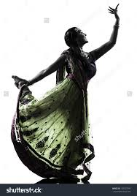
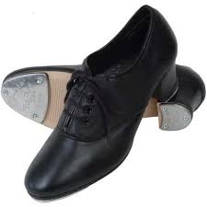

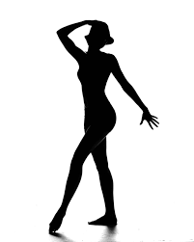

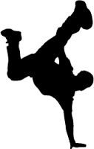
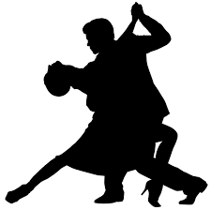

Dance Styles
Task: Pick a dance style you don’t know a lot about, research it and complete the following fact file.
Dance style:

Key features:

Key people:

Examples of dance works in this style:

What do you think about the style? What stands out to you?

Dance Styles
Task: You have been asked to choreograph a dance that has three sections- each section uses a different dance style. Complete the plan of how you will order this including ideas, music you will mix together, costume etc.

Section one
Dance Style:

Ideas:

Section two
Dance Style:

Ideas:

Section three
Dance Style:

Ideas:

