INFRA
Wayne McGreggor

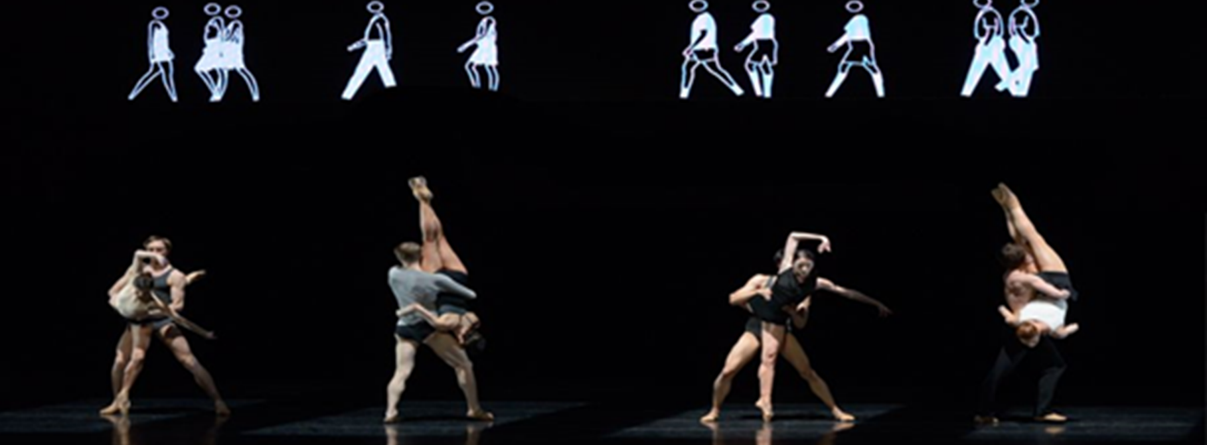

Name: _______________________________

General Facts
Choreographer: Wayne McGregor
Music: Max Richter

Set: Julian Opie

Costume: Moritz Junge

Lighting: Lucy Carter
Sound design: Chris Ekers
Performed by: The Royal Ballet

Dancers: 12 + extras for the crowd [Section 7]

Created : November 2008
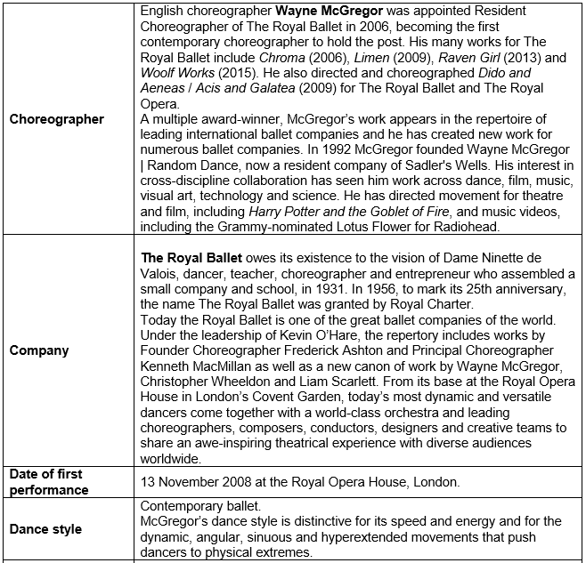
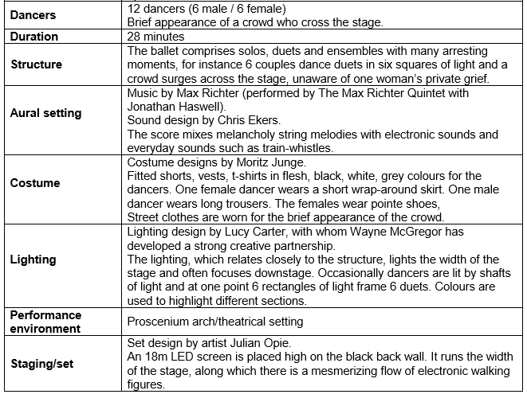
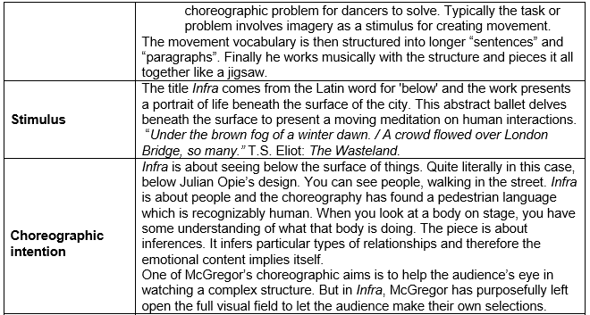
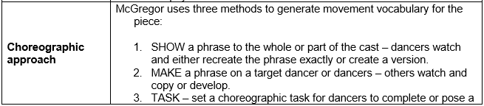
Stimulus

Choreographic intention

Choreographic Approach
Structure

How many sections are there?

Identify where each section takes place on the graph below:

Describe each climax/highlight of the dance

X1
X2
X3

Lighting
The lighting for Infra helps to create the subterranean world that Infra implies. Whilst everything ‘above the surface’ remains black and white, the world below tells a different story.
What type of lighting is being used in each of the following images?
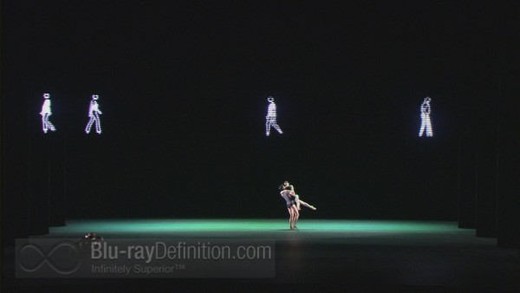
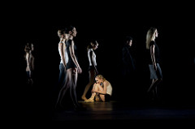
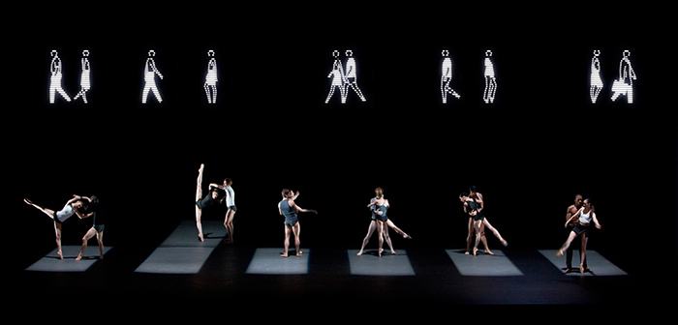

Lighting links
Stimulus: below the surface of the city
Stimulus: The London bombings
Stimulus: The waste land
Choreographic intent: Different human relationships below the surface of things
Highlight dancers
Structure
Aural setting
Space
Extra:
Costume
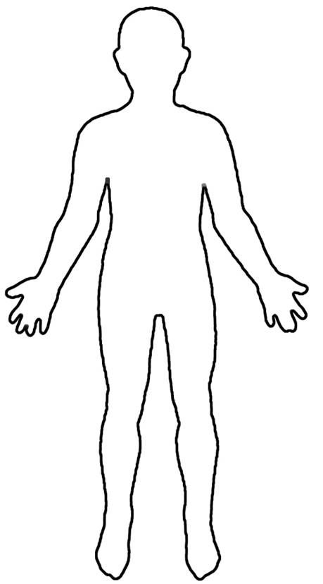

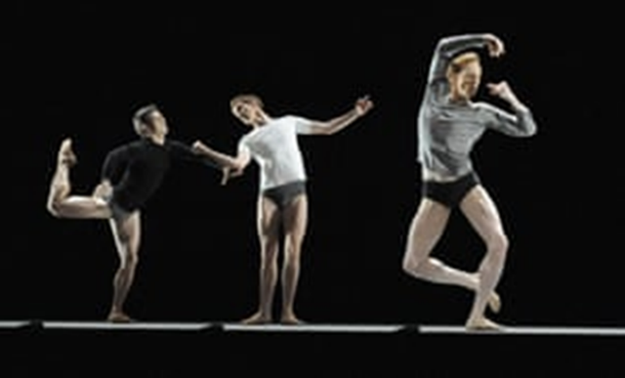
Costume Links
Stimulus: below the surface of the city | 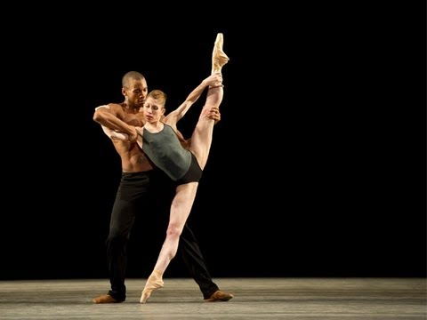
Stimulus: The waste land
Choreographic intent: Different human relationships below the surface of things
Complements the set
Genre/Style
Era
Gender
Extra:

Set Design
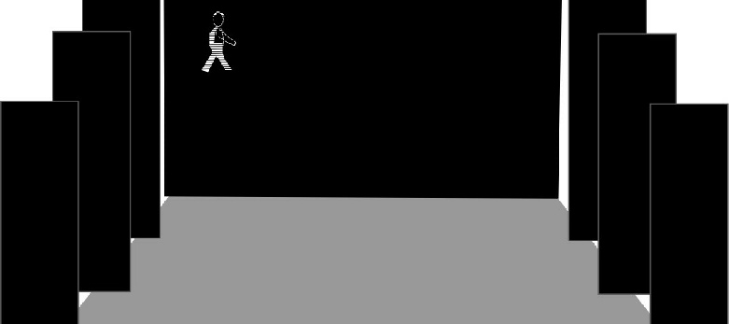
A grey dance floor, black tabs and black backcloth.
An LED screen is seen high up on the backcloth, showing a variety of LED people in black and white walking to and fro.
The front curtain is black, completing the monochrome effect.

“The dancers below, in the subway, if you will, provide a contrast between bland routine and the horror of crisis, between clinical video and flesh and blood and between two disparate, competing visual worlds.”
Set Design links
Stimulus: below the surface of the city
Stimulus: The London bombings
Stimulus: The waste land
Choreographic intent: Different human relationships below the surface of things
Lighting
Structure
Era
Climax
Extra:
Aural Setting

Highlight key points from the extract below- taken from the interview with Wayne McGreggor about Infra
“I had a very clear idea that I wanted to work with Max Richter, who is an incredible composer, who is able to work with music that is both electronic and orchestral. So it’s incredible live instruments, as well as, manipulation of sound and found sound. But the thing that he does really brilliantly is that he taps into, memory.
He gives you traces in sounds that make you think about other things and that’s a really incredible way of being able to anchor your work in an emotional territory that we all share. And so for me, Max’s music is always very wide screen, it’s a landscape in which all of this incredible work emerges.
So in Infra we were working a little bit from a T.S. Elliot poem ‘The Wasteland’ because there was something around the language and the scope and the expanse of that, which was really rich to fuel our imagination.
I would send him a few lines and he would create a kind of musical idea from that, and send it back to me. He might just send me a musical idea from something he had had as a reference. We would just exchange in that way and then I would say this is really interesting or I really feel for this, or I’m not sure about this. And at that moment you don’t throw anything away, even the things you are not sure about, because you never know when they are going to be useful. But over time you start to build this collection of material, and then honestly it builds itself, it structures itself. You just know at a certain point that that jigsaw needs to be arranged in this way, and you do that together. And so that’s the beautiful thing about working with a living composer, that you have the luxury of spending time with them, and you have the luxury of being able to develop something really genuinely together.”

Aural Setting Links
Stimulus: below the surface of the city
Stimulus: The London bombings
Choreographic intent: Different human relationships below the surface of things
Location
Set
Lighting
Structure
Gender
Extra:
Performance environment
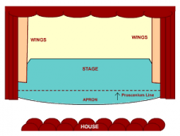
The type of stage is called ________________________

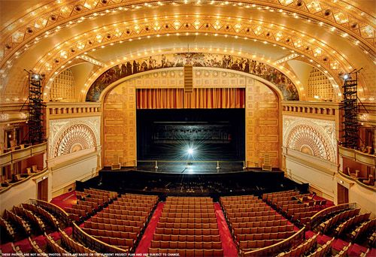

Choreographic devices used
CONTACT – 03:53-07:05
CLIMAX – 09:54-13:13
HIGHLIGHT- 23:13-25:00

