Of Mice and Men – Characters

Name________________

[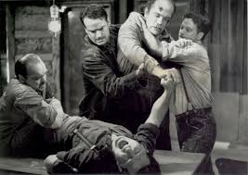](http://www.google.co.uk/imgres?q=of+mice+and+men&um=1&hl=en&sa=N&rlz=1R2RNRN_enGB417&biw=1366&bih=540&tbm=isch&tbnid=bhz9ne0Fx_O4dM:&imgrefurl=http://www.virtual-history.com/movie/image/5290&docid=bY4Sijix6sascM&imgurl=http://www.virtual-history.com/movie/photo/06/large/06085.jpg&w=600&h=424&ei=2pwFT-jHBZTo8QPDn9DFAQ&zoom=1)

Fill in the worksheets with as much information as you can and continue to do it while we are studying to help you revise for the exam.

Add details about events, useful quotations and page references to help prove the statements written around the different characters.

Has no problems being on his own

Has pretty bad mood swings

Is trapped in his life with Lennie

[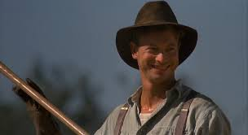](http://www.google.co.uk/imgres?q=of+mice+and+men+george&um=1&hl=en&rlz=1R2RNRN_enGB417&biw=1366&bih=540&tbm=isch&tbnid=nOMzL5iFTTZ7fM:&imgrefurl=http://www.dvdbeaver.com/film/dvdcompare/miceandmen.htm&docid=bVO4AJhoNA54NM&imgurl=http://www.dvdbeaver.com/film/dvdcompare/mice/35.52.jpg&w=800&h=437&ei=K58FT66rHo_-8QOP4dHRAw&zoom=1)

George

His dreams keep him going

Has no control over his life

Can be pretty aggressive

Identifies with animals

Is an overgrown child

[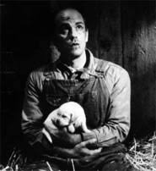](http://www.google.co.uk/imgres?q=of+mice+and+men+lennie&um=1&hl=en&rlz=1R2RNRN_enGB417&biw=1366&bih=540&tbm=isch&tbnid=cnDtVGisGBHumM:&imgrefurl=http://fictivecharacters.wordpress.com/category/of-mice-and-men-by-john-steinbeck/&docid=b_k4WbuIC57mtM&imgurl=http://fictivecharacters.files.wordpress.com/2010/11/8009271.jpg&w=185&h=202&ei=gaAFT4jNAZSk8gOo4szzCA&zoom=1)

Lennie

Lennie is a killer

Is dependant on George in body and mind

Is a stirrer

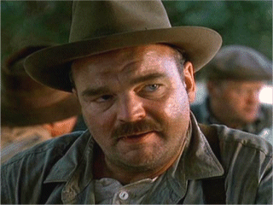

Crooks

Is very insensitive

Fighting – He’s always looking for a scrap

Restlessness – Curley is very jumpy

[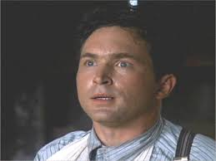](http://www.google.co.uk/imgres?q=of+mice+and+men+curley&um=1&hl=en&rlz=1R2RNRN_enGB417&biw=1366&bih=540&tbm=isch&tbnid=Mig6UOi0OqPbbM:&imgrefurl=http://blogs.swa-jkt.com/swa/10827/2011/11/28/curley-of-mice-and-men/&docid=cjotqreLx50uhM&imgurl=http://blogs.swa-jkt.com/swa/10827/files/2011/11/Casey_Siemaszko_22277_4.gif&w=320&h=240&ei=7qIFT5-JL4Tr8QPP2sjOAQ&zoom=1)

Curley

Relationships – Nobody likes him

He’s the only one with personal possessions

He’s the only one on the ranch with his own room

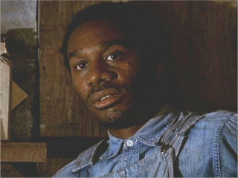

Crooks

He has little power in an unfair world

He’s a victim of Racism

Is open, friendly and keen to impress

Is destined for a life on the ranch



Whit

Likes to be in on the action

Is already doomed to a tragic life

Has a good awareness of what is going on around him

He is the spiritual leader of the men – ‘Godlike’

Slim is the top bunkhouse worker

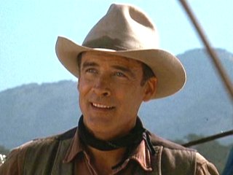

Slim

He’s not cruel but he is practical

He is there at the key moments

He accepts his own fate and that of others

The men have a lot to say about her

She’s a disruptive influence

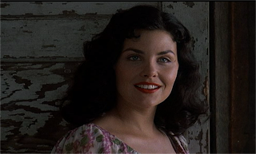

Curley’s wife

She’s not stupid

She’s very lonely

She’s been married for two weeks but is already unhappy

He hurts no-one and is positive about others

He’s frail and powerless like his dog

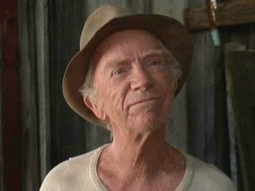

Candy

He has a weakness for kidding himself about things

Glossary of Character/ Place names and explanations

Curley – Like his hair he’s tense and wound-up tight like a spring

Slim – Tall and Elegant like his name

Crooks – His back is crooked

Candy – An ironic name as his life is anything but sweet

Whit – Dictionary says it means the smallest part imaginable

Carlson – The word ‘Carl’ means a man of the common people

Lennie Small – Not in size but brains maybe?

George Milton – There’s nothing in this at all is there.

Curley’s Wife – She his given no name by Steinbeck but all she wants is attention and recognition; even the prostitutes are given a name in the story! She ‘belongs’ to someone else; she’s just someone’s wife, she has no identity.

Soledad – Is the local town. It means loneliness in Spanish. The men go to Soledad to spend their wages and by doing this trap themselves in their lives. Basically they go to Loneliness but remain lonely! Loneliness is a key theme in the novel.

Weed – Is where George and Lennie come from and where Lennie gets in trouble with his previous ‘bad thing.’ A weed is something unwanted that deprives plants of essential space and food so they can’t grow. Like that, this memory/ action spoils George and Lennie’s new life!

Finally…

The title of the novel is from a Robert Burns poem:

The best laid schemes o’mice and men

Gang aft agley (*often go wrong*)

And leave us nought but grief and pain

For promised joy

So (if you know the poem before you read the book,) what it’s telling us is not to expect to be happy and that plans (no matter how well laid out) will always fail. Failure is inevitable.

Given the time that this novel is set and the things that were happening at the time, do you think that this is a realistic viewpoint or merely depressing?

Of Mice and Men – Historical and Authorial context

[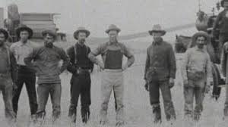](http://www.google.co.uk/imgres?q=of+mice+and+men&um=1&hl=en&sa=N&rlz=1R2RNRN_enGB417&biw=1366&bih=540&tbm=isch&tbnid=HO0xoA_X8PLTaM:&imgrefurl=http://www.bbc.co.uk/learningzone/clips/john-steinbecks-of-mice-and-men-historical-context-pt-1-4/8168.html&docid=DAhRX5vBjVVKwM&imgurl=http://www.bbc.co.uk/learningzone/clips/8168.preview.jpg&w=512&h=288&ei=2pwFT-jHBZTo8QPDn9DFAQ&zoom=1)

Fill in the worksheets with as much information as you can and continue to do it while we are studying to help you revise for the exam.

This should give you an idea about what was happening at the time the novel is set.

John Steinbeck – Discuss and answer these questions

1. Steinbeck was born in the Salinas Valley in 1902 – the places in the book are really in West California. How might this influence the novel?
2. Steinbeck worked on ranches in the school holidays. Would this have an effect on anything?
3. He kept a dog and had daily contact with animals when he was growing up. Interesting?
4. He lived rurally and his parents owned some land. Why is this important?

1930’s America and racism – What do you know about…

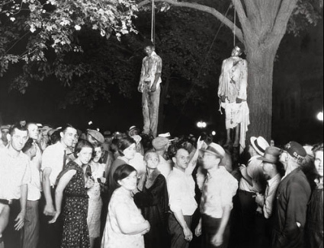

Racist violence – Thomas Shipp and Abram Smith were in jail accused of rape and murder but a crowd broke into the jail, took them outside and lynched them

Racist language: Not acceptable now but common then

Segregation

The American Economy – What are the effects?

Eastern owners going bankrupt and land being repossessed

Banks collapsing

Drought and over-farming

Increasing farm mechanisation

Migration West to California to look for work

High unemployment, poverty and homelessness

**1920’s**

**1930’s**

Do we se these **things in the novel?**

**1929**

* **American Stock market on Wall Street crashes catastrophically**

Consumer boom – more people could afford new electrical goods like fridges and radios

Rebuilding of cities, skyscrapers and roads

Low interest, low unemployment and lowinflation

Refugee camps

The American dream

In what way is the American dream dead during the depression and by the end of the novel?

“All men are created equal, that they are endowed by their creator with certain unalienable rights, that among these are life, liberty and the pursuit of happiness.”

- Declaration of Independence, 4th of July 1776

Glossary of Historical context Language

Jerkline Skinner – Controls a team of Mules on a wagon

Pounding your tail/ Bustin’ a gut – Working very hard

Bucking grain – Filling sacks and loading them on a wagon

Cultivator – A big machine which breaks up the soil

Jackson Fork – A mechanical fork

(your) Jack – Your pay at the end of the month

Swamper – Cleaner and general chores guy

Stable buck – Person who looks after the Horses/ Mules

Euchre – a card game

Flop-house/ Cat-house – Brothel

Floosy – Prostitute

Purty – Pretty

Clean – Disease free

Crack – Sex

Bow-legged/ Burned – Catching a sexually transmitted disease

Shots of Corn – A double Whisky

Blown your stake – Spent all your wages

Canned – Sacked

Booby hatch – Lunatic asylum

Bum steer – Bad information

Bindle – Bedroll/ sleeping bag

Bindle bum/ Bindle stiff – Person who moves no further than their bed

[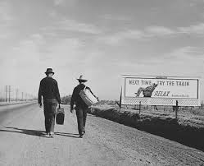](http://www.google.co.uk/imgres?q=of+mice+and+men&um=1&hl=en&sa=N&rlz=1R2RNRN_enGB417&biw=1366&bih=540&tbm=isch&tbnid=A2zA5EewE0GWeM:&imgrefurl=http://www.shmoop.com/of-mice-and-men/teaching.html&docid=ux70qFBv6XX3rM&imgurl=http://www.shmoop.com/images/teachers_editions/of-mice-and-men.jpg&w=402&h=326&ei=2pwFT-jHBZTo8QPDn9DFAQ&zoom=1)Of Mice and Men – Themes, symbols, motifs structure and genre

Fill in the worksheets with as much information as you can and continue to do it while we are studying to help you revise for the exam.

Loneliness and Isolation

Slim – (ranch workers) “get so lonely they don’t want to talk to nobody

George – (ranch guys) “are the loneliest in the world”

Crooks – A guy needs somebody – to be near him” & A guy goes nuts if he ain’t got nobody. Don’t make no difference who the guy is, long as he’s with you.

Play Solitaire

Work for the rest of their lives

Like orphans

Nothing to look forward to

No family

Lonely

Single

Dreams

No-ones truly happy in the novel; Everyone’s missing something!

1. America is supposed to be built on promise and opportunity. >> 2. It promised independence, land and a decent living through honest work. >> 3. It also means that anyone could become successful. >> 4. The problem is that it’s very difficult to get ahead unless you’ve got money in the first place. >> 5. It’s great for those who get it but not the unlucky others!

George & Lennie dream of a better life

People on the ranch are going nowhere

How do these statements relate to Dreams in the novel?

George’s dreams die with Lennie

Trouble is…dreams are not real

Hands

To survive in the 1930’s you needed hands to work and hands to fight; survival of the fittest, it’s a man’s world!

George

Slim

Lennie

Candy

Curley

Curley’s wife

How do hands relate to these characters?

Life on the ranch

Hierarchy:

The Boss

Whit, Calrson, George

Candy, Crooks, Lennie

Slim

Curley

Why are the characters in the novel in this order and are Curley and Slim in the right places?

What does it look like?

The ranch is very basic. Look at the map below and the key words around the outside. The ranch is like a machine and the men exist inside it, they have no lives, so add statements about their lives on the ranch to show this.

*It’s not beautiful like the riverside*

The Barn

*They’re basically homeless*

*It’s like a jail*

*There are no luxuries*

*They don’t have identities*

*Their play is restricted*

The Farmhouse

The Bunkhouse

All the options are bad…

Lennie’s death was inevitable…

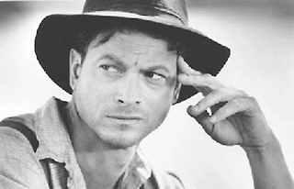

Why did I shoot Lennie?

Add your comments from

what you know in the novel

Death is Lennie’s new dream

George has to kill Lennie…

Candy’s dog

Candy is useless like his dog – how?

It’s a cruel world on the ranch – how?

Slim has the authority to save the dog but doesn’t – why?

Carlson kills Candy’s dog – why?

Symbolism in the novel

The novel is full of (binary) opposites and contrasts.

Nature – both idyllic but scary

Find quotations from the novel that nature’s paradise is actually an illusion. It’s beautiful to look at but actually a dog eat dog world; survival of the fittest. A bit like human life really. Look around the points in the novel by the pool at the start and the end…

Scary/ an illusion…

Idyllic/ Beautiful…

Vs.

Light vs Dark – How light becomes dark; hope fades to black

As the novel goes on, things seem to get darker and by the end of the novel it ‘climbs out of the valley completely’ (find it!) See if you can find quotations from the 6 chapters which show the invasion of dark over light…

Binary opposites – Characters in opposition

The novel is full of character who oppose each other. The name for this is Binary opposites. An example of this is:

Good vs Evil

Slim vs Curley’s wife

Slim is portrayed as being a bit like God. He has ‘authority,’ he is ‘ageless’ and his eyes are described as ‘calm, Godlike.’

Curley’s wife however is described by George as a trap for men: ‘she’s a rattrap if ever I seen one.’ She is portrayed as temptation and wears red, like the Devil!

So this is one binary opposite. Can you think of any others and why they are opposite? Curley vs Slim, Candy vs Carlson?

The Structure of the novel

Nature starts and ends the novel. It’s balanced, It starts outdoors, ends there and spends the time in between indoors. It’s true, find it! Check out how detailed the natural descriptions are and bland the interiors are

The novel is like a play. Each

chapter has one location with descriptions like stage

directions at the start, characters enter and exit, each character is very distinctive from

the others and it takes place over one very long weekend!

George and Lennies’ journey is

a bit of a rollercoaster ride. Ups

and downs, nothing goes right for

them at all. Just when they think

it all looks good, reality bites!

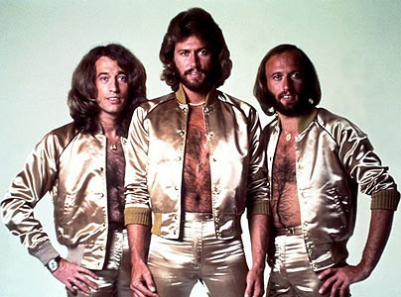Genre – Tragedy

Of Mice and Men is a tragedy. It’s full of

dashed hopes, smashed dreams, death and

unfulfilled lives. There is no way out for the people involved (depressing eh?)

Look at the three sections below and find bits in the novel which prove them…

|  |
| --- |
| Lennie is doomed because of what he does, the way he is and how he acts/ reacts |
| George knows that trouble is inevitable and can seemingly forsee the future… |
| No-one is happy at the end of the novel…  1. George/ Lennie/ Curley’s wife  2. Candy  3. Crooks  4. Curley  5. Whit/ Carlson  6. Slim |