Session 1 Lesson Resource Year 1, Unit 2 History: Toys in Time
What am I? Riddle Cards
Print these clues back to back with the pictures to create your own Riddle Cards.

What am I?  I am made of plastic.  You can use me to build things.  I have knobbly bits. | What am I?  I am soft and squishy.  You can sculpt and mould me into different shapes.
What am I?  I am brightly coloured.  I can be stretched.  I am great at going down stairs! | What am I?  I am made of plastic.  I have hair.  My arms and legs move.
What am I?  I need electricity to work.  I have lots of wires.  I can be lots of different games. | What am I?  I have two wheels.  You can stand on me.  I can go very fast!

Session 1 Lesson Resource Year 1, Unit 2 History: Toys in Time
What am I? Riddle Cards
Print these clues back to back with the pictures to create your own Riddle Cards.

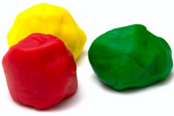  Play Doh | 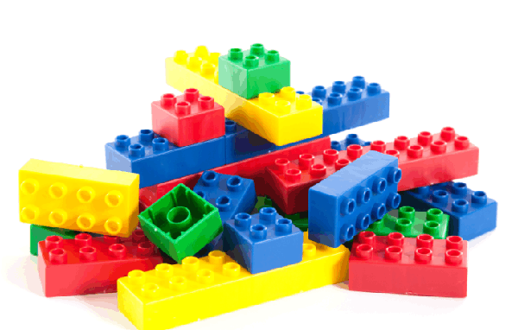  Lego
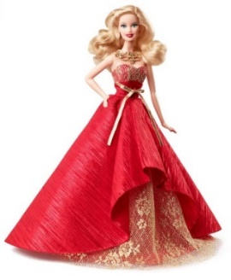  Doll | 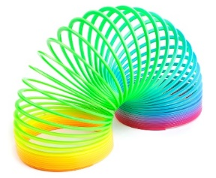  Slinky
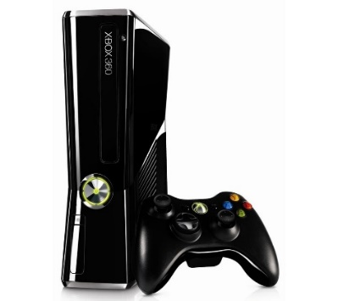  Games Console | 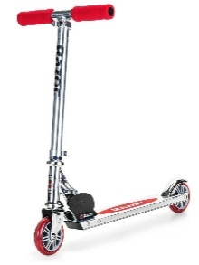  Scooter

