R EVISION

PACK

1a. Complete the sequences by filling in the missing Roman numerals. |  |  | 1b. Complete the sequences by filling in the missing Roman numerals.
X XII  XXXVI XXXVIII  LX LXII  a)  b)  c)  VF  D |  |  | XLV XLVII  LXVIII LXX  XCII XCIV  a)  b)  c)  VF  D
2a. Write the following Roman numerals in ascending order.  L XIX XV XXXI  D |  | VF | 2b. Write the following Roman numerals in ascending order.  XLVII C LXVII XCI  D |  | VF
3a. Use <, > or = to comp statements.  LXXI  D  85  XLVIII | lete the  21  XCV  48 | VF | 3b. Use <, > or = to compl statements.  XXXVIII  D  50  86 | ete the  38  XLIX  LXXXVII | VF
4a. The Twin Towers were destroyed in 2001.  Circle the correct Roman numeral.  MMI MMMI CCI  D |  | VF | 4b. The Prophet Muhammad was born in the year 570.  Circle the correct Roman numeral.  DLX DLXX DCCL  VF  D
1a. Complete the calculations. Write the answers in Roman numerals. |  | 1b. Complete the calculations. Write the answers in Roman numerals.
LX + 20 =  90 – XXXVI =  XCI + 8 =  PS  D |  | XLIX – 30 =  85 + XIII =  74 – XXIV =  PS  D
2a. Using your knowledge of Roman numerals to 100, work out the value of the Roman numeral below.  CC  Explain your reasoning.  D | R | 2b. Using your knowledge of Roman numerals to 100, work out the value of the Roman numeral below.  CL  Explain your reasoning.  D | R
3a. Arrange the cards below to create different Roman numerals. Each card may only be used once.  X  L  I  Find all the possibilities.  D | PS | 3b. Arrange the cards below to create different Roman numerals. Each card may only be used once.  V  X  I  Find all the possibilities.  D | PS
1a. Complete the sequences by filling in the missing Roman numerals. |  |  | 1b. Complete the sequences by filling in the missing Roman numerals.
CIII CV  CCLV CCLVII  DXXIV DXXVI  a)  b)  c)  VF  E |  |  | CCCLI CCCLIII  CDVII CDVIX  DCXV DCXVII  a)  b)  c)  VF  E
2a. Write the following Roman numerals in ascending order.  CMI CCCXC DC CXCIX  E |  | VF | 2b. Write the following Roman numerals in ascending order.  CCCXL CXLII CCLXXX DCCXII  E |  | VF
3a. Use <, > or = to comp statements.  CDLV  E  699  CDXXVII | lete the  355  DCXCIX  430 | VF | 3b. Use <, > or = to compl statements.  DCCXLI  E  897  CCCLXVIII | ete the  761  CMXX  833 | VF
4a. The Battle of Hastings occurred in 1066.  Circle the correct Roman numeral.  MLXVI MLXV CLXVI  E |  | VF | 4b. The War of the Roses began in 1455.  Circle the correct Roman numeral.  MCLV MDLV MCDLV  VF  E
1a. Complete the calculations. Write the answers in Roman numerals. |  | 1b. Complete the calculations. Write the answers in Roman numerals.
200 + CCI = DC – 45 =  CCCL + 150 =  PS  E |  | 485 – CCXV =  241 + DCXXXIV =  CMXI – 303 =  PS  E
2a. Using your knowledge of Roman numerals to 1,000, work out the value of the Roman numeral below.  MMM  Explain your reasoning.  E | R | 2b. Using your knowledge of Roman numerals to 1,000, work out the value of the Roman numeral below.  MLX  Explain your reasoning.  E | R
3a. Arrange the cards below to create different Roman numerals. Each card may only be used once.  C  X  C  I  Find all the possibilities.  E | PS | 3b. Arrange the cards below to create different Roman numerals. Each card may only be used once.  I  V  C  X  Find all the possibilities.  E | PS
1a. Complete the sequences by filling in the missing Roman numerals. |  |  | 1b. Complete the sequences by filling in the missing Roman numerals.
CCXX CCXXIV  CDXLV CDLV  DCL DCLXX  a)  b)  c)  VF  GD |  |  | CCCIII CCCIX  CMXL CMLX  DXIV DCCXIV  a)  b)  c)  VF  GD
2a. Write the following Roman numerals in descending order.  DCXIV DXCVIII CMXCI DCCXC  GD |  | VF | 2b. Write the following Roman numerals in descending order.  DCXXV DCV CMXC DLXIII  GD |  | VF
3a. Use <, > or = to comp statements.  CLXXXIV  GD  CCLXXXIV  DCXLVII | lete the  CXCII  CCCLVII  DCLXXIV | VF | 3b. Use <, > or = to compl statements.  CV  GD  CMXCVI  DLXVII | ete the  XCVIII  M  DLXVII | VF
4a. Queen Victoria was born in  MDCCCXIX.  Write this as a number.  GD |  | VF | 4b. Shakespeare was born in MDLXIV.  Write this as a number.  GD |  | VF
1a. Complete the calculations. Write the answers in Roman numerals. |  | 1b. Complete the calculations. Write the answers in Roman numerals.
CCCXII + CVI =  DCCXXI – CCXV =  CDXCI + CCCLX =  PS  GD |  | M – DXLVIII =  DCXXIX + CXIII =  CMVI – CDXIV =  PS  GD
2a. Using your knowledge of Roman numerals to 1,000, work out the value of the Roman numeral below.  MCDIX  Explain your reasoning.  GD | R | 2b. Using your knowledge of Roman numerals to 1,000, work out the value of the Roman numeral below.  MMDCII  Explain your reasoning.  GD | R
3a. Arrange the cards below to create different Roman numerals. Each card may only be used once.  I  X  C  I  D  Find all the possibilities.  GD | PS | 3b. Arrange the cards below to create different Roman numerals. Each card may only be used once.  X  V  C  I  C  Find all the possibilities.  GD | PS

1a. Use the cards to complete the part whole model. |  |  |  |  |  |  |  | 1b. Use the cards to complete the part whole model.
D  VF  167  314  342  857  ?  ?  348 |  |  |  |  |  |  |  | VF  D  626  ?  ?  245  240  141  183
2a. Complete the bar model.  465  124 ? 202  VF  D |  |  |  |  |  |  |  | 2b. Complete the bar model.  938  ? 85 344  VF  D
3a. Ben thinks of a number. He adds and subtracts the following numbers:  100s 10s 1s  +  –  =  What number did he start with?  D  VF |  |  |  |  |  |  |  | 3b. Kate thinks of a number. She adds and subtracts the following numbers:  100s 10s 1s  +  –  =  What number did she start with?  D  VF
4 two-step ca answer?  D  100  10  100  1  +  – | lcul  10  10  10  1 | atio  10  1  10  1 | a. Which of the following cards create a n that  10  1  1 | giv  10  10  100  1 | es 8  10  10  10  1 | 9 a  10  1  10  1 | s the  10  10  1  VF | 4 two-step c answer?  D  100  10  100  1  +  – | alc  10  1  100  1 | ulati  10  100  1 | b. Which of the following cards create a  on th  10  1  1 | at gi  10010  10  100  1 | ves 222  10  10  10  1  10  1  1  100 | as the 10  10  1  VF
1a. Tree A is 378m tall.  Tree B is 253m shorter than tree A.  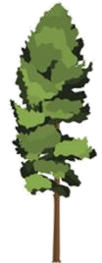  Tree C is 73m taller than tree A.  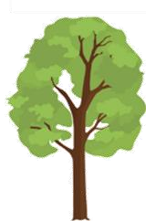 378m 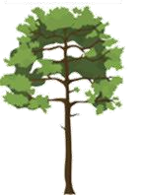A – 253m A + 73m  Tree A Tree B Tree C  What is the total height of the trees?  PS  D |  |  |  |  | 1b. A school orders 455 maths books.  They order 258 fewer English books than maths books, and 86 more art books than English books.  Maths English Art  455 Maths – 258 English + 86  How many books are ordered in total?  PS  D
2a. There are 500 marbles in a pack.  100 100 100 100 100  Box A has 141 marbles. Box C has 152 more than box A.  ?  Box A  Box B  Box C  H  T  O  H  T  O  +  How many marbles are in box B?  Convince me.  D |  |  |  | R | 2b. Eric has 723 stamps in his collection  100 100 100 100 100 100 100 10 10 1 1 1  Book A has 423 stamps in. Book B has 225 fewer than book A.  ?  Book A  Book B  Book C  H  T  O  H  T  O  –  How many stamps are in book C?  Convince me.  R  D
3 following calculation.  225g +  100  10  10  0  10  1  1  1  1  1  Solve your  D | 334  100  100  100  1  1  word | a. Write a word problem to go with the  g  –  10  10  10  1  1  problem. | = 414g  100  10  0  10  100  1  1  1  1  100  PS |  | 3b. Write a word problem to go following calculation.  512  cm  –  +  cm  123  100  10  10  0  1  1  100  10  0  100  100  10  10  1  1  1  Solve your word problem.  D | wit  = | h the  317  100 100  100  1  1  1 | cm  1  1  10  1  1  PS
1a. Use the cards to complete the part whole model. |  | 1b. Use the cards to complete the part whole model.
E  VF  2,089  2,890  1,272  9,004  ?  ?  5,643 |  | VF  E  7,081  ?  ?  3,506  2,135  1,444  1,440
2a. Complete the bar model.  7,429  1,532 ? 965  VF  E |  | 2b. Complete the bar model.  8 ,498  ? 3,009 999  VF  E
3a. Tony thinks of a number.  After he adds 6,424 and subtracts 2,825, his number is 5,095.  What number did he start with?  E  VF  1,000  10  1  1,000  10  1  1,000  10  1  1,000  10  1  1,000  10  1  10  10  10  10 |  | 3b. Alycia thinks of a number.  After she subtracts 3,724 and adds 2,999, her number is 4,526.  What number did she start with?  VF  E  1  1,000  100  10  1,000  100  10  1,000  100  1,000  100  100  1  1  1  1  1
4a. Which of the following cards create a two-step calculation that gives the answer?  E  +  3,566  3,688  5,645 | 6,184 as  4,105  –  VF | 4b. Which of the following cards create a two-step calculation that gives the answer?  E  +  3,055  403  6,234 | ,875 as  2  304  –  VF
1a. A charity want to raise £9,559.  They raise £4,522 in the first month.  They raise two thousand, six hundred and twenty-five pounds less in the second month.  In the third month, they raise £1,540 more than what they raised in the second month.  Does the charity reach their goal? | 1b. A warehouse is receiving a bulk shipment of pet food.  6,016 of the tins are dog food.  They receive 4,634 fewer tins of cat food than dog food.  They receive 1,020 more tins of fish food than cat food.  How many tins of pet food do they receive in total?
PS  E | PS  E
2a. Jack is organising his sticker collection. He has 9,292 stickers in total.  Box A has 4,906 stickers. Box C has 1,208 fewer stickers than box A.  A  4,906  B  C  How many stickers are in box B?  Convince me.  R  E | 3b. There are 4,498 counters in one bulk bag.  Box A holds 1,197 counters. Box B holds 586 more counters than box A.  A  1,197  B  C  How many counters are in box C?  Convince me.  R  E
3a. Write a word problem to go with the following calculation.  ml  7,886ml – 4,392ml+=6,399ml  Solve your word problem.  PS  E | 3b. Write a word problem to go following calculation.  £  £6,688 + £2,501 –  Solve your word problem.  E | with the  = £7,626  PS
1a. Roy had £8,409. He spent £3,678 on a holiday and then spent the rest on a TV and a bike.  Select the two cards which show how much he spent on the TV and bike. | 1b. Sue had £6,112. She spent £1,978 on a computer and then spent the rest on a motor bike and a handbag.  Select the two cards which show how much she spent on the motor bike and handbag.
GD  VF  £2,573  £2,753  £1,978 | VF  GD  £245  £524  £3,889
2a. Complete the calculation.  6,324 – 2,962 = + 1,587  VF  GD | 2b. Complete the calcul  7,003 –  GD | ation.  = 1,698 + 364  VF
3a. Sam has 5,431 marbles.  He won 2,558 but lost 4,278.  How many marbles did he start with?  VF  GD | 3b. Izzy has 2,567 pennies in her piggy bank.  This month she has put 3,786 pennies in but has taken 4,099 out.  How many pennies did she start with?  VF  GD
4a. Find a route through the table that leads from one shaded box to the other.  8,346ml – 5,421ml + 3,009ml  – 2,359ml + 3,758ml – 352ml  + 3,758ml – 3,956ml 5,789ml  VF  GD | 4b. Find a route through the table that leads from one shaded box to the other.  987g + 5,988g + 2,977g  + 7,888g – 4,009g – 8,697g  – 6,186g – 1,713g 1,255g  VF  GD
1a. A printing company are recording their quarterly sales. They want to print 8,500 flyers in this quarter.  In January, they printed 2,264 flyers.  In February, they printed half the amount printed in January.  In March, they printed 234 more than January and February combined.  Have they met their goal for this quarter?  PS  GD | 1b. Jet Air are tracking the number of bookings made year on year to measure the company’s growth.  Year Number of bookings  2016 2,267  2017 Up 2,796  2018 Down 2,978  How many bookings were made in each year and in total?  PS  GD
2a. 4,432 buttons are made in three hours. It takes six hours to make enough buttons to fill three boxes.  When Box B has been filled, there are 3,363 buttons remaining. Box C holds half the amount of buttons as Box A.  A  B  C  How many more are there in box A than box C?  R  GD | 2b. Three boxes hold 9,567 elastic bands altogether. When box C has been filled there are 6,909 elastic bands left.  Box A has twice as many elastic bands as box B.  A  B  C  How many more are there in Box C than Box B?  R  GD
3a. These are the items in a school stationery cupboard. Write a word problem using the information from the table. It must have at least two steps and the answer must be a 4-digit number.  Item Number  Pens 2,764  Pencils  Rulers 2,009  Total 8,672  Solve your word problem.  PS  GD | 3b. These are the results of a traffic survey. Use the information to write a word problem. It must have at least two steps and the answer must be a 4-digit number.  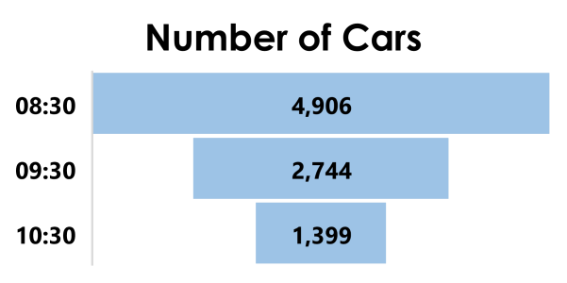  Solve your word problem.  PS  GD

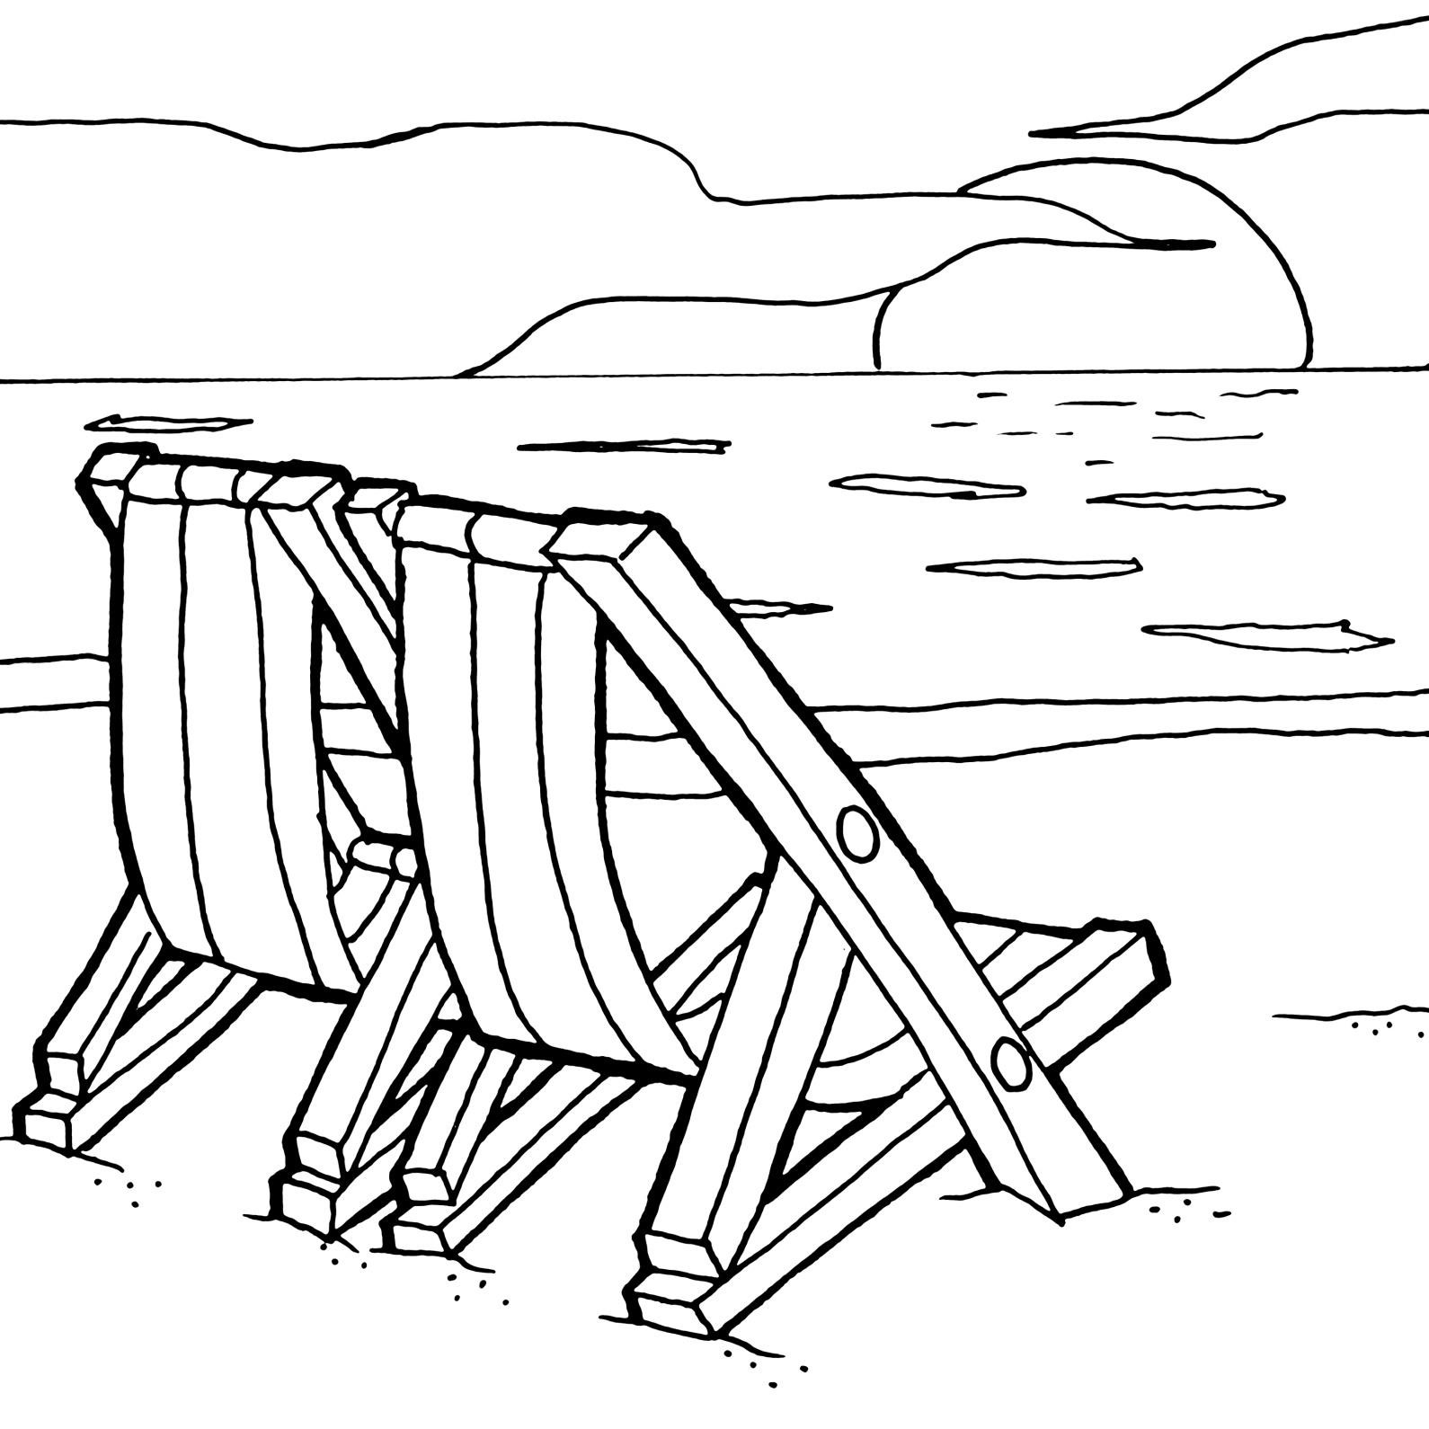
Match the answers to the calculations and colour them correctly.
Dark Blue

500

100

90

10
10
x
3
Yellow
100


100
10
10
x
4
x
100
7
x
10
9
x
100
Now colour the rest of the picture.
x

by 10, 100, 1,000 Colour by Numbers
Red
20


10
800


100
x
9
10
Orange

400

100

70

10
10
x
5
Brown

30

10
x
6
100
10
8
x
2
x
10
Light Blue

60

10
5
x
100
6
50
20
7
4
3
8
2
1
5
9
600
80
500
100
30
90
900
70
400
 | Multiplying and Dividing Word Problems
1. | - 8 times a number is 200. What is 80 times the number?  - 6 times a number is 8.4. What is 60 times the number?  - 70 times a number is 56. What is 7 times the number?  Explain your answers to all parts.
2. | Lizzie and Jane share 2690 beads equally between them. They create jewellery items to sell at the school fayre. Jane needs 7 beads per item and Lizzie needs 8 beads per item. Who, if anyone, will have the most number of beads left over?
3. | Daniel gets €592.50 when he exchanges £500. He decides to exchange another £300. How much is this in Euros?
4. | It takes 12 weeks for a sunflower to grow 15cm. How many minutes is this?
5. | 14 x x = 1694  The same number is missing from each box. What is the missing number?
Add and Subtract Fractions
1. With a partner, play the game below.
Cut the spinners out and take it in turns to spin!
Each spinner will give you a fraction.
Add the two fractions together.
A point is received for each correct answer.
The person with the highest number of points after 10 spins is the winner.
Were some pairs easier to add together? Why?
Spinner 1 Spinner 2
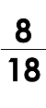
DP
2. Play the game with a partner. You need a different coloured pencil each.
Choose two fractions to subtract. If the answer is less than one half, shade both boxes. The first person to travel from one side of the board (in any direction) to the other is the winner. You cannot choose fractions with the same denominator.
DP

1a. Circle the sentence below which has used a fronted adverbial.  - We all went into the cinema before it rained.  - Finally, we all went to the cinema.  - We all went to the cinema quickly. | 1b. Circle the sentence below which has used a fronted adverbial.  - Firstly, you should visit the museum.  - You should visit the museum before you do anything else.  - We will certainly visit the new exhibition.
VF  D | VF  D
2a. Insert a comma after the fronted adverbial in the sentence below.  Eventually we all made it to Harriet’s birthday party.  VF  D | 2b. Insert a comma after the fronted adverbial in the sentence below.  Sadly Emma lost her dog at the beach.  VF  D
3a. True or false? The adverbial used in the sentence below is an adverbial of place and can be moved to the front of the sentence.  I bought an expensive chocolate bar from the corner shop.  VF  D | 3b. True or false? The adverbial used in the sentence below is an adverbial of time and can be moved to the front of the sentence.  You will find many tasty snacks in the top cupboard.  VF  D
4a. Identify which adverbial in the sentence below can be moved to the beginning of the sentence.  I parked my car under the bridge this morning.  VF  D | 4b. Identify which adverbial in the sentence below can be moved to the beginning of the sentence.  The ladies were still dancing in high heels at midnight.  D | VF
1a. Rewrite the sentence below with the adverbial phrase at the beginning of the sentence.  Niamh ran home excitedly to see her birthday cake. | 1b. Rewrite the sentence below with the adverbial phrase at the beginning of the sentence.  The team captain jumped up happily when they scored a goal.
A  D | A  D
2a. The children are discussing which adverbials are best to use in a sentence.  Outside  Bill  Libby  Nearby  _______________________ it was sunny but not particularly warm.  Whose adverbial would fit best?  A  D | 2b. The children are discussing which adverbials are best to use in a sentence.  Already  This morning  Finn  Ava  _______________________ his cat came home with a mouse he had found.  Whose adverbial would fit best?  A  D
3a. Jenny thinks that the phrase ‘in the morning’ can be moved to the beginning of the sentence and used as a fronted adverbial.  The postman will deliver our letters  in the morning.  Is she correct? Explain your answer.  R  D | 3b. Riley thinks that the phrase ‘into his mum’s car’ can be moved to the beginning of the sentence and used as a fronted adverbial.  Shaun finds it hard to get into his  mum’s car.  Is he correct? Explain your answer.  R  D
1a. Circle the sentence below which has used a fronted adverbial.  - Suzie walked past the beach after she had finished shopping.  - After finishing her shopping, Suzie went for a walk along the beach.  - Suzie liked to collect shells when she went walking on the beach. |  | 1b. Circle the sentence below which has used a fronted adverbial.  - We always sit next to the window above the wing.  - Children usually choose the window seat so that they get the best view during the flight.  - A few rows behind, there are some seats with extra legroom.
E | VF | E | VF
2a. Insert a comma after the fronted adverbial in the sentence below.  On a Monday evening my children both have dancing lessons with different teachers.  E | VF | 2b. Insert a comma after the fronted adverbial in the sentence below.  Before long the lost dog returned unharmed to his relieved owner.  E | VF
3a. True or false? The adverbial used in the sentence below is an adverbial of frequency and can be moved to the fro of the sentence.  The mouse was frequently seen running around in the kitchen, avoiding the cat.  E | nt VF | 3b. True or false? The adverbial used in the sentence below is an adverbial of frequency and can be moved to the front of the sentence.  My sister is usually in trouble when she sulks in her bedroom and ignores everyone.  VF  E
4a. Identify which adverbial in the sentence below can be moved to the beginning of the sentence.  The driver pulled over somewhere near here, and frantically ran out of the car towards the river.  E | VF | 4b. Identify which adverbial in the sentence below can be moved to the beginning of the sentence.  He left the party earlier than planned so he could rest before his important cricket match the following day.  VF  E
1a. Rewrite the sentence below with the adverbial phrase at the beginning of the sentence.  The children in Miss. Treacle’s class could barely see the luxurious cruise ship in the distance. | 1b. Rewrite the sentence below with the adverbial phrase at the beginning of the sentence.  Michael had been living in his grandmother’s house with his labrador since 2010.
A  E | A  E
2a. The children are discussing which adverbials are best to use in a sentence.  Will  Beth  As soon as  they were told  Always  The children returned to their seats without a sound.  Whose adverbial would fit best?  A  E | 2b. The children are discussing which adverbials are best to use in a sentence.  Simon  Isla  Overseas  Below the sea  The deep sea divers discovered an old, ruined pirate ship.  Whose adverbial would fit best?  A  E
3a. Linda thinks that the words ‘went to the local park’ can be moved to the beginning of the sentence and used as a fronted adverbial.  Every Friday afternoon, Charlie went to the local park to play  rounders with his friends until late.  Is she correct? Explain your answer.  E R | 3b. Kieran thinks that the words ‘with her cousin’ can be moved to the beginning of the sentence and used as a fronted  adverbial.  Is he correct? Explain your answer.  R  E  Laurie runs to the ice cream van  with her cousin and buys them  both a tasty treat.
1a. Circle the sentence below which has used a fronted adverbial.  - A beautiful second goal flew into the back of the net after a few agonising minutes on the pitch.  - Shortly after, following a tense few minutes on the pitch, another goal flew into the back of the net.  - All the spectators cheered as another shot zoomed effortlessly into the net. | 1b. Circle the sentence below which has used a fronted adverbial.  - Carefully, without making a sound, Tommy unbuckled Esme and carried her into the house.  - Tommy crouched down awkwardly and unbuckled his daughter without disturbing her sleep.  - Esme, who was blissfully unaware of what was happening, was lifted up.
VF  GD | VF  GD
2a. Insert a comma after the fronted adverbial in the sentence below.  To annoyingly make matters worse, after being delayed in the airport for three hours, Ben's suitcase couldn't be located.  VF  GD | 2b. Insert a comma after the fronted adverbial in the sentence below.  A few hours later that day despite Olive's repeated presses of the doorbell, nobody answered and she began to worry.  VF  GD
3a. True or false? The adverbial of frequency used in the sentence below can be moved to the front of the sentence.  Much to her disappointment, during the holidays, Julia rarely had many visitors.  VF  GD | 3b. True or false? The adverbial of frequency used in the sentence below can be moved to the front of the sentence.  Oddly enough, Richard, who normally had a great sense of direction, couldn’t find his way back to his hotel.  VF  GD
4a. Identify which adverbial in the sentence below can be moved to the beginning of the sentence.  It’s really important to eat more carbohydrates than usual before a big race as the muscles in your body will store more energy allowing for plenty of exercise.  VF  GD | 4b. Identify which adverbial in the sentence below can be moved to the beginning of the sentence.  Melanie had wanted a promotion in the company for a long time although it was unlikely to happen now as her new manager wasn’t very fond of her.  VF  GD
1a. Rewrite the sentence below with one adverbial phrase at the beginning of the sentence.  Once or twice, the teenagers had been camping with their friends during the summer holidays. | 1b. Rewrite the sentence below with one adverbial phrase at the beginning of the sentence.  With huge grins on their faces, they went to the waterpark at the weekend as they loved the slides.
A  GD | A  GD
2a. The children are discussing which adverbials are best to use in a sentence.  Kyle  Azra  in large  groups  occasionally  Dolphins are known to follow ships far out at sea.  Which adverbial fits best at the start and which fits best within the sentence?  A  GD | 2b. The children are discussing which adverbials are best to use in a sentence.  Josh  Jill  in a strange  turn of events  without any  warning  The egg started to move and cracked open.  Which adverbial fits best at the start and which fits best within the sentence?  A  GD
3a. William thinks that the words ‘to the local homeless shelter’ can be moved to the beginning of the sentence and used as a fronted adverbial.  After her thirtieth birthday party,  Charlotte took any leftover food to the local homeless shelter.  Is he correct? Explain your answer.  GD _{R} | 3b. Carrie thinks that the words ‘the next door neighbours’ can be moved to the beginning of the sentence and used as an adverbial.  Bravely, the new residents asked the next door neighbours to mind their own business from now on.  Is he correct? Explain your answer.  GD _{R}

1a. Name the punctuation used for parenthesis in the following sentences.  - My neighbour, who is ninety-two years old, was a soldier during the War.  - My cousins – who live in Edinburgh – are visiting next weekend. | 1b. Name the punctuation used for parenthesis in the following sentences.  - Dinosaurs (which are now extinct) lived millions of years ago.  - The park, which has a petting farm, is open to the public everyday.
VF  D | VF  D
2a. Circle the punctuation used for parenthesis in the sentence below.  The children – who were going to the zoo on a school trip – had to be in school for half past eight.  VF  D | 2b. Circle the punctuation used for parenthesis in the sentence below.  The spotty dog, which lives at the end of our street, chases after the postman.  VF  D
3a. Underline the parenthesis in the sentence below.  The trim-trail, which had been recently installed in our playground, was enjoyed by all the children.  VF  D | 3b. Underline the parenthesis in the sentence below.  The alien – which was green with yellow eyes – had three heads.  VF  D
4a. True or false? Commas are used correctly for parenthesis in the sentences below.  T F  A. I went to the museum (with my dad) at the weekend.  B. My brother, who is three years older than me, has just left college.  VF  D | 4b. True or false? Commas are used correctly for parenthesis in the sentences below.  T F  A. The football team, who had just lost a game, were downcast.  B. Last week, I went to my friend’s house for a sleepover.  VF  D
1a. Which of the following sentences use correct punctuation to show parenthesis?  - Gabriel, who had been off ill for a few days, returned to school on Monday.  - Gabriel who had been off ill for a few days returned to school on Monday.  - Gabriel, who had been off ill for a few days returned to school on Monday. | 1b. Which of the following sentences use correct punctuation to show parenthesis?  - Wednesday’s football match was cancelled.  - The football match, due to take place on Wednesday, was cancelled.  - On Wednesday, the football match was cancelled.
A  D | A  D
2a. Hafsa and Cian are using commas to show parenthesis. Who has used punctuation correctly? Explain how you  know.  R  D  Cian  Hafsa  The rain, which had been  falling heavily all day, finally  stopped.  The rain which had been  falling heavily all day, finally  stopped. | 2b. Sean and Chuan are using dashes to show parenthesis. Who has used punctuation correctly? Explain how you  know.  R  D  Chuan  Sean  The sun  –  which had been  beating down all day  –  began to set.  The sun  –  which had been  beating down all day began  to set.
3a. Which sentence does not use punctuation for parenthesis? Tick one.  - The ferry – which was due to set sail at noon – was delayed by two hours.  - The large, blue ferry finally set off from the port of Dover.  Explain how you know.  R  D | 3b. Which sentence does not use punctuation for parenthesis? Tick one.  - The sleek, red sports car was broken into late on Monday night.  - The car (which had a smashed windscreen) had been broken into on Monday night.  Explain how you know.  R  D
1a. Name the punctuation used for parenthesis in the following sentences.  - The passenger smiled through gritted teeth and said nothing (she wasn’t very happy about the plane’s delay).  - The Amazon rainforest – which is in Brazil – is the world’s largest tropical rainforest and covers an area of over 5 million square kilometres. | 1b. Name the punctuation used for parenthesis in the following sentences.  - The sea appeared to be calm and still when viewed from the beach (underneath however there was a strong current).  - The baby giraffe, which had just been born, struggled to stand on his weak spindly legs and had to be helped by his mother.
VF  E | VF  E
2a. Circle the punctuation used for parenthesis in the sentence below.  The old decrepit castle, which sat on top of the hill, had been abandoned for hundreds of years and nobody dared to enter it.  VF  E | 2b. Circle the punctuation used for parenthesis in the sentence below.  The old brown box, which had been sat in the corner of the attic for many years, was covered with dust and cobwebs but the key was surprisingly clean.  VF  E
3a. Underline the parenthesis in the sentence below.  The vegetable patch – which sat in the allotment – was looked after by my grandad and I used to help him with it during the summer holidays.  VF  E | 3b. Underline the parenthesis in the sentence below.  The elegant ballerina – who was about to star in her own stage show – had been training for many years and now her dream had come true.  VF  E
4a. True or false? Commas are used  T F  A. I went to the cinema to see Trolls with my dad, and we had a giant bucket of popcorn.  B. My dad, who is seventy, signed up to take part in a marathon because he loves running.  correctly for parenthesis in the sentences below  VF  E | 4b. True or false? Commas are used  T F  A. My brother likes to travel and is currently in Madagascar, an island south east of Africa.  B. We will be visiting my cousins in London, and we will see the Christmas lights.  correctly for parenthesis in the sentences below  VF  E
1a. Which of the following sentences use correct punctuation to show parenthesis?  - The sofa bed in the corner of my bedroom is used – when my friends stay – and when granny comes to visit  - The sofa bed – in the corner of my bedroom is used when my friends stay and – when granny comes to visit.  - The sofa bed – in the corner of my bedroom – is used when my friends stay and when granny comes to visit. |  | 1b. Which of the following sentences use correct punctuation to show parenthesis?  - The school fayre, which takes place on Sunday, has a range of different stalls though the tombola is the best.  - The school fayre, is on Sunday, and there will a range of different stalls although the tombola is the best.  - The school fayre (which is an annual event) has a range of different stalls and the tombola is the best.
A  E |  | A  E
2  punctuation know.  E  Sean  Hannah | a. Hannah and Sean are using commas to show parenthesis. Who has used correctly? Explain how you  She was afraid of heights, but she faced her fears and attempted the high ropes in her gymnastics lesson.  She attempted the high ropes, even though she was afraid of heights, and faced her fears.  R | 2b. Steph and  punctuatio know.  E  Gabriel  Steph | Gabriel are using commas  to show parenthesis. Who has used n correctly? Explain how you  The children had to stay inside at breaktime, because it was a snowy day and they didn’t all have coats.  It was a snowy day, which meant that the children had to stay inside at breaktime, and the school closed early.  R
3a. Which sentence does not use punctuation for parenthesis? Tick one.  - Our class went on a school trip to Chester Zoo as part of our Science topic, and I bought a toy tiger for my little sister.  - Our class went on a trip to Chester Zoo last week, which was linked to our Science topic.  Explain how you know.  R  E |  | 3b. Which sentence does not use punctuation for parenthesis? Tick one.  - It was my mum’s birthday so we went to see a show at the Opera House – which was amazing.  - We went to see an amazing show at the Opera House, because it was my mum’s birthday.  Explain how you know.  R  E
1a. Name the punctuation used for parenthesis in the following sentences.  - The long, dark, winding path (which seemed to go on forever) finally led us to our destination where we froze in fear.  - During the weekend, the swimming team – who had been training all week – prepared themselves for the annual gala as they wanted to win. | 1b. Name the punctuation used for parenthesis in the following sentences.  - Once we had decided where we wanted to go, my friend – who always organises events – booked the tickets.  - Much to the annoyance of the passengers, the train (which was heading to Glasgow) had come to a stop on the tracks because a fault had been detected.
VF  GD | VF  GD
2a. Circle the punctuation used for parenthesis in the sentence below.  As morning came, the damage from the storm, which had been causing havoc throughout the night, could be seen clearly across the village and some people were unable to open their doors.  VF  GD | 2b. Circle the punctuation used for parenthesis in the sentence below.  As the fog finally cleared, the aeroplane – which had been grounded for over three hours – was given the signal to prepare for take off and the passengers sighed with relief.  VF  GD
3a. Underline the parenthesis in the sentence below.  As the misty, grey fog cleared from the sky, the spectacular views of the city could now be seen, which made the climb worthwhile.  VF  GD | 3b. Underline the parenthesis in the sentence below.  As we sat around the campfire with the family, my brother – who is a great musician – started to play a soft tune on his guitar and we all began to sing along.  VF  GD
T F  A. The triathlon, which consists of cycling, swimming and running, takes place today and starts at twelve o’clock sharp.  B. Early on Sunday morning, I will be attending a choir performance in church and I am really looking forward to it.  4a. True or false? Commas are used correctly for parenthesis in the sentences below.  VF  GD | T F  A. This evening, the concert begins at seven when the community choir will perform directly after the orchestra, who are opening the show.  B. Although it was snowing, the children braved the cold and started to build a snowman.  4b. True or false? Commas are used correctly for parenthesis in the sentences below.  VF  GD
1a. Which of the following sentences use punctuation to show parenthesis?  - As the sun began to set over the campsite, my dad – who was ready to make dinner – started to build a fire  - My dad, who had built a fire, started to make dinner as the sun began to set over the campsite.  - The sun began to set over the campsite, so my dad built a fire then started to make the dinner. |  | 1b. Which of the following sentences use punctuation to show parenthesis?  - Every Wednesday, my friends Hafsa, Isabel and Hannah come for dinner before we go to gymnastics club.  - Before we go to gymnastics club – which takes place on Wednesdays – Hafsa, Isabel and Hannah come for dinner.  - Hafsa, Isabel and Hannah come for dinner before we go to gymnastics,
A  GD |  | which takes place on Wednesdays.  GD  A
2  punctuation know.  GD  Johnny  Alice | a. Alice and Johnny are using commas to show parenthesis. Who has used correctly? Explain how you  My mum, dad and sister came to support me at the netball game, which was the last game of the season, and we won!  For the last game of the season, my mum, dad and sister came to support me and we won the match in the last minute.  R | 2b. Jake and  punctuatio know.  GD  Ben  Jake | Ben are using commas to  show parenthesis. Who has used n correctly? Explain how you  Although they weren’t going on holiday until Saturday, they decided to pack early so that they were ready.  They decided to pack their suitcase and leave for the airport early – they did not want to be late!  R
3a. Which sentence does not use punctuation for parenthesis? Tick one.  - Cian, Kelly and Lucy love playing sports and are on many teams, which is why they are busy on every day of the week.  - Cian, Kelly and Lucy play for many school teams because they love to play different sports.  Explain how you know.  GD  R |  | 3b. Which sentence does not use punctuation for parenthesis? Tick one.  - After the football game, we all went to Pizza Planet to celebrate our win – which is our new postmatch tradition.  - Recently, we have started a new post-match tradition of going to Pizza Planet after every football match. Explain how you know.  GD  R

Summer
© Classroom Secrets Limited 2020
Visit
kids.classroomsecrets.co.uk
for online games to support learning.
Join our Group:
Coronavirus Home Learning Support for Teachers and Parents
Summer Sunset – Follow-Up Work
- Where in the world could this be? What clues are there to suggest this?

- Think of three words to describe the landscape and environment of this scene?

- Why do you think the houses are mainly painted white?

- What time of day do you think this is? What clues are there to suggest this?

- How many people live here? Why do you think this?

- How old do you think this village is? What makes you think this?

Summer Sunset – Vocabulary
Write the definitions for each of these words.
Mediterranean
coastal
dusk
environment
twilight
antiquated
temperate
sparsity
climate
luminescence
inhabitants
traditional

Sorting Advertisement Vocabulary
Write the vocabulary in the correct column in the table.
20% off! Whilst stocks last. The Moon orbits the Earth.
Bang! The firework exploded… Do you want bright, white teeth?
Cut along the dotted line. I am writing to request…
For a limited time only! Snow closes local schools!
This roaring, red, racing car is “What do you want for tea?” the must have toy of the year. asked Mum.
Cool trainers, designed for cool The tangy, orange flavour will
kids! tickle your taste buds.
Many thanks for your reply… Smart people choose smart prices!
I should use these in an advertisement | I should NOT use these in an advertisement

Dinosaurs
Hundreds of millions of years ago, in what is known as the Mesozoic Era, dinosaurs walked the earth. Some were gentle giants; others, ferocious beasts. The Mesozoic Era is divided into three periods: the Triassic period, Jurassic period, and Cretaceous period.

Triassic Period (248 – 205 million years ago)
245 million years ago, the global temperature is believed to have averaged around 10 – 15 ˚C (50 – 60 ˚F). Towards the end of the Triassic period, evidence suggests that planet Earth became drier and hotter. Deserts covered most of the land, while forests of tree ferns flourished in the Northern hemisphere and conifers near the equator.
One of the earliest known dinosaurs was the Coelophysis, a carnivorous, bipedal predator who emerged around 200 million years ago. The first specimen was found in 1881 in New Mexico, USA. The Coelophysis is estimated to have weighed about 15 – 20kg, and measured approximately 3 metres in length. It was a fast and agile dinosaur with exceptional depth perception, and probably hunted small, lizard-like prey.
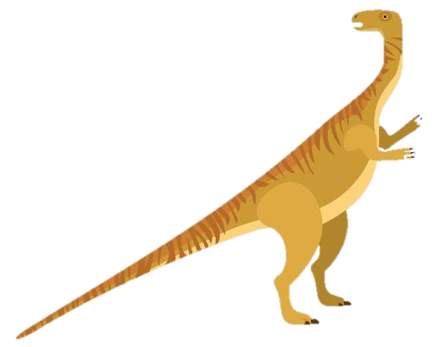
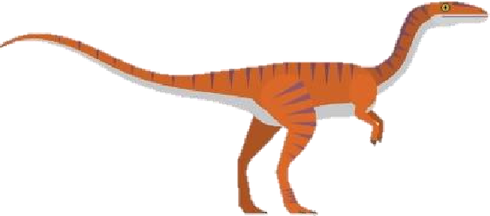
Towards the end of the Triassic period lived the Plateosaurus, a giant herbivore. It had a long, flexible neck, and flat but sharp plant crushing teeth. It is believed the Plateosaurus weighed between 600 and 4,000 kilograms, and grew to be anywhere between 4.8 and 10 metres long. Like the Coelophysis, the Plateosaurus was bipedal and stood on two legs; unlike the Coelophysis, it was strong and stocky, with powerful arms and hind legs.

Jurassic Period (205 – 142 million years ago)
During the Jurassic period, rainfall increased and the oceans rose. Vegetation became lush and plentiful, and giant forests and ferns replaced most of the desert areas that covered Earth’s surface.
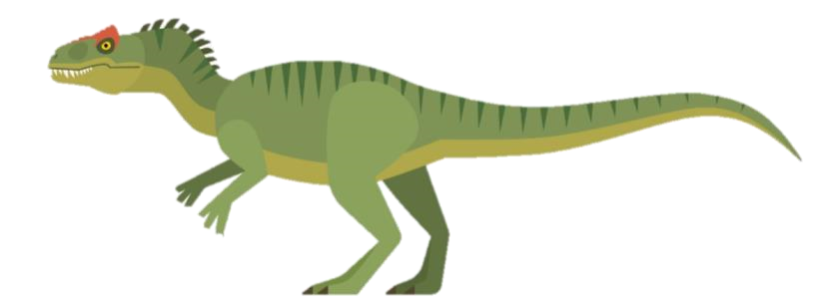
The Allosaurus reigned at the top of the food chain during the Jurassic period. It was a large bipedal predator; its massive jaw armed with dozens of saw-like serrated teeth. Averaging about 9 metres long and weighing an estimated
2300 kilograms, the Allosaurus had large, muscular hind legs, small arms, and a long, powerful tail. Some palaeontologists believe it was a social creature who hunted in packs; others believe it was extremely aggressive and kept to itself. Nevertheless, the Allosaurus was ferocious, and likely hunted large herbivores or even other carnivores.
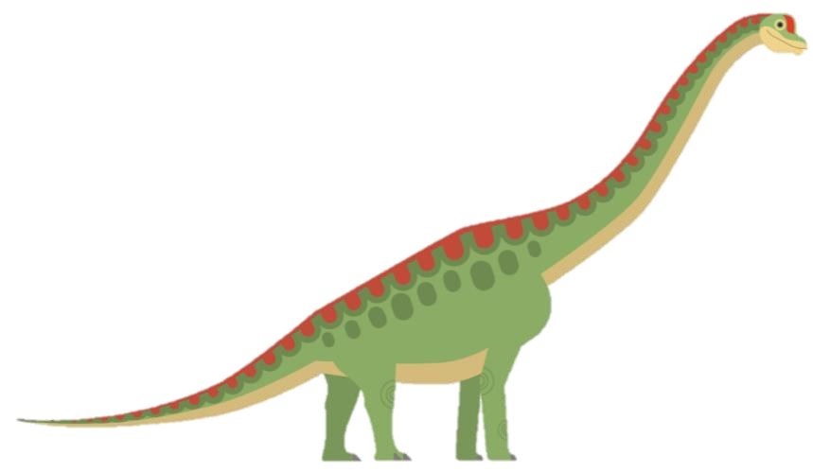
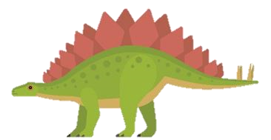
About the size of a modern day bus, the Stegosaurus was a herbivore with short forelimbs which kept its small head close to the ground and its spiked tail high in the air. The Stegosaurus’ trademark plates which ran along their back might have been used as a defence mechanism, but it is believed their primary function was to control body temperature.
Another well known herbivore, the long-necked Brachiosaurus, roamed the earth during the Jurassic period. It is thought to have been about
26 metres long, and weighed more than 30,000 kilograms; some specimens suggest it weighed almost double! It fed mostly on foliage, or plant matter, at least 5 metres off the ground. Palaeontologists estimate the Brachiosaurus ate around 250 kilograms of plant matter daily.

Cretaceous Period (142 – 65 million years ago)
Around the middle of the Cretaceous period, the Earth began to cool. The giant forests of the Jurassic period started to decline and different vegetation, including flowering plants, began to develop.
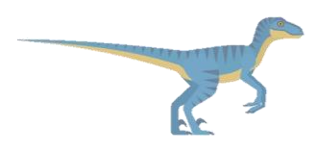
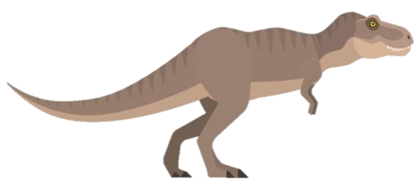
The Cretaceous period was ruled by none other than the ‘Tyrant Lizard King’: the Tyrannosaurus rex. Its skull measured 1.5 metres, and was balanced by a long, heavy tail. Its jaw was filled with massive serrated teeth that delivered a devastatingly strong bite. Likely an apex predator, the Tyrannosaurus rex preyed on herbivores and other carnivores alike.
Another well known carnivore from the Cretaceous period is the
Velociraptor. Weighing about 15 kilograms and averaging about
1.8m long (not much bigger than a domestic turkey), the
Velociraptor were bipedal, feathered dinosaurs with a large sickle shaped claw on each hind foot, which they used to take down prey.
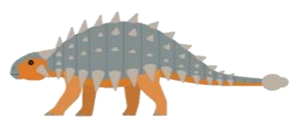
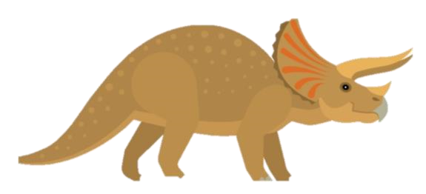
Looking something like a prehistoric tank, the herbivore Ankylosaurus was covered in armoured plates and had a large club on the end of its tail to protect it from predators. While it was only about 1.7 metres high, it weighed about 6000 kilograms – it had short, strong legs to carry all that weight. Fellow herbivore, the Triceratops, had armour which makes it one of the most recognisable of all the dinosaurs; its trademark bony frill and three facial horns have traditionally been viewed as defensive weapons against predators.

Extinction
66 million years ago, after approximately 163 million years of existence, dinosaurs disappeared. Most experts believe a giant asteroid crashed into the Earth and wiped them all out. So how do we know so much about them?

Dinosaur Remains
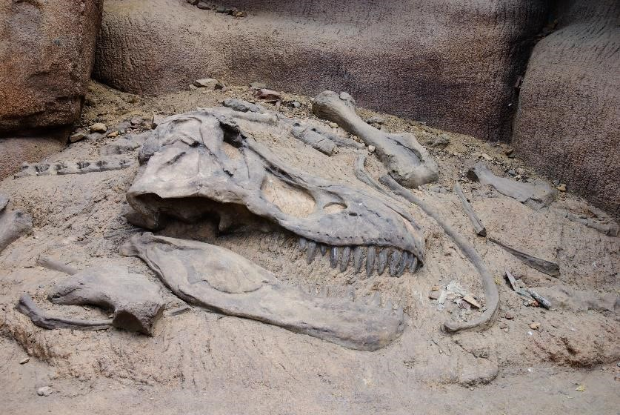
Palaeontologists from all over the world study fossils to learn about these great creatures. Fossils are preserved remains or traces of animals and plants, usually found in rock. There are many different methods of fossilisation. One type of fossil is formed if a dinosaur died near water. Its body was eventually covered in layers of sediment like ash, mud or sand. The soft parts of the body would rot away, leaving the hard bones of the skeleton behind. Over time, layers of sediment would continue to build up and become extremely heavy. The layers around the skeleton were under so much pressure that they are compacted and become rock. Eventually, minerals found in the groundwater seeped in to dissolve and replace the bones in the skeleton, and these minerals hardened to form a fossil.
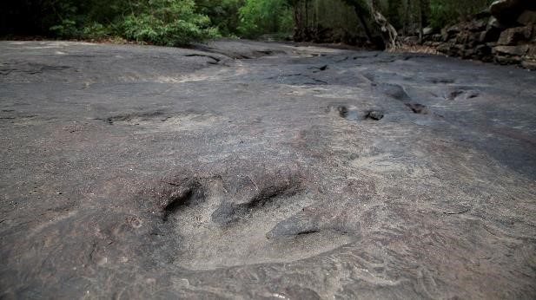
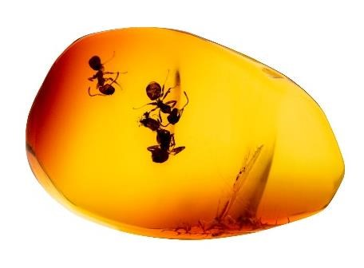
Palaeontologists excavate a fossil by removing the rock and earth carefully from around the specimen. During the excavation, the fossil is repeatedly photographed and labelled. For small or fragile fossils, special hand tools are used, including trowels, brushes, and tiny picks (somewhat like dental tools). Bigger fossils might require larger tools, such as shovels or jack-hammers. However a fossil is excavated, once it has been dug out of the ground, it is carefully packed up and moved to the lab. There, it will be cleaned, documented, and studied carefully by specialised scientists.
Some fossils formed in amber give us clues about insects, spiders, and plants from millions of years ago. Amber is formed when lumps of a sticky syrup-like resin seeps out of trees and traps small creatures. Eventually, this hardened resin is buried in sediment and fossilised. Amber is popular for its beautiful colouring, and is often used in jewellery.
Palaeontologists also study trace fossils, which show the marks left behind by a dinosaur while it was alive, including tracks, burrows, and droppings. These fossils give insight into the behaviour of dinosaurs. Studying fossils allows us to walk in the footsteps of dinosaurs millions of years after they died.
Dinosaurs – Comprehension

Section A
Which is not a period of the Mesozoic Era?
Jurassic |  |  | Cretaceous |  |  | Triassic |  |  | Prehistoric
Which is considered to be one of the earliest known dinosaurs?
Stegosaurus |  |  | Coelophysis |  |  | Allosaurus |  |  | Ankylosaurus
Which dinosaur appeared in the Jurassic period?
Triceratops |  |  | Allosaurus |  |  | Plateosaurus |  |  | T-Rex
According to their diets, which dinosaur does not belong in this group?
Ankylosaurus |  |  | Velociraptor |  |  | Allosaurus |  |  | Coelophysis
Which of these dinosaurs had the biggest skull?
Coelophysis |  |  | Stegosaurus |  |  | T-Rex |  |  | Velociraptor
Number the dinosaurs in the order they appeared in history.
Stegosaurus |  |  | Coelophysis |  |  | Plateosaurus |  |  | T-Rex

Section B
Use the information in the text to decide whether these statements are true or false.
 | True | False
The Tyrannosaurus rex and the Brachiosaurus roamed the Earth at the same time.
An apex predator, like the Tyrannosaurus rex, is a predator at the top of its food chain.
The Jurassic period of the Mesozoic Era was more than 250 million years ago.
By the end of the Triassic period, rainfall increased and the oceans rose.
The Triceratops is renowned for its trademark frill and three facial horns.
Experts believe a giant asteroid caused the extinction of the dinosaurs.

Section C
Choose one dinosaur from each period to complete this fact chart.
Name | Period | Length | Weight | Diet | Notable feature

Section D
Use a dictionary to find the meaning of the following words from the text.
apex predator
bipedal
conifer
excavate
foliage
forelimbs
palaeontology
serrated

