Maths
This half term we are revising counting to 5 and ensuring that the children have a secure knowledge of each number and how to count accurately.
We use the bbc Numberblocks programmes to support this. This is the link for episode 1: https://www.bbc.co.uk/iplayer/episode/b08bzzns/numberblocks-series-1-one
The children will be counting objects in different arrangements:
The children need to understand that this is always 5 even when the counters are moved.
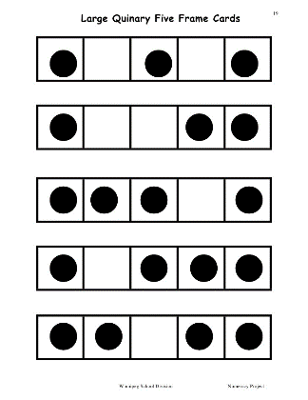
The children will be practising counting accurately using 1:1 correspondence: https://www.youtube.com/watch?v=dvyLUpE6o7A
The children will be using a 5 frame which looks like this:

This link explains how we use them: https://www.themeasuredmom.com/counting-with-five-and-ten-frames/
You can print or draw one out.

As well as counters we also use ‘real’ objects such as pasta and buttons. We also use Numercon which looks like this:
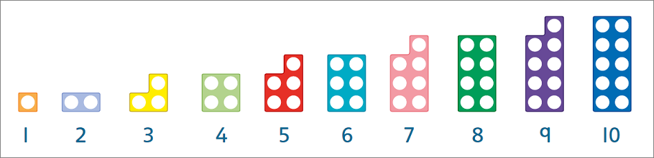

These are the weekly Maths themes this term:
Week beginning | Theme | Useful link
2.11.20 | Counting 1,2,3 | https://www.bbc.co.uk/iplayer/episode/b08bzzns/numberblocks-series-1-one  https://www.bbc.co.uk/iplayer/episode/b08bzgt8/numberblocks-series-1-two  https://www.bbc.co.uk/iplayer/episode/b08bzgxx/numberblocks-series-1-three
9.11.20 | Comparing 1,2,3. Circles and triangles | Circle: https://www.youtube.com/watch?v=YRWbpsREIVU  Triangle: https://www.youtube.com/watch?v=2wFMdKb0cz0
16.11.20 | Positional language ‘Rosie’s walk’. | https://www.youtube.com/watch?v=rYuINILGW1A
23.11.20 | Number 4 and Kipper’s birthday. | https://www.bbc.co.uk/iplayer/episode/b08d61cv/numberblocks-series-1-four  Kipper’s birthday: https://www.youtube.com/watch?v=mm1BXicbFeU
30.11.20 | Number 5 | https://www.bbc.co.uk/iplayer/episode/b08d630h/numberblocks-series-1-five
7.12.20 | One more and one less | https://www.fantasticfunandlearning.com/one-more-one-less-activities.html

Using the table above please focus on the appropriate theme. Use the links above to introduce the themes.
Suggested activities:
Roll a dice and count the spots. Match to the appropriate digit. Say what is one more or one less.
Play a board game which involves counting and/or rolling a dice. Snakes and ladders, ludo etc.
Count sets of objects, rearrange the objects. How many are there now? Say what is one more and one less.
Practice writing numbers with chalk, felt tip pens, sand.
Hunt for numbers around the house. Record by writing the number, taking a photo.
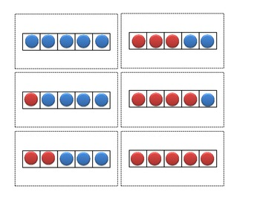
Making different amounts up to 5. Compare the sets. Use the 5 frame.
How many ways can you make 5? (This can be done with two different coloured lego bricks, types of pasta, buttons etc)

Hunt for circles and triangle around the house.
Create a picture collage using circles and triangles.
After reading Rosie’s walk, child places a toy in the correct place eg under the table, beside the TV, on top of the cupboard.

