Phonics
Phonics is taught daily. The children are introduced to the new sound and taught how to say, read and write the sound. We use the Jolly Phonics rhymes, actions and stories. This link introduces each sound: https://www.youtube.com/channel/UCRtMqfyqwo3NL-g7qsrUfWQ/videos
‘Geraldine the Giraffe’ helps children to hear the phoneme in context: https://youtu.be/sUmUpf-JNoU
Phonemes (sounds) are introduced in the following order:
Week beginning: | Phonemes (sounds)
2.11.20 | ck e u r
9.11.20 | h b f l
16.11.20 | ff ll ss
23.11.20 | ch sh th ng
30.11.20 | ai ee igh oa
7.12.20 | OO/oo ar or
Look at the table above to identify which sound you and your child should be learning at home.
Some of our new phonemes are digraphs eg ff, ch, oa. These are two letters that make one sound. This link explains this further: https://www.youtube.com/watch?v=nfWCcIz2Qjk
Here are some additional resources which may be useful:
Jolly Phonics website: https://www.jollylearning.co.uk/jolly-phonics/
Jolly Phonics songs with words: https://youtu.be/jvAYUvQUrGo
Videos of children saying the pure sounds, singing the Jolly Phonics songs and making the actions: https://www.youtube.com/playlist?list=PL4Lm2K-C_b0eSqQS4yHcQW3KaFIiDCFug

Use the following activities to teach one phoneme (sound) each day:
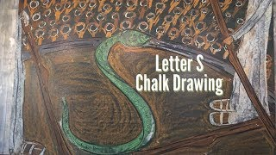
Phonics
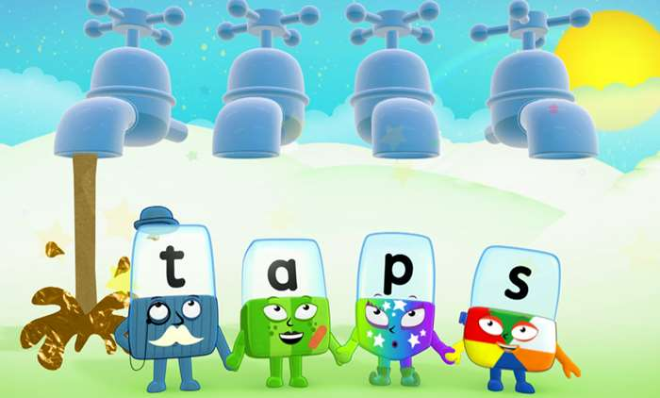
New Letter
- Teach the letters using the pure sound and Jolly Phonics action:
https://www.youtube.com/watch?v=yVyry9jpVjI
Jolly phonics songs:
https://www.youtube.com/watch?v=2Xy2e78qxNg
- Practise writing the letter in the air, with your finger on your hand, on the floor, on your leg.

Look, Listen and Note:
- Can your child say the pure sound?
- Can they recognise the letter on a flashcard?
- Can they make the shape/ write the letter in the air?
- Can they find the letter in a story book, magazine, on a cereal box ..

Activities:
Sort objects into those that have the sound and those that don’t.
Draw the letters in a variety of sizes and media, e.g. chalk, paint etc.
Sound hunt – can you see anything around the room that begins with chosen sound?

Top Tip: For all the Jolly Phonics songs, see here:
https://youtu.be/jvAYUvQUrGo
Top Tip 2: Print out or make flashcards for
the sounds.

Sort objects/ pictures into groups which start with individual sounds.

Play musical statues. When the music stops, show the children a letter flashcard. They have to make sound and do the action/ trace in air.

How many words can you think of that start with the chosen sound? Can you try to draw pictures to match your words?

