Key Stage 3
Quarantine Pack
PE
Spring 2

Welcome to the PE quarantine pack for this half term! Please can you work your way through the tasks set.
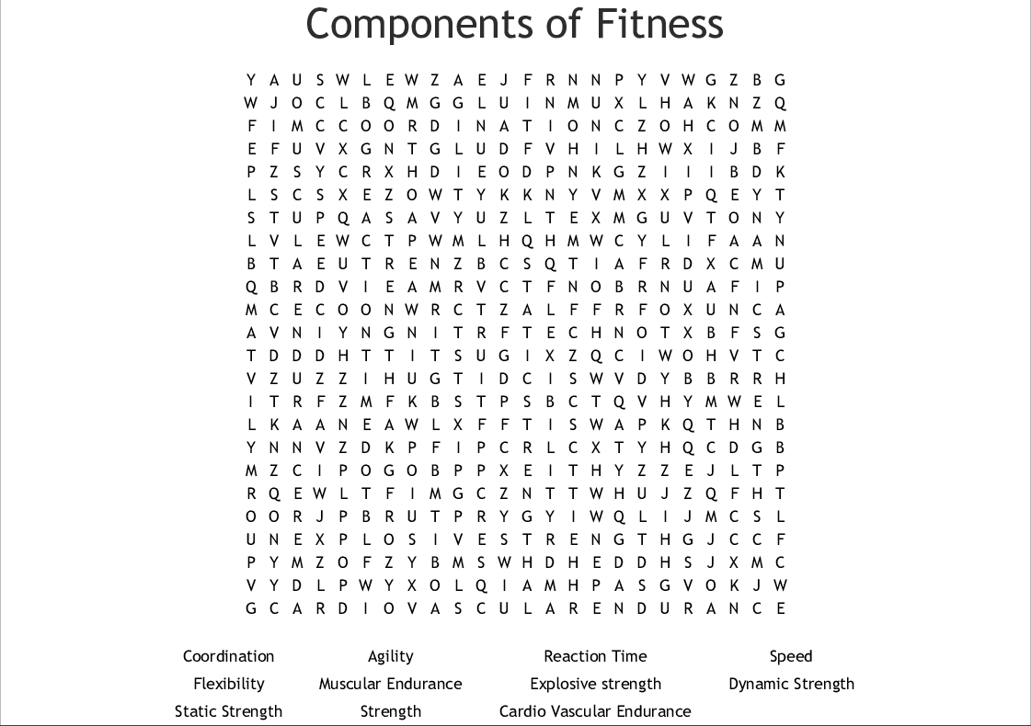
Task 1 – Fitness
Task 2 – Protective Clothing
Using the diagram below of a sports performer please decide what sport they play and draw some protective equipment that they wear on to the person. Please could you invent some extra protective equipment that you think might help them and draw those on to writing a little bit about what it is and how it works.

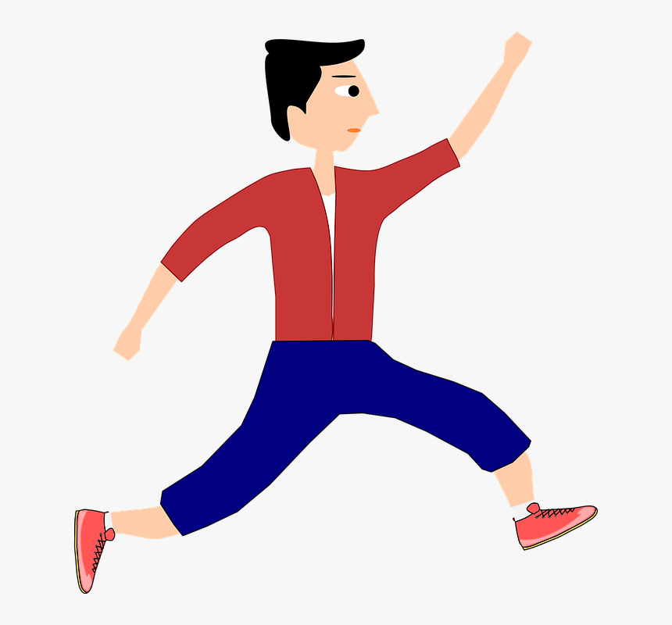

Task 3 – Sports Role model
On the mind map below please add other traits you think makes a good sports role model. One has been done for you.

Good Communicator. This is important to give clear instructions, feedback or encouragement.

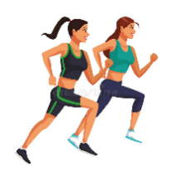
What makes a good sports role model?

Task 4 – Rules
Use the sheet below to list 10 rules of a sport of your choice. also, please could you include a diagram of the playing area for example, a football pitch or netball court. If you want to challenge yourself include the measurements on the playing area or how big and wide it is.
Rules
1.
2.
3.
4.
5.
6.
7.
8.
9.
10.

Playing area

Task 5 – Warm up
List the 5 stages for a warm up and give some examples of activities you could do. Please include pictures. (We delivered a PowerPoint on this during lockdown, see how much you can remember?)

Stage 1

Stage 2

Stage 3

Stage 4

Stage 5

Task 6 – Kit
Please use the templates below to design your own sport kit. If your kit is more then just a t-shirt and shorts please add some templated of your won and design them.
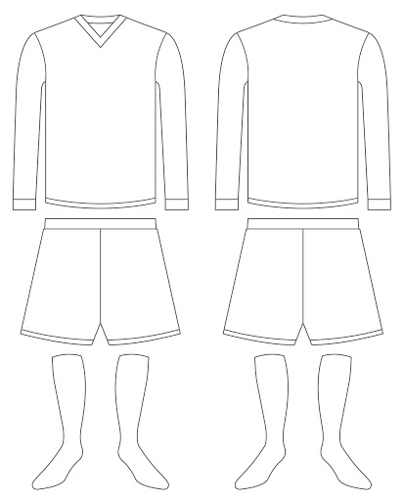

Task 7 – Badge
Please use the space below to design a sports badge for a Mayfield School sports team? You can use the template below or delete it and start from scratch.

