`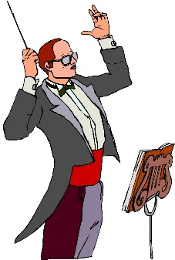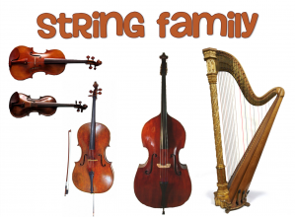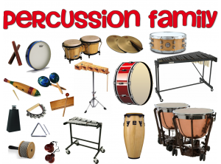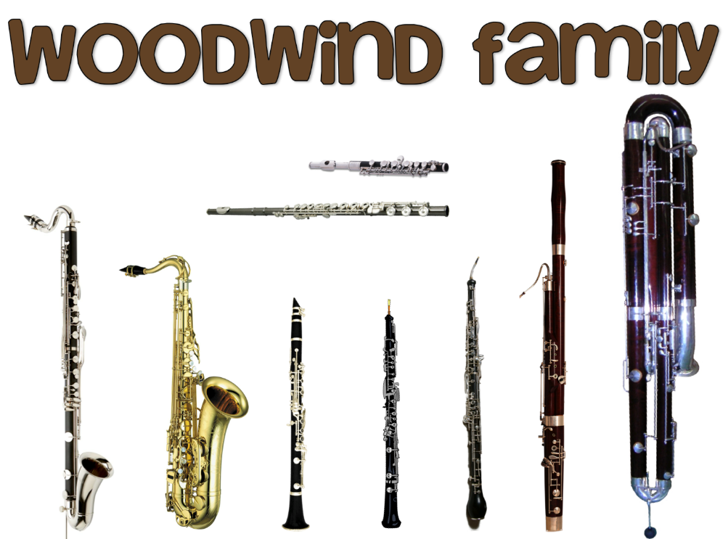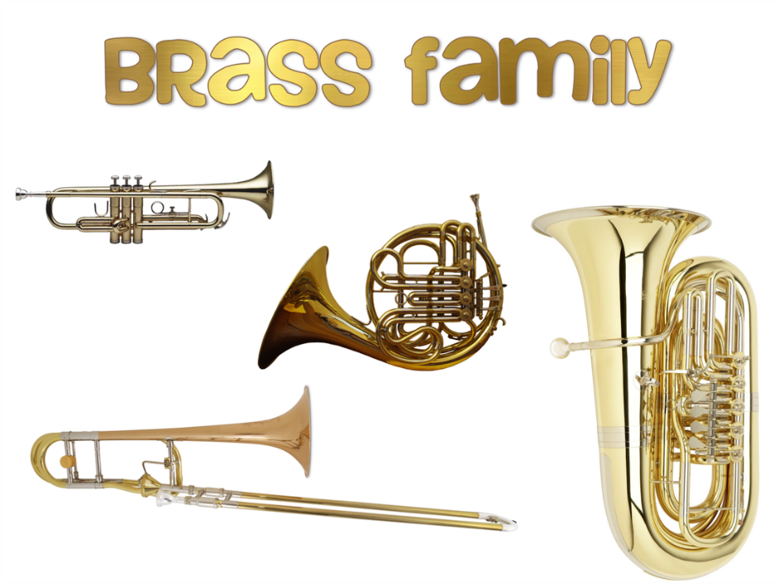

My favourite instrument of the orchestra is:

Because:

My favourite piece of music I listened to or watched while completing my passport is….

If I could learn to play one instrument from the orchestra it would be the…

“Sonority City”

Instruments of the Orchestra Passport

**Name:   
Class:**

**Teacher:**

**Sonority City - Instruments of the Orchestra Reflection**

PAGE 1

PAGE 20

ARCO GONG VIOLA

BASSOON GUIRO WOODBLOCK

BATON MARACAS VIOLIN

BOW OBOE WOODWIND

BRASS ORCHESTRA XYLOPHONE

CABASA PERCUSSION

CELLO PIANO

CLARINET PICCOLO

CONDUCTOR PITCH

CYMBALS PIZZICATO

DRUM REEDS

ENSEMBLE SECTION

FAMILY SONORITY

FANFARE STRINGS

FLUTE TAMBOURINE

GLOCKENSPIEL TIMBRE

TIMBRE TIMPANI

TRIANGLE TROMBONE

TRUMPET TUBA

E G E U S P I D I P O R P A O Y R R T C

N L U K S G G R L H Z E O T L F X I B L

O O K I A Z Q X C O R C A T E O M L D A

B C I T R K O S O C L C K P C B I X Z R

M K L T B O I U U O I J E D R U F V Q I

O E D I C N T S S Z S D E E R B D K J N

R N Y L A E S D Z Y T I R O N O S N E E

T S L P W I S I W O O D B L O C K N O T

F P M H O A P I O M L F L U T E S P C C

H I X N E N I R U O B M A T O E G I R G

T E F Y P K U R L C A R Q B M T N A A P

L L A A L R D L O R D Y C B S U I N D Y

D S N R O O E U A B P E L Y D B R O R F

G L F T C C P C Q P O E L N M A T S V A

Z R A S B A A H I Q A E I G F B S L R M

L L R E N S B T O Q S W G O N G A W W I

K L E H X O C A B N D I Q G H A C L T L

W N J C J H T O S O E O L O C C I P S Y

R K D R D T W A O A T R U M P E T R I U

N I L O I V V W B A S S O O N T K S T W

**Sections of the Orchestra Visited**

**Put the date for when you have visited each family or section of the orchestra and filled in all the keyword definitions and the description of each musical instrument.**

**Family/Section of Date Visited:**

**the Orchestra**

Strings

Woodwind

Brass

Percussion

Complete your “Sonority City – Instruments of the Orchestra” passport as you journey through the families, sections and instruments of the orchestra. You may choose to include pictures of the instruments in your passport. Include interesting facts *(What does each instrument look like?*

*What is each instrument made from? How is the sound produced? How is the instrument played? How would you describe its* ***Sonority/Timbre****?)* – don’t just copy and paste from the internet! Make your passport colourful and eye catching. Make your facts easy to see and remember – stick to the point! Listen to one of the recommended pieces of music as you visit each section and family of the orchestra and give definitions of all the key words that you meet along your travels.

Violin

PAGE 19

PAGE 2

**The Layout of the Orchestra**

*Is there a set layout for an orchestra? Who sits where? Can you find a diagram for this?*

**The Role of the Conductor**

*Who is a conductor? What do they do?*

*What is their white stick called? (Picture)*

*Is there a set pattern of movements that a conductor does?*

*Name some famous orchestral conductors.*

**Violin**

PAGE 3

PAGE 18

**The Halle Orchestra (LSO)**

*Research information about this orchestra. Who conducts it? Where is it based? How many people play for the orchestra? Where do they do their concerts? How often does it rehearse? Do they have guest soloists? How much does each player earn from being in the orchestra? Try to include pictures.*

**The London Symphony Orchestra (LSO)**

*Research information about this orchestra. Who conducts it? Where is it based? How many people play for the orchestra? Where do they do their concerts? How often does it rehearse? Do they have guest soloists? How much does each player earn from being in the orchestra? Try to include pictures.*

**Viola**

**Cello**

PAGE 17

PAGE 4

**Untuned Percussion Instruments**

**Bass Drum Snare Drum**

**Cymbals Woodblock**

**Guiro Triangle**

**Gong Tambourine**

**Cabasa Maracas**

**Double Bass**

**Harp**

PAGE 5

PAGE 16

**Tuned Percussion Instruments**

**Timpani**

**Xylophone**

**Glockenspiel**

**Tubular Bells**

**Piano**

**Strings Section Key Words – Find the definition….**

* **Bow**
* **Arco**
* **Pizzicato**
* **Pitch**

**A piece of music for Strings I have watched/listened to is:** *(suggestions of pieces of music for Strings are given below – use YouTube or Spotify)*

**Name of Piece:**

**Composer/Artist:**

**Words that describe the *SONORITY* or *TIMBRE* of this music:**

**I liked/disliked this piece of music because:**

**Suggested Watching/Listening for Music for Strings**

* **Elgar**: Introduction and Allegro for string quartet and string orchestra Op. 47
* **Michael Tippett**: Fantasia Concertante on a Theme by Corelli - A Far Cry
* **Paul Hindemith**: Trauermusik for Viola and String Orchestra
* **Dvořák**: Serenade for Strings
* **Elgar**: - Sospiri for String Orchestra and harp, Op. 70
* **Vivaldi**: - Concerto for Two Violins & Two Cellos
* **Beethoven**: String Quartet Op.133 "Grosse Fugue"
* **The Verve**: Bittersweet Symphony *(listen out for the Strings playing the Riff)*

PAGE 15

PAGE 6

**Percussion Section Key Words – Find the definition….**

* **Tuned Percussion**
* **Untuned Percussion**

**A piece of music for Percussion I have watched/listened to is:** *(suggestions of pieces of music for Percussion are given below – use YouTube or Spotify)*

**Name of Piece:**

**Composer/Artist:**

**Words that describe the *SONORITY* or *TIMBRE* of this music:**

**I liked/disliked this piece of music because:**

**Suggested Watching/Listening for Music for Percussion**

* **Chávez**: Toccata for Percussion Ensemble
* **Steve Reich:** Music for Pieces of Wood *(features the Claves)*
* **Eric Ewazen:** Symphony for Percussion
* **Olga Hans:** Entelecheia *(features Percussion and Orchestra)*

**Flute**

PAGE 7

PAGE 14

**Brass Section Key Words – Find the definition….**

* **Fanfare**
* **Harmonic Series**
* **Brass Band**
* **Embouchure**

**A piece of music for Brass I have watched/listened to is:** *(suggestions of pieces of music for Brass are given below – use YouTube or Spotify)*

**Name of Piece:**

**Composer/Artist:**

**Words that describe the *SONORITY* or *TIMBRE* of this music:**

**I liked/disliked this piece of music because:**

**Suggested Watching/Listening for Music for Brass**

* **Ingolf Dahl**: Music for Brass Instruments
* **Penderecki**: Capriccio for Tuba Solo
* **Rimsky-Korsakov:** Trombone Concerto
* **Richard Strauss:** Concerto for French Horn & Orchestra No.1 Op.11
* **Dizzy Gillespie**: A Night in Tunisia *(a famous jazz Trumpeter)*
* **Calvin Harris & Rag ‘n’ Bone Man:** Giant *(listen out for the Trombone)*
* **Chicago:** If you leave me now *(listen out for the French Horn)*
* **Omi**: Cheerleader *(listen out for the Trumpet)*

**Piccolo**

**Clarinet (& Bass Clarinet)**

**Oboe**

PAGE 13

PAGE 8

**Bassoon & (Double Bassoon)**

**Cor Anglais**

**Saxophone**

**Trombone**

**Tuba**

**French Horn**

PAGE 9

PAGE 12

**Trumpet**

**Woodwind Section Key Words – Find the definition….**

* **Flutes**
* **Reeds**
* **Mouthpiece**
* **Keys**

**A piece of music for Woodwind I have watched/listened to is:** *(suggestions of pieces of music for Woodwind are given below – use YouTube or Spotify)*

**Name of Piece:**

**Composer/Artist:**

**Words that describe the *SONORITY* or *TIMBRE* of this music:**

**I liked/disliked this piece of music because:**

**Suggested Watching/Listening for Music for Woodwind**

* **Carl Nielsen:** Wind Quintet, Op.43 *(also includes a French Horn from the Brass section)*
* **Gustav Holst:** First Suite in Eb for Wind Band *(also includes Brass and Percussion)*
* **Mozart:** Clarinet Concerto in A Major K.622 *(also includes full orchestra)*
* **Mozart:** Concerto for Bassoon in B flat major, KV. 191 *(also includes full orchestra)*
* **Dvořák**: II. Largo “From the New World” Symphony No.9 *(features the Cor Anglais)*
* **The Stereophonics**: Handbags and Gladrags *(listen out for the Oboe)*
* **John Grant**: Down Here *(features the Bass Clarinet)*
* **Men at Work:** Down Under *(listen out for the Flute)*

PAGE 11

PAGE 10