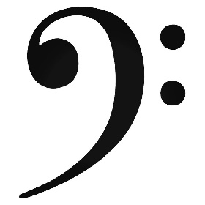
BASS Clef Staff Notation

Name Form

Identify the following note names all given in the BASS CLEF.

