Funeral March from Beethoven’s Symphony Number Seven
This ‘funeral march’ is taken from the second movement of Beethoven’s Symphony No.7 and is performed at low pitch, using 2-parts entirely in the BASS CLEF. Work out the correct note names, watching out for some sharps (#) which last for the whole bar they first appear in.
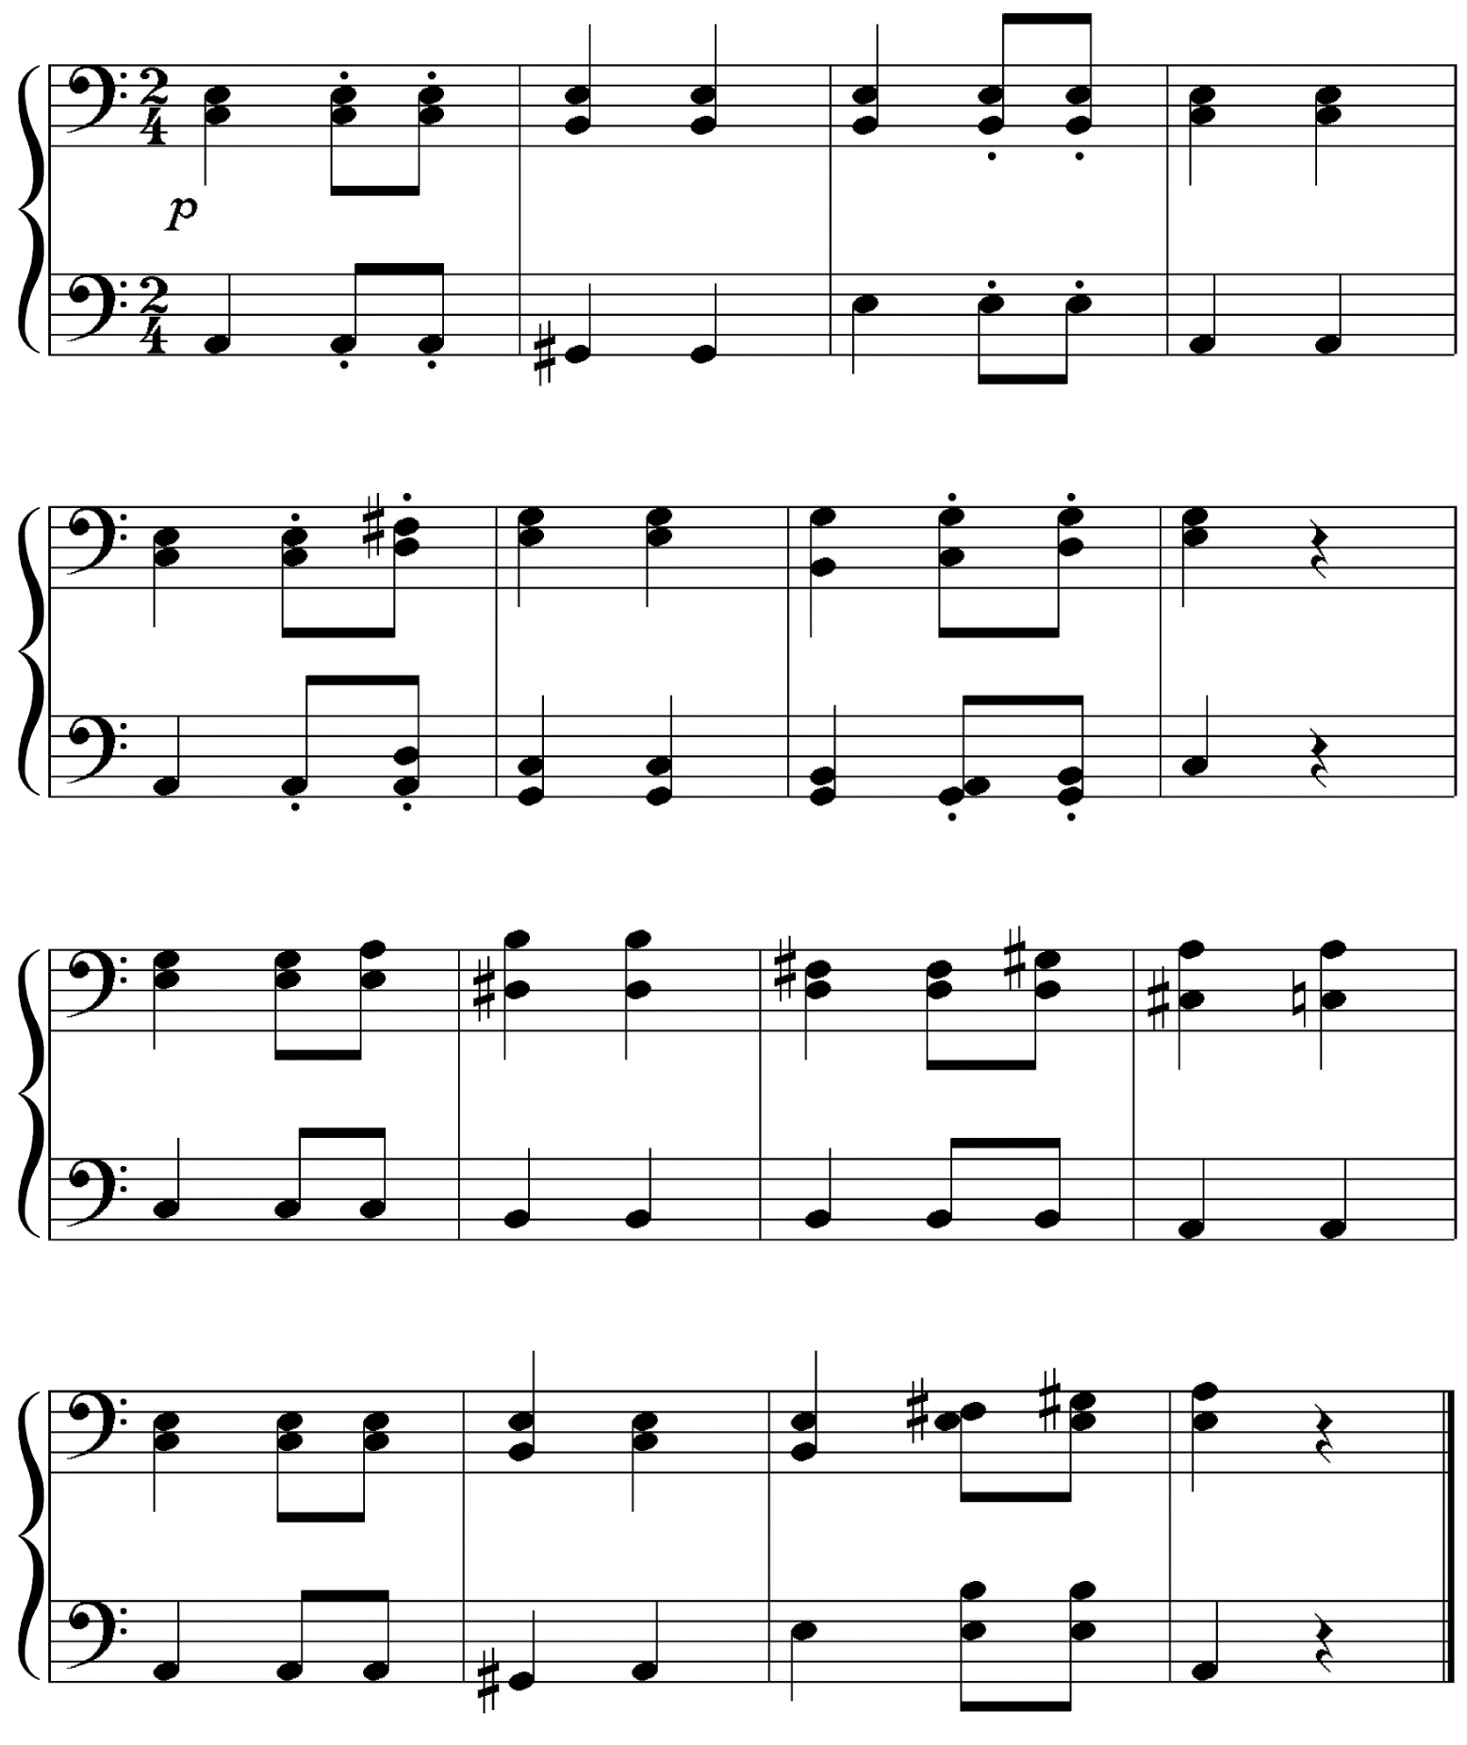

Funeral March from Beethoven’s Symphony Number Seven
ANSWER
