Simple and Compound Time
Name Form

A TIME SIGNATURE shows the number of beats in a bar. A time signature is two numbers placed one above the other at the beginning of a piece of music. The TOP NUMBER tells us how many beats there are in each bar; the BOTTOM NUMBER tells us what sort of beat to count. A piece with crotchet beats has 4 on the bottom line of its time signature. Minim beats have 2 on the bottom. Quaver beats have 8 on the bottom.
ACTIVITY 1
Write out the meanings of the following time signatures in full. The first one has been done for you.
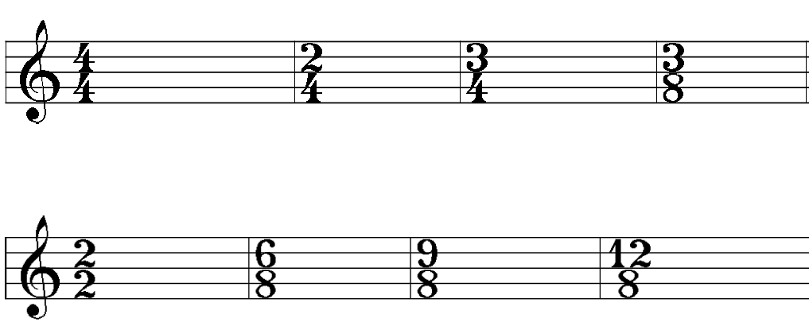

Four crotchets beats in a bar

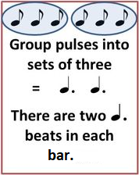
In SIMPLE TIME, each beat is divisible into HALVES. In COMPOUND TIME, each beat (you can see that all the sets of three quavers below equal a dotted crotchet) divides into THIRDS. It is this dividing of the beat into three which gives music written in compound time a dancing rhythm – lilting if the speed is moderate or slow and skipping if the music moves swiftly.
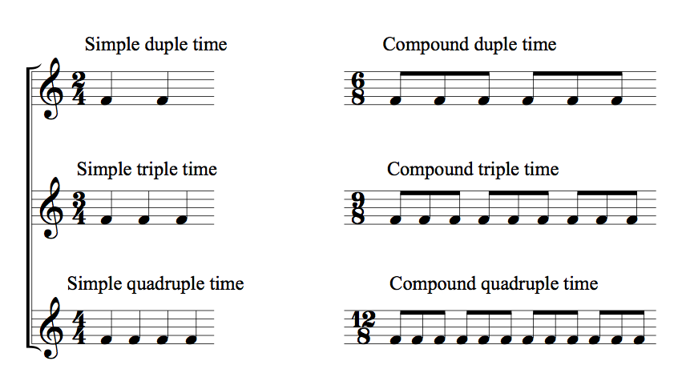
ACTIVITY 2
Look back at the time signatures given in activity 1. Add them to the following table depending on whether they are SIMPLE TIME signatures or COMPOUND TIME signatures.
SIMPLE TIME SIGNATURES | COMPOUND TIME SIGNATURES

ACTIVITY 3
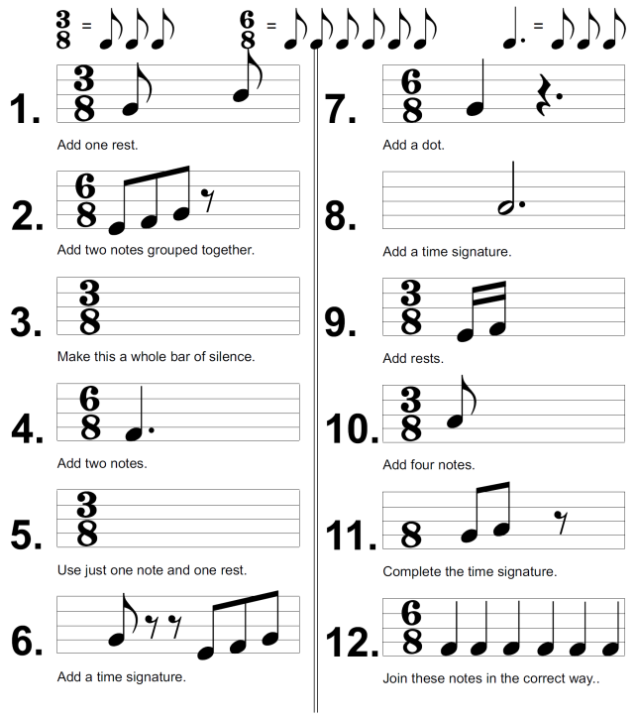
ACTIVITY 4
Add the missing bar lines at the appropriate places, noting the time signature carefully.
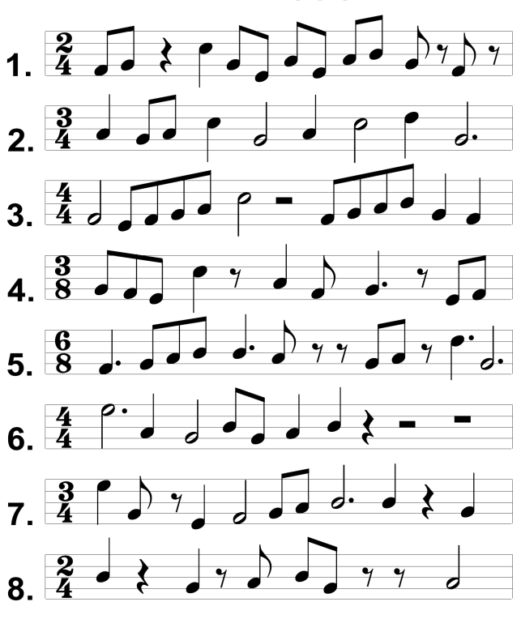

Simple and Compound Time
ANSWERS
ACTIVITY 1
Write out the meanings of the following time signatures in full. The first one has been done for you.
Six quaver beats in a bar

Twelve quaver beats in a bar

Nine quaver beats in a bar

Two minim beats in a bar

Three quaver beats in a bar

Three crotchet beats in a bar

Two crotchet beats in a bar
Four crotchets beats in a bar

ACTIVITY 2
Look back at the time signatures given in activity 1. Add them to the following table depending on whether they are SIMPLE TIME signatures or COMPOUND TIME signatures.
SIMPLE TIME SIGNATURES | COMPOUND TIME SIGNATURES
4 3 2 2 3  4 4 4 4 8 | 6 9 12  8 8 8

ACTIVITY 3
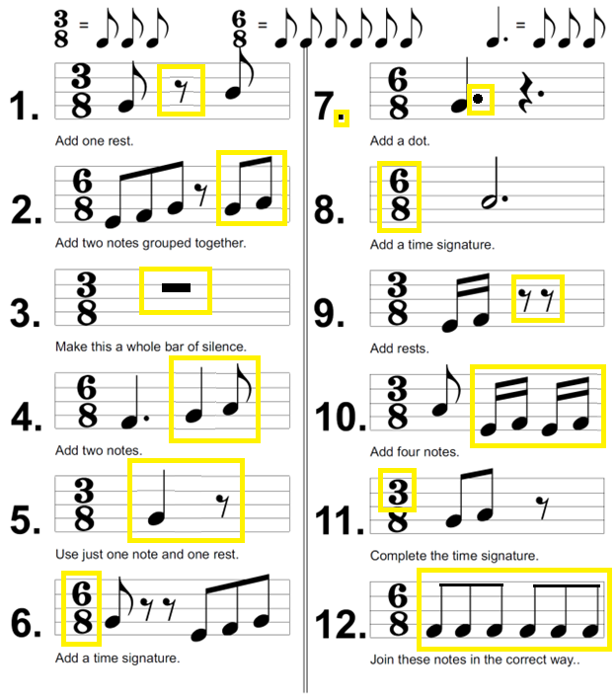

ACTIVITY 4
Add the missing bar lines at the appropriate places, noting the time signature carefully.
