## MCj00961070000[1]SYNCOPATION

## Name Form

Syncopation is when the **OFFBEATS** in a rhythm- e.g. beats 2 and 4 in 4/4 time - are given a greater degree of emphasis than the main beats - e.g. beats 1 and 3 in 4/4 time. Rhythms that ‘fit in between the beats of a bar’ can be described as **SYNCOPATED**. In Samba, syncopated rhythms create complex rhythms. This is particularly relevant in sections of Samba such as the **MID-SECTIONS,** where musicians explore syncopation through improvisation. New rhythms in Samba are often formed because of experimentation with syncopated rhythm.

**1. There are 9 different Samba rhythms below. Some of them include SYNCOPATION**, **others do not. Draw a circle around or identify those Samba rhythms which do include SYNCOPATION** **within the rhythm.**

a) 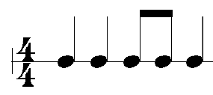 b) 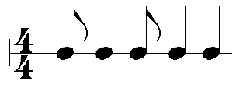 c)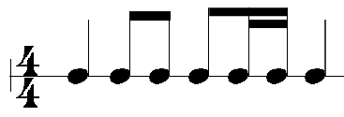

d)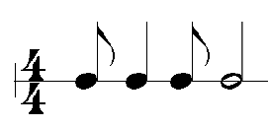 e)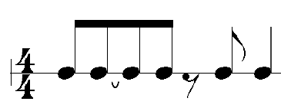 f)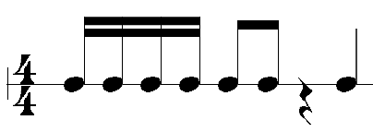

g) 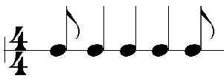 h) 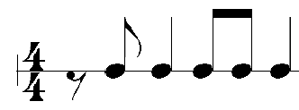 i) 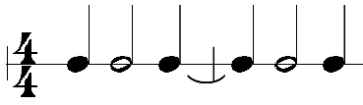

**2. The following SYNCOPATED Samba rhythms are all made up of 2 bars. Insert the missing barline at the correct place within the middle of the rhythm. All rhythms are in 4/4 time.**

a) 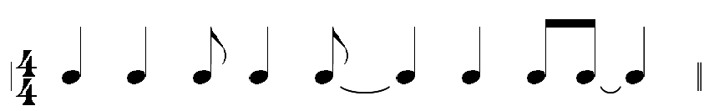

b) 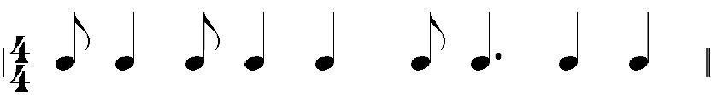

c) 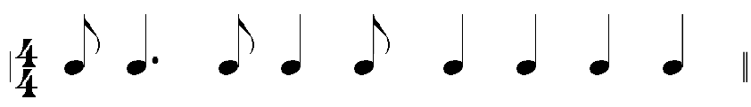

d) 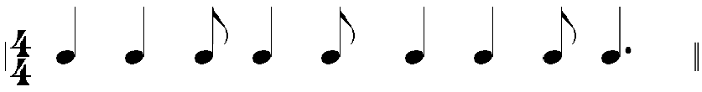

**3. Write the pulse/beat counts using “1 + 2 + 3 + 4 +” under the beats of each of the following SYNCOPATED Samba rhythms. The first two bars of the first Samba rhythm has been done for you.**

a) 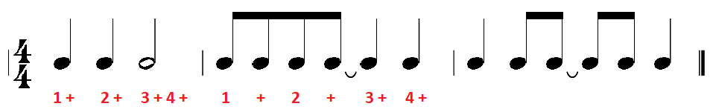

b) 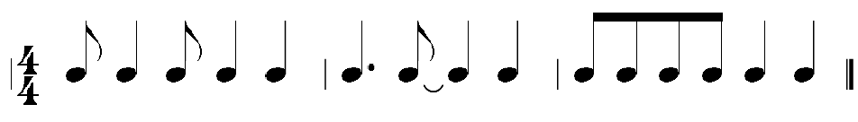

c) 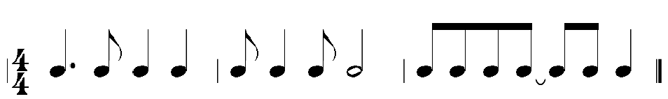

d) 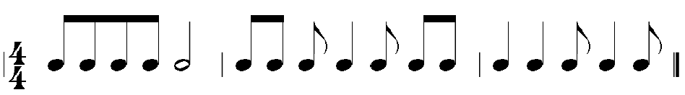

## MCj00961070000[1]SYNCOPATION

## ANSWERS

Syncopation is when the **OFFBEATS** in a rhythm- eg beats 2 and 4 in 4/4 time - are given a greater degree of emphasis than the main beats - eg beats 1 and 3 in 4/4 time. Rhythms that ‘fit in between the beats of a bar’ can be described as **SYNCOPATED**. In Samba, syncopated rhythms create complex rhythms. This is particularly relevant in sections of Samba such as the **MID-SECTIONS,** where musicians explore syncopation through improvisation. New rhythms in Samba are often formed as a result of experimentation with syncopated rhythm.

**1. There are 9 different Samba rhythms below. Some of them include SYNCOPATION**, **others do not. Draw a circle around or identify those Samba rhythms which do include SYNCOPATION** **within the rhythm.**

a)  b)  c)

d) e) f)

g)  h)  i) 

**2. The following SYNCOPATED Samba rhythms are all made up of 2 bars. Insert the missing barline at the correct place within the middle of the rhythm. All rhythms are in 4/4 time.**

a) 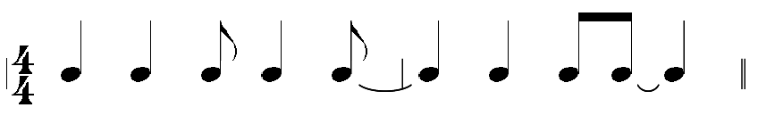

b) 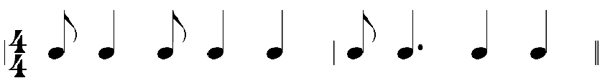

c) 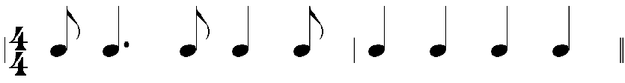

d) 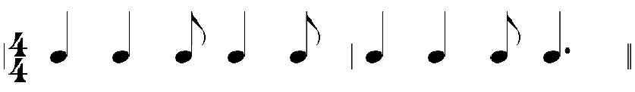

**3. Write the pulse/beat counts using “1 + 2 + 3 + 4 +” under the beats of each of the following SYNCOPATED Samba rhythms. The first two bars of the first Samba rhythm has been done for you.**

a) 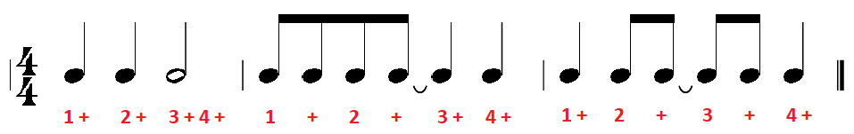

b) 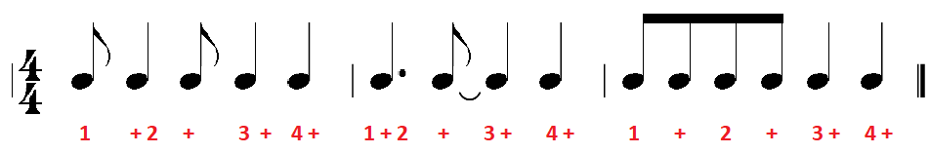

c) 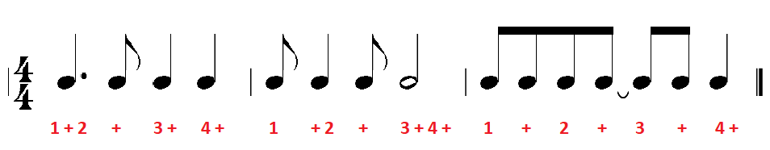

d) 