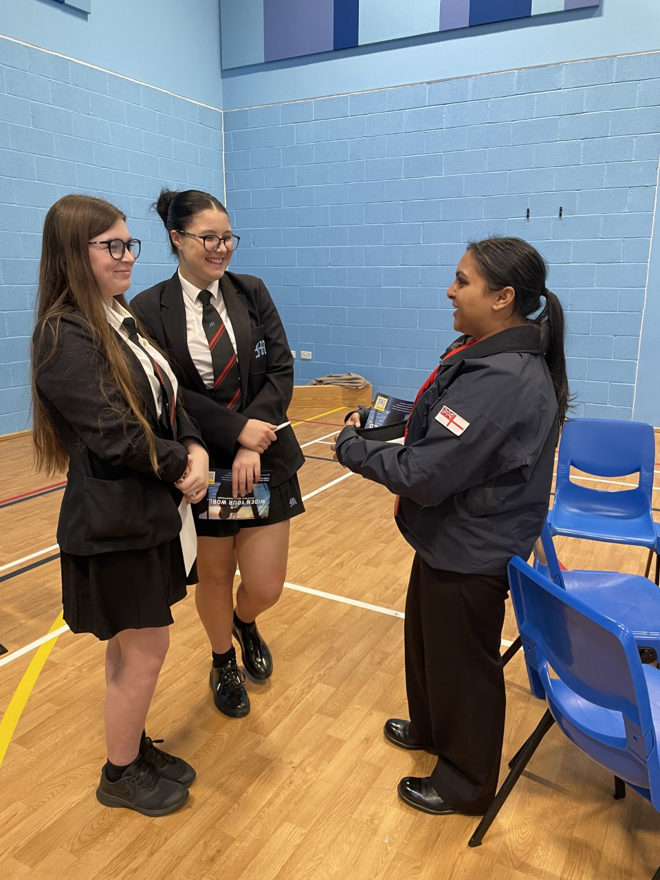

Year 10 – National Apprenticeship Week

Wednesday 8th February Year 10 pupils had a chance to interact and ask questions to current apprentices in the city as part of the ‘Apprenticeship Bus’ visiting the school. There was a variety of careers present. The visitors all mentioned that our pupils were engaged, respectful and asking important questions about their futures.