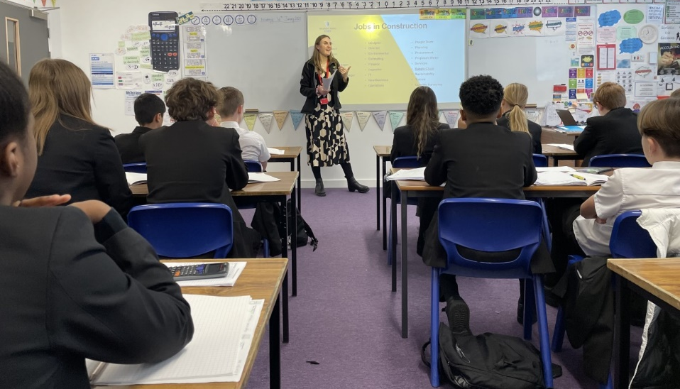
Aspirations Week 16th January 2023
On Monday 16th some pupils during their maths lesson had a talk by a Current Degree Apprentice talking about their role as a trainee Management Apprentice and about jobs with the company Willmott Dixon Construction Limited and the variety of careers there are within this sector.

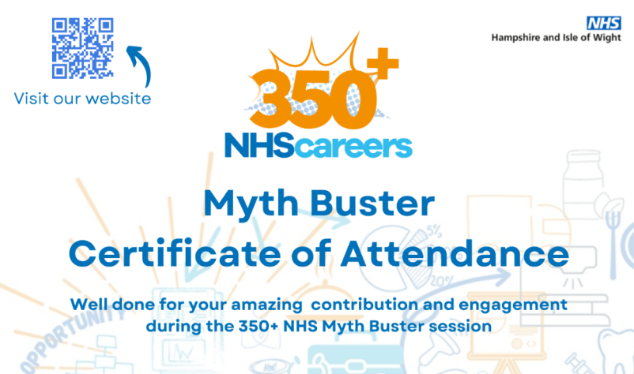
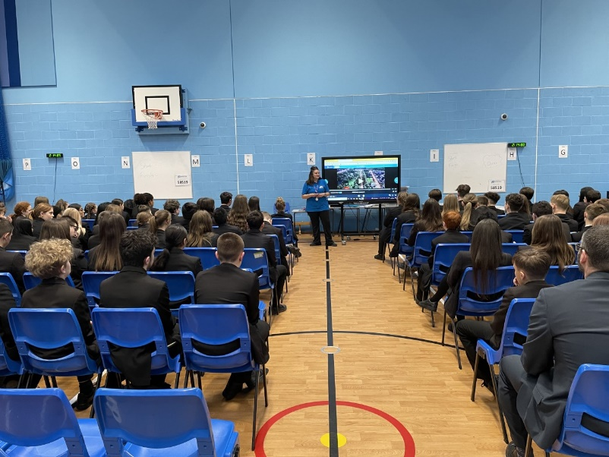
We also had the NHS in for a talk about the 350+ jobs that are available within the NHS to the whole of Year 9. The NHS is one of the biggest employers within our city so weas great to raise the profile of all the careers available to pupils.
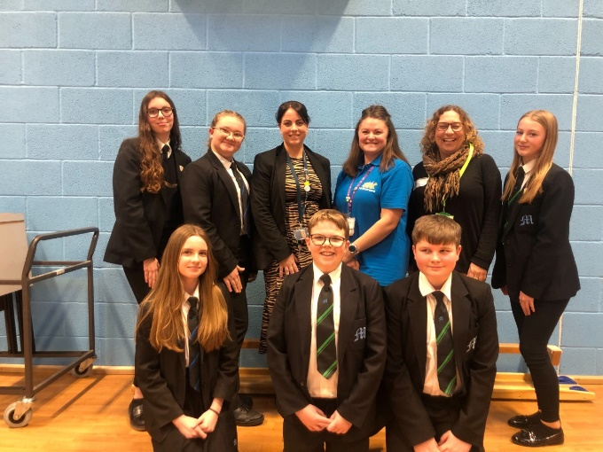

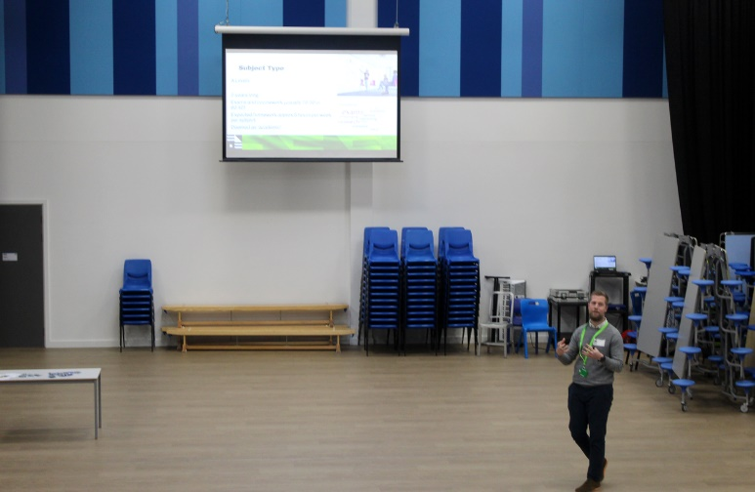

We also had City of Portsmouth College in for our house assemblies in January to deliver an assembly about A Levels, technical, vocational and T level qualifications.
This was great to see all the options pupils have post 16 (after they leave Year 11) and getting this knowledge of choices across to all our pupils to then share ideas withing tutor groups of what might suit their learning needs.

