**American Civil Rights: How did Black Americans gain Civil Rights?**

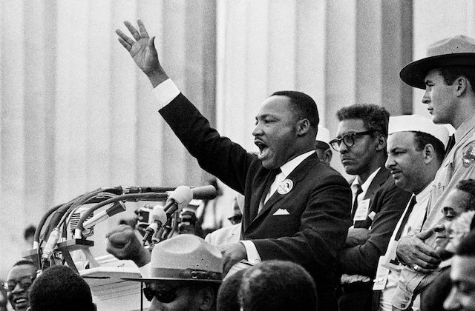

Name: ____________________

Class: ­­­­­­______________________

**Task One:** Using the letters that make up the words **American Civil Rights**, see how many words that you can create. Add your words to the table below:

|  |  |  |  |
| --- | --- | --- | --- |
| 1. Civil | 2. Right | 3. | 4. |
| 5. | 6. | 7. | 8. |
| 9. | 10. | 11. | 12 |
| 13. | 14. | 15. | 16. |
| 17. | 18. | 19. | 20. |
| 21. | 22. | 23. | 24. |
| 25. | 26. | 27. | 28. |
| 29. | 30. | 31. | 32. |
| 33. | 34. | 35. | 36. |
| 37. | 38. | 39. | 40. |
| 41. | 42. | 43. | 44. |
| 45. | 46. | 47. | 48. |
| 49. | 50. | 51. | 52. |
| 53. | 54. | 55. | 56. |
| 57. | 58. | 59 | 60. |

|  |  |  |
| --- | --- | --- |
| 1861-1865: The American civil war. The southern slave states try to break away from the USA. | 1915: The Klu Klux Klan, a secret society of violent white racists, is founded. | 1955: Martin Luther King emerges as leader of the “non-violent” civil rights movement. |
| 1909: National Association for the Advancement of Coloured People, founded. | 1881: The Tuskegee University in Alabama is founded by African-American educator Booker T. Washington. | 1865: Slavery is abolished by President Lincoln after his victory in the civil war. |
| 1954: ‘whites only’ schools are declared illegal. | 1870s: “Jim Crow” laws are enacted in the south, legalising discrimination against black people. | 1955: Rosa Parks, a black woman, is arrested for refusing to give her bus seat to a white person. |
| **1**957: The “Little Rock” Crisis. Nine black American students were initially prevented from entering the racially segregated Little Rock Central High School. | 1963: MLK leads the famous “March on Washington” where he delivers his “I have a dream” speech. | 1964: President Johnson signs the Civil Rights Act, which prohibits racial discrimination. |

**Tasks:  
  
1)** Produce a timeline of the events in the boxes below. These events are jumbled up so make sure they go in the right order! Use symbols to help you remember key events if you wish. **2)** Explain which two events from your timeline were most important.  
 *The two most important events on my timeline are… because…***3)** which two events would you like to know more about? Explain your choices.  
  
**4)** Slavery was ended in 1865, it took nearly 100 years for the black people of America to gain their civil rights. How do you think they felt? Use a range of adjectives.

**Section 1: The Jim Crow Laws**

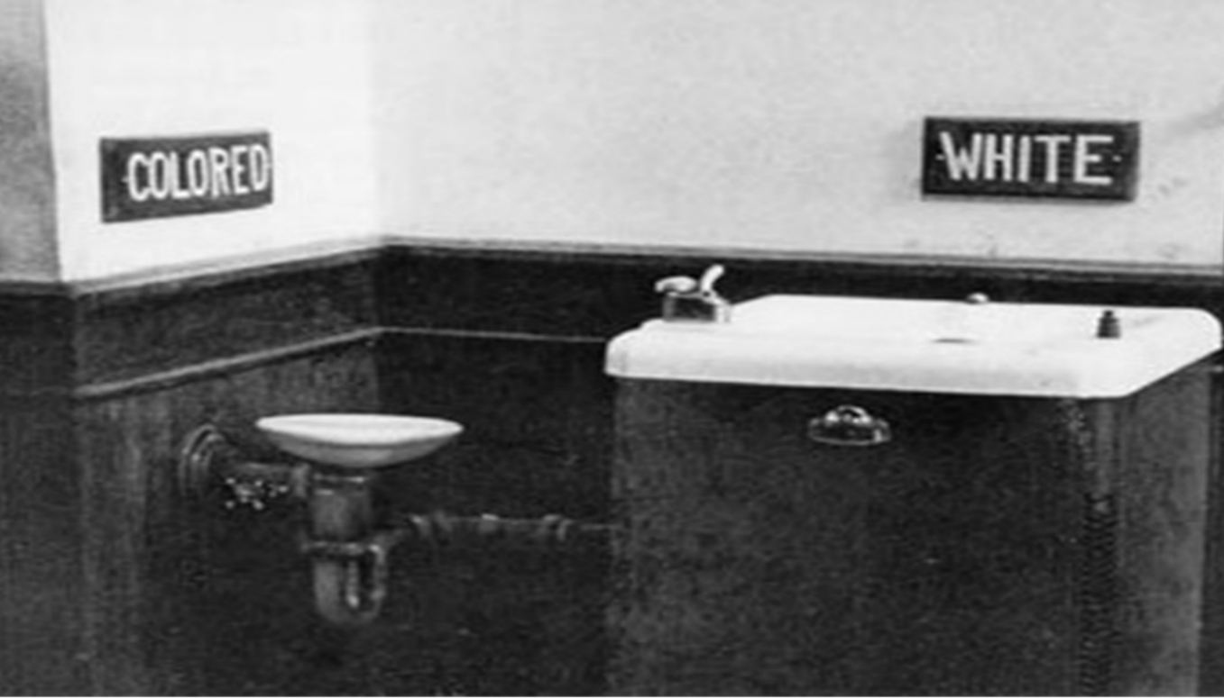Examine the image below, then answer the questions underneath:

1: Write down three questions you would like to ask about this image.

_______________________________________________________________________________________________________________________________________________________________________________________________________________________________________

2. Can you explain what this image shows?

_______________________________________________________________________________________________________________________________________________________________________________________________________________________________________

**Keywords for this topic:**

|  |  |
| --- | --- |
| Segregation | Separating people because of their race, religion or culture. |
| Civil Right Movement | A struggle by African Americans to achieve social and political equality with white Americans. |

Can you think of any modern-day examples of segregation? Write them in the space below:

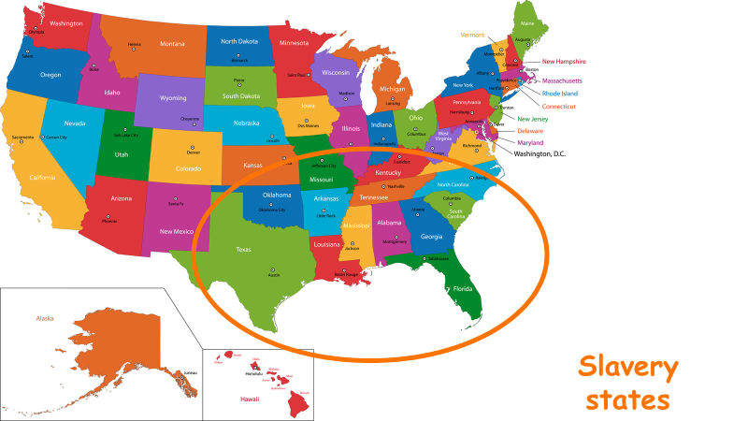This topic focuses on America and the states that had been linked to slavery. They are shown on the map below:

**Jim Crow:**

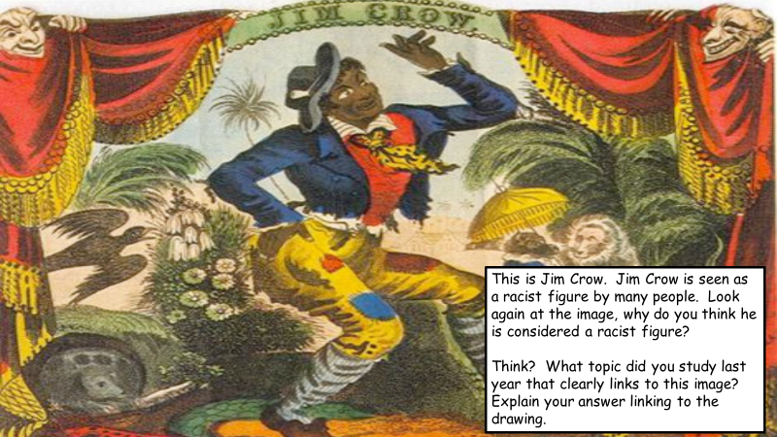

_________________________________________________________________________________________________________________________________________________________________________________________________________________________________________________________________________________________________________________________________________________________________________________________________________________________________________________________________________________________________________________________________________________________________________________________________________________________________________________________________________________________________________________________________________________________________________________________________________________________________________________________________________________________________________________________________________________________________________________________________________________________________________

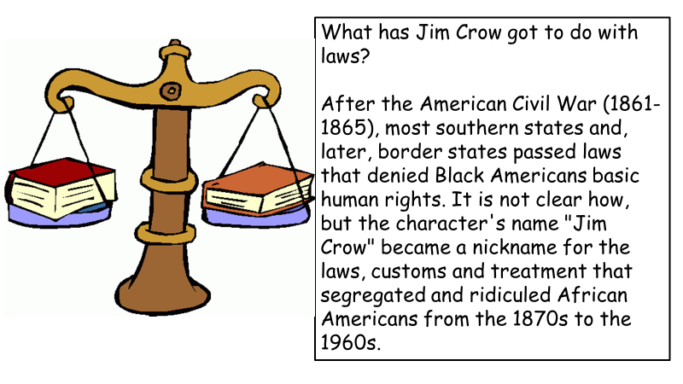

1. Why did the American Southerners want to keep slavery?
2. Use the source below and your own knowledge to identify the types of place that were segregated in the South.

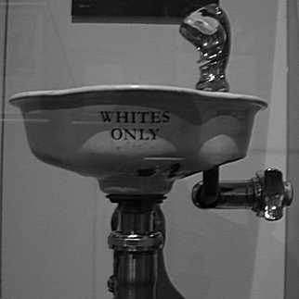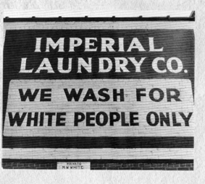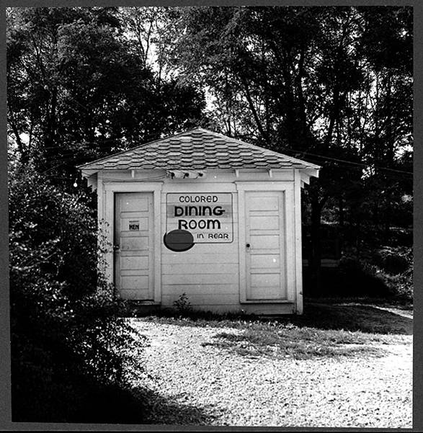

1. How were black people in the south prevented from voting?

Internet task: Watch this youtube video: <https://www.youtube.com/watch?v=ij6DWZ-W-KA> about the Jim Crow Laws. Write down three ways Black Americans were treated differently.

1. _____________________________________________________________________
2. _____________________________________________________________________
3. _____________________________________________________________________

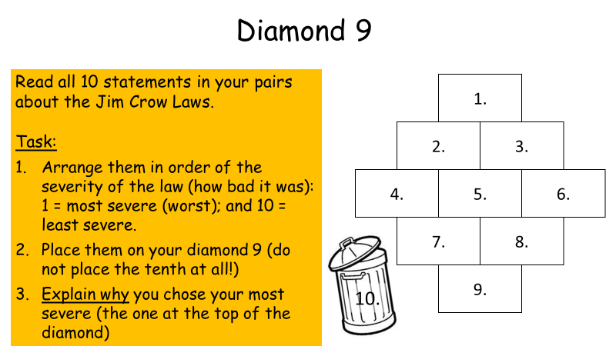

**Jim Crow Laws:**

|  |  |
| --- | --- |
| No white nurses are to work in  a hospital where black people  are being treated. | Black and white people will have separate waiting rooms for buses and trains. |
| In restaurants it is against the law to serve black and white  people in the same  room. | Black and white people shall have separate public  drinking  fountains. |
| Black and white people should  not marry. | There will be separate schools for black and white children. |
| Black people are not allowed to take books out of libraries. | Black people must give up their seats on both trains and buses  for a white person. |
| If a black and white person (man and woman) are found living together they shall be imprisoned for a  period of a year and fined. | Anyone found printing books or leaflets about the rights of  black people will be  imprisoned and fined. |

**Diamond Nine to be completed:**

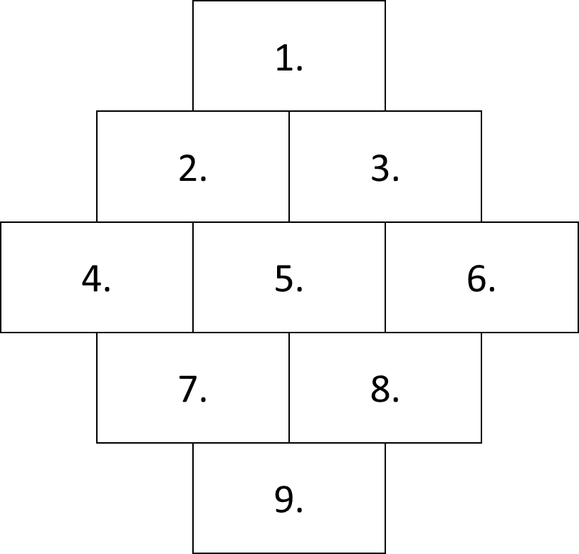



10. I ‘binned’ this law because___________________________________________________

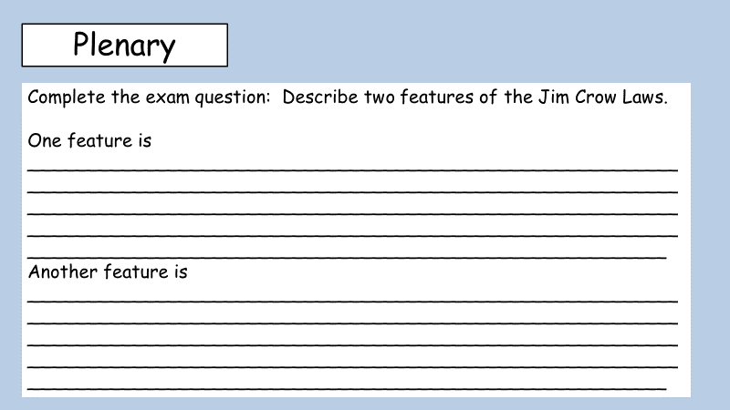

**Remember a feature is a detail!**

**Section 2: The Ku Klux Klan**

1. Describe the beliefs of the Ku Klux Klan. https://www.bbc.co.uk/bitesize/clips/z44tvcw

________________________________________________________________________________________________________________________________________________________________________________________________________________________________________________________________________________________________________

1. 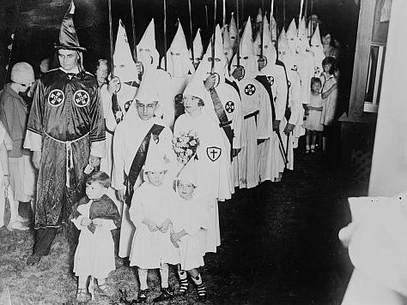Use the source a and your own knowledge to explain why the Klan was so widespread in the South.
2. How useful is the source below in explaining why black people didn’t vote?

A Negro in the Deep South who tried to register to vote might lose his job or credit. He might be beaten or killed. ‘I don’t want my job cut off’, one man explained. Another was more blunt ‘I don’t want my throat cut’, he said.

*A black Southerner commenting on why he didn’t vote.*

________________________________________________________________________________________________________________________________________________________________________________________________________________________________________________________________________________________________________

________________________________________________________________________________________________________________________________________________________________________________________________________________________________________________________________________________________________________

________________________________________________________________________________________________________________________________________________________________________________________________________________________________________________________________________________________________________

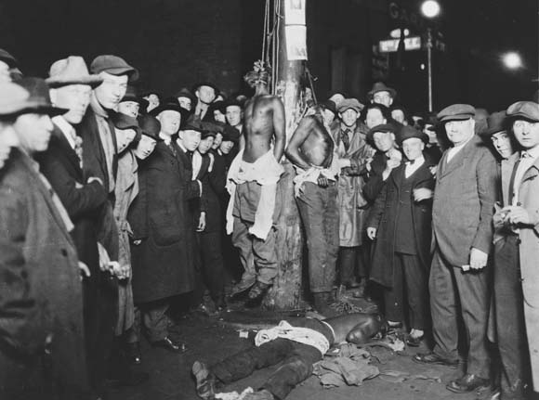

…The KKK would come…with guns and break up the meetings. Very frequently, they were police in hoods… the KKK would beat them up and cart them off.

(Jose Yglesias describing his experiences in 1931)

1. Use the two sources above and your own knowledge to explain why it was so difficult to stop the practice of lynching

________________________________________________________________________________________________________________________________________________________________________________________________________________________________________________________________________________________________________

________________________________________________________________________________________________________________________________________________________________________________________________________________________________________________________________________________________________________

1. Explain which different groups of people that the Klan were against.

________________________________________________________________________________________________________________________________________________________________________________________________________________________________________________________________________________________________________

________________________________________________________________________________________________________________________________________________________________________________________________________________________________________________________________________________________________________



1. What does the image on the crest of NAACP suggest about its aims?

________________________________________________________________________________________________________________________________________________________________________________________________________________________________________________________________________________________________________

____________________________________________________________________________________________________________________________________________________

1. Explain what the NAACP campaigned for.

________________________________________________________________________________________________________________________________________________________________________________________________________________________________________________________________________________________________________

________________________________________________________________________________________________________________________________________________________________________________________________________________________________________________________________________________________________________

________________________________________________________________________________________________________________________________________________________________________________________________________________________________________________________________________________________________________

________________________________________________________________________________________________________________________________________________________________________________________________________________________________________________________________________________________________________

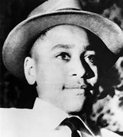**Section 3: The Murder of Emmett Till**

**This story is one of the most harrowing in history. The treatment of this 14-year-old boy will go down as one of the darkest moments in civil rights movement.** [**https://www.youtube.com/watch?v=5fWsbnx-Ly0**](https://www.youtube.com/watch?v=5fWsbnx-Ly0) **Watch the video and make a timeline of the story of Emmett Till**

1. List three ways in which the fact that Emmett Till came from the North may have affected events before and after his murder.
   1. ____________________________________________________________________
   2. ____________________________________________________________________
   3. ____________________________________________________________________
2. Write a short paragraph to explain why you think Emmett Till’s mother, Mamie Bradley, had an open viewing of his body at the funeral home.

_______________________________________________________________________________________________________________________________________________________________________________________________________________________________________

_______________________________________________________________________________________________________________________________________________________________________________________________________________________________________

_______________________________________________________________________________________________________________________________________________________________________________________________________________________________________

1. List points for and against the statement, ‘The murder of Emmett Till created a lot of publicity but made no difference to the position of black Americans’. Notice that the statement gives no timescale and talks about no particular group.

|  |  |
| --- | --- |
| **For** | **Against** |
|  |  |

**Section 4: Separate but Equal: Brown vs the Board of Education**

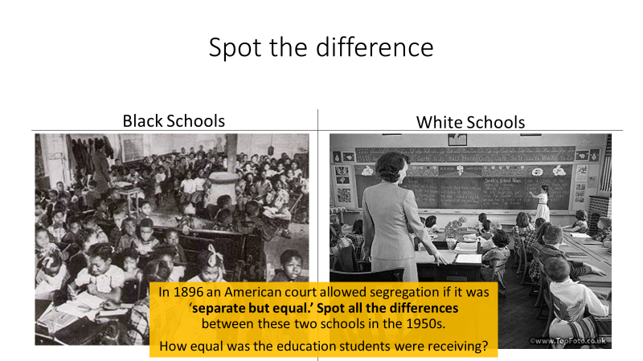**Task One: Complete the table below identifying similarities and weaknesses**

|  |  |
| --- | --- |
| **Similarities** | **Differences** |
|  |  |
|  |  |
|  |  |
|  |  |
|  |  |

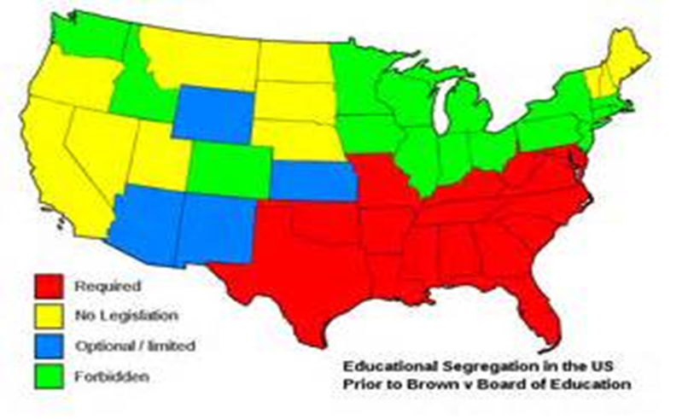**Our next topic takes us to Topeka:**

1. What does the map above show about segregation in education in the USA before the Brown decision?

________________________________________________________________________________________________________________________________________________________________________________________________________________________________________________________________________________________________________

____________________________________________________________________________________________________________________________________________________

1. Using the source below, what reasons did Chief Justice Warren give in his dismissal of the Jim Crow laws?

**Source by Chief Justice Warren**

Separating white and colored children in schools had a detrimental effect on colored children. The impact is greater when it has the sanction of the law; for the separating of the races is usually interpreted as denoting the inferiority of the Negro group… We conclude that in the field of public education the doctrine of ‘separate but equal’ has no place. Separate educational facilities are inherently unequal’.

________________________________________________________________________________________________________________________________________________________________________________________________________________________________________________________________________________________________________

____________________________________________________________________________________________________________________________________________________

________________________________________________________________________________________________________________________________________________________________________________________________________________________________________________________________________________________________________

____________________________________________________________________________________________________________________________________________________

**Task: Read the information on the Brown Vs Board of Education case below. Highlight the key events and use it to create a storyboard to explain what happened.**

Linda Brown was a young African American girl who lived in Topeka, Kansas. She was born in 1943, and her family wanted the best education for her. There was a good school, Sumner Elementary only 7 blocks from her home.

The school was for white children, and due to the segregation in American schools, Linda was not allowed to attend. Linda was forced to attend Monroe Elementary School for African American children. Monroe Elementary School had broken ceiling tiles, cracks in the floors and walls, broken windows and no central heating. She had to walk 2 miles to school every single day.

Her father, Oliver Brown, was helped by the National Association for the Advancement of Coloured people (NAACP) to bring a legal case against the education board. This court case was called Brown versus Board of Education. On 19 May 1954 the court declared that segregation was against the law and the constitution of the USA. The Board of Education of Topeka and every other education board were forced to bring segregation to an end.

In theory, this should have ended segregation in schools. However many schools ignored this, and by 1956, in six southern states, not a single black child was attending any school where there were white children.

|  |  |
| --- | --- |
|  |  |
|  |  |
|  |  |
|  |  |
|  |  |
|  |  |

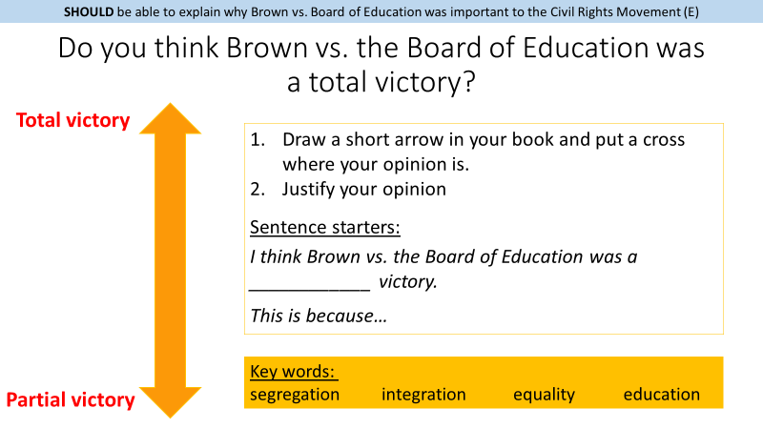

Complete this task in the space below:

________________________________________________________________________________________________________________________________________________________________________________________________________________________________________________________________________________________________________

________________________________________________________________________________________________________________________________________________________________________________________________________________________________________________________________________________________________________

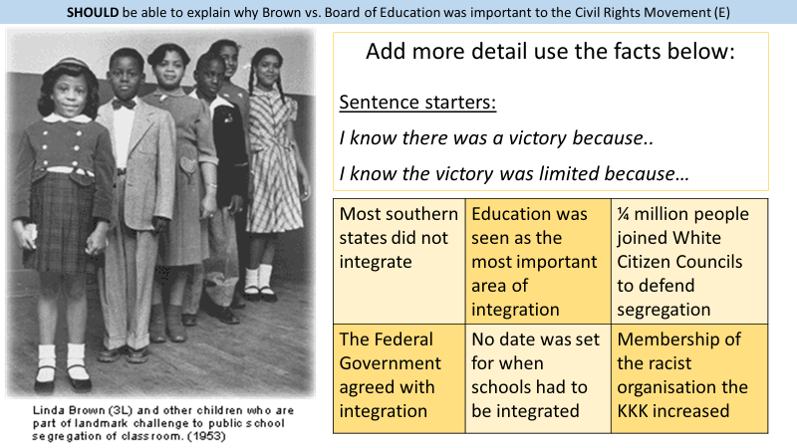

**Task: Complete the sentence starters using the information above:**

I know there was a victory because: __________________________________________________________________________________________________________________________________________________________

I know the victory was limited because: _______________________________________________________________________________________________________________________________________________________________________________________________________________________________________

**Section Three: What happened at Little Rock?**

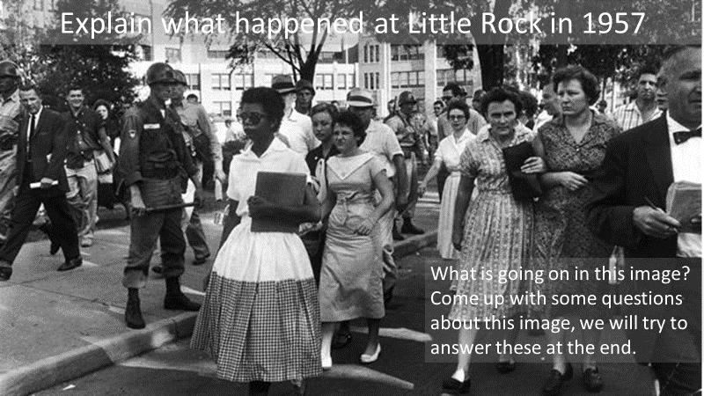**Task: Examine the image below. What do you think is happening? Write down three questions you would like to ask.**

**__________________________________________________________________________________________________________________________________________________________________________________________________________________________________________________________________________________________________________________________________________________________________________________________________________________________________________________________________________________________________________________________________________________________________________________________________________________________________________________________________________________________________________________________________________________________________________________________________**

**Task: Read the information about Little Rock below and answer the questions that follow:**

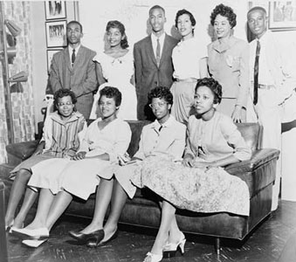**Little Rock Arkansas**

The little Rock 9

The 1950s in the USA was a busy decade in terms of changes to the education system and laws. Many reforms were brought in including the end of segregated schools and the separate but equal schooling for blacks and whites.

May 17, 1954 **Brown vs. Board of Education** Case legally challenged the 1879 law which allowed elementary schools to be racially segregated. After the case the government called for all schools to be desegregated. 9 black students enrolled in Little Rock Central High School in 1957.

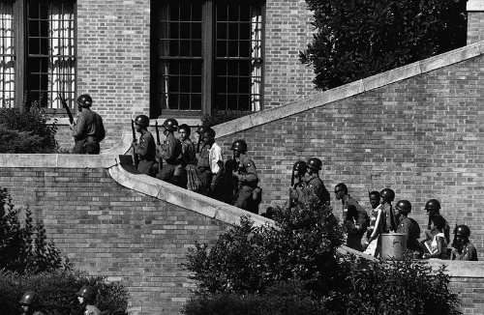The day before nine black students were to be admitted to Central High School, the governor of Arkansas, Orville Faubus ordered 270 National Guards to help maintain law and order. He said that he believed that there would trouble between the white and the black students. In fact he bought in the troops to keep the black students out of a ‘white’ school.

On the first day of school the students were advised by the school board not to show up. On the second day they arrived with the company of ministers, but were prevented from entering the building by the National Guard. In the town of Little Rock in Arkansas, a federal (national) law was being challenged by a state governor. On the 23rd September the students managed to sneak into their school by using the back entrance, thus avoiding the large crowd of white people outside the front doors. When the mob found out they were inside, they began attacking African Americans on the street and reporters.

The next day On September 24, the President and the United States Army went to Little Rock. The army allowed the nine students to successfully enter the school the next day.

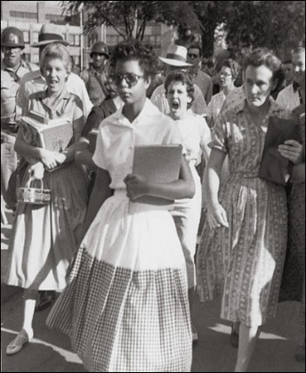Eight of the nine students stayed the whole academic year and one graduated to college. The nine were still subjected to a year of physical and verbal abuse (spitting on them, calling them names) by many of the white students.

This event was particularly significant as it showed the determination of the black students. All but one was willing to endure the prejudice and discrimination from the white students and police to get the education they wanted, as they stayed the whole academic year. The fact that one of the black students graduated to college was a step closer for the African Americans towards equality.

Elizabeth Eckford, one of the little Rock 9 trying to enter little rock on her first day.

1. How many black students enrolled in Little Rock Central High School?
2. What court case had allowed black students to enrol in white schools?

_______________________________________________________________________

1. What happened to the students when they arrived for their second day of school?

__________________________________________________________________________

1. What group was sent to help the students by the government?

________________________________________________________________________

1. How many students finished the year?

________________________________________________________________________

Source Questions:

**1. Study Source A.**

**What can you learn from Source A about what happened at Little Rock in September 1957?**

They glared at me with a mean look and I was very frightened and didn’t know what to do. I turned around the crowd came toward me. They moved closer and closer. The crowd began to follow me, calling me names. When I got to the front of the school, I went up to the guard. He didn’t move. When I tried to squeeze past him, he raised his bayonet. Somebody started shouting “Lynch her! Lynch her!”. I tried to see a friendly face in the mob – someone maybe who would help. I looked into the face of an old woman and it seemed a kindly face. But when I looked at her again, she spat at me.

**From ‘The Long Shadow of Little Rock’, a book published in 1962. These are the words of Elizabeth Eckford, one of the nine black students to enrol at Littlerock High School in 1957.**

**__________________________________________________________________________________________________________________________________________________________________________________________________________________________________________________________________________________________________________________________________________________________________________________________________________________________________________________________________________________________________________________________________________________________________________________________________________________________________________________________________________________________________________________________________________________________________________________________________**

**2. *Study Sources A, B and C. Does the evidence of Sources B and C support (agree with) Elizabeth Eckford’s account of events at Little Rock (Source A)? You may include differences in your answer.***

**SOURCE B: from an article in the *New York Times*, September 1957; it describes the reaction in Little Rock to the arrival of black students**

A man yelled: “Look, they’re going into our school.”The crowd now let out a roar of rage.

“They’ve gone in,” a man shouted. “Oh God”, said a woman, “the Negroes are in school.” A group of six girls, dressed in skirts and sweaters, hair in pony-tails, started to shriek and wail. “The Negroes are in our school,” they howled hysterically. Hysteria swept from shrieking girls to members of the crowd. Women cried hysterically, tears running down their faces.

**SOURCE C: a photograph of Elizabeth Eckford taken on her first day at Little Rock**

**High School in September 1957**

______________________________________________________________________________________________________________________________________________________________________________________________________________________________________________________________________________________________________________________________________________________________________________________________________________________________________________________________________________________________________________________________________________________________________________________________________________________________________________________________________________________________________________________________________________________________________________________________________________________________________________________________________________­­­­­­­­­­­­­­­­­­­­­­­­­­­_________________________________________________________________________________________________________________________________________________________________________________________________________________________________________________________________________________________________________________________________________________________________________________________________________________________________________________________________________________________________________________________________________________________________________________________________________________________________________________________________________________________________________________________________________________________________________________________________________________________________________________________________________________________________________________________________________________________________________________________________________________________________________________________________________________________________________________________________________________________________________________________________­­­­­­­­­­­­­­­­­­­­­­­­­­__

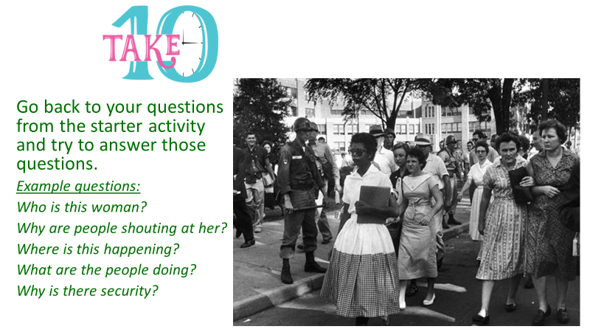___________________________________________________________________________________________________________________________________________________________________________________________________________________________________________________________________________________________________________________________________________________________________________________________________________________________________________________________________________________________________________________________________________________________

**Section 5: Montgomery Bus Boycott**

Create a mind map below showing the significance of Rosa Parks arrest and the following Montgomery Bus Boycott.

What were the two most significant features of Rosa Park’s involvement in the Bus Boycott? Explain your answer.

___________________________________________________________________________________________________________________________________________________________________________________________________________________________________________________________________________________________________________________________________________________________________________________________________________________________________________________________________________________________________________________________________________________________

Give three reasons why the Montgomery Bus Boycott begin in December 1955?

* __________________________________________________________________________
* __________________________________________________________________________
* __________________________________________________________________________

Who were the Dixiecrats and what were their political beliefs?

________________________________________________________________________________________________________________________________________________________________________________________________________________________________________________________________________________________________________________________________________________________________________________________________

Draw a timeline for the events of the Montgomery Bus Boycott starting with the arrest of Rosa Parks and ending with the desegregation of the Montgomery buses.

Sections 6: Peaceful Civil Rights Movement, 1960’s

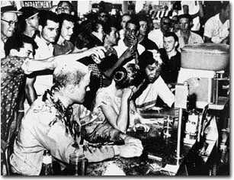

Research information of the Greensboro sit-in and answer the questions blow

1. What was a sit-in?

____________________________________________________________________________________________________________________________________________________

1. How did the Greensboro start and how did it spread?

____________________________________________________________________________________________________________________________________________________

1. What NAACP, CORE, SCLC and SNCC stand for? What were their aims?

________________________________________________________________________________________________________________________________________________________________________________________________________________________________________________________________________________________________________

1. Why were the events at Greensboro so important for the civil rights movement?

________________________________________________________________________________________________________________________________________________________________________________________________________________________________________________________________________________________________________

1. What was the significance of these events?

_____________________________________________________________________________________________________________________________________________________________________________________________________________________________________________________________________________________________________________________________________________________________________________________________________________________________________________________________________________________________________________________________________________________________________________________________________________________________________________________________________________________________________________________

**Source by** **James Peck, a member of the Freedom Rides, wrote about his experiences in Alabama on 14th May, 1961, in his book, *Freedom Rider* (1962)**

When the Greyhound bus pulled into Anniston, it was immediately surrounded by an angry mob armed with iron bars. They set about the vehicle, denting the sides, breaking windows, and slashing tires. Finally, the police arrived and the bus managed to depart. But the mob pursued in cars. Within minutes, the pursuing mob was hitting the bus with iron bars. The rear window was broken and a bomb was hurled inside. All the passengers managed to escape before the bus burst into flames and was totally destroyed. Policemen, who had been standing by, belatedly came on the scene. A couple of them fired into the air. The mob dispersed and the injured were taken to a local hospital.

Examine the source above and explain how the freedom rides were received by many in the South.

__________________________________________________________________________________________________________________________________________________________

____________________________________________________________________________________________________________________________________________________________________________________________________________________________________________________________________________________________________________________

Make a timeline of the Freedom Rides from May 1961 to November 1961

Why did Martin Luther king choose Birmingham to demonstrate?

List three reasons.

Make a mind map to suggest reasons why President Kennedy became so involved in the crisis at Birmingham

Study the source below. What did President Kennedy mean when he said ‘We face a moral crisis’?

Give two things you can infer from the source about Kennedy’s attitude to civil rights.

**From a speech made on television by President Kennedy on 11th June 1963, about the need to improve civil rights for black Americans.**

We preach freedom around the world, and we mean it.. But are we to say that the world – and much more importantly to one another – that this is the land of the free except for the Negroes? We face a moral crisis as a country and a people. It cannot be met by a repressive police action. It cannot be left to increased demonstrations in our streets. It is a time to act in Congress and in our daily lives.

1. ______________________________________________________________________________________________________________________________________________
2. ______________________________________________________________________________________________________________________________________________

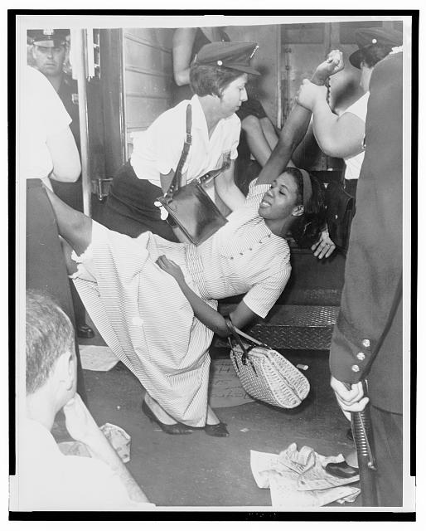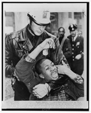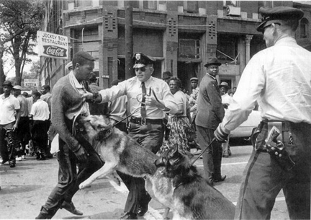

The March on Washington – <https://www.youtube.com/watch?v=5Q_I_2m5TbA>

1. Why was MLK seen as such so inspirational?

_____________________________________________________________________________________________________________________________________________________________________________________________________________________

1. Why was it important for the civil rights movement to have the support of famous actors and protest singers?

__________________________________________________________________________________________________________________________________________________________________________________________________________________________________________________________________________________________________________________________________________________________________________________________________________________________________________

1. Write a list of why you think the Mach on Washington was so successful?
   * ________________________________________________________________
   * ________________________________________________________________
   * ________________________________________________________________
   * ________________________________________________________________
2. Can you suggest reasons why King’s ‘I have a dream speech’ has become one of the most famous in history?

I have a dream that one day on the red hills of Georgia, the sons of former slaves and the sons of former slave owners will be able to sit down together at the table of brotherhood.

I have a dream that one day even the state of Mississippi, a state sweltering with the heat of injustice, sweltering with the heat of oppression, will be transformed into an oasis of freedom and justice.

I have a dream that my four little children will one day live in a nation where they will not be judged by the color of their skin but by the content of their character.

I have a dream today!

I have a dream that one day, down in Alabama, with its vicious racists, with its governor having his lips dripping with the words of "interposition" and "nullification" -- one day right there in Alabama little black boys and black girls will be able to join hands with little white boys and white girls as sisters and brothers.

I have a dream today!

MLK 1963

_______________________________________________________________________________________________________________________________________________________________________________________________________________________________________________________________________________________________________________________________________________________________________________________________________________________________________________________________________________________________________________________________________________________________________________________________________________________________________________________________________________________________________________________________________________________________________________________________________________________________________________________________________________

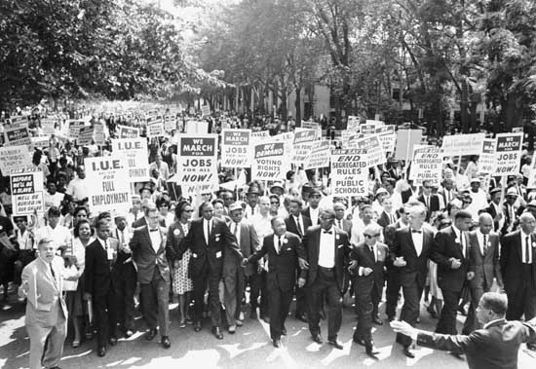

Do some further independent research on the Mississippi murders. What happened and what where the outcomes?

_________________________________________________________________________________________________________________________________________________________________________________________________________________________________________________________________________________________________________________________________________________________________________________________________

Explain bothe the Civil Rights Act of 1964 and the Voting rights act of 1965 and how the helped orgdinary black people.

______________________________________________________________________________________________________________________________________________________________________________________________________________________________________________________________________________________________________________________________________________________________________________________________________________________________________________________________________________

Sections 6: Black Power- Militant Struggle for rights

Who was Malcolm X and what where his beliefs?

__________________________________________________________________________________________________________________________________________________________

What was the Nation of Islam?

__________________________________________________________________________________________________________________________________________________________

Why was Malcom X prepared to use violence?

__________________________________________________________________________________________________________________________________________________________

Using this source and your own knowledge, explain why Malcom X disagreed with Martin Luther King

"He got the peace prize, we got the problem.... If I'm following a general, and he's leading me into a battle, and the enemy tends to give him rewards, or awards, I get suspicious of him. Especially if he gets a peace award before the war is over."

Malcom X commenting on M L King.

______________________________________________________________________________________________________________________________________________________________________________________________________________________________________________________________________________________________________________________________________________________________________________________________________________________________________________________________________________

Create a newsppaer article on the assissnation of Malcom X.

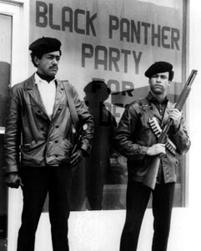

1. Who was Stokely Carmichael and what where his aims?
2. Describe the aims and objectives of the black power movement.

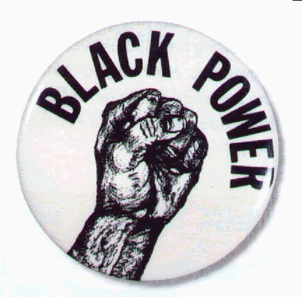____________________________________________________________________________________________________________________________________________________________________________________________________________________________________________________________________________________________

1. Why do you think the symbol for black power was clenched fist?

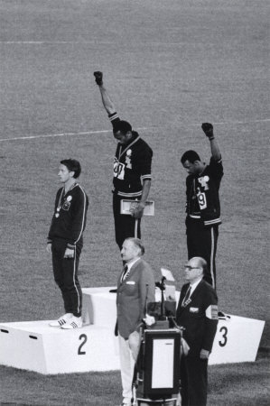___________________________________________________

1. Who were the black panthers and what were their beliefs?
2. Complete the following table

|  |  |  |
| --- | --- | --- |
|  | Similarities with others | Differences to others |
| Malcolm X |  |  |
| Stokely Carmichael/Black Power |  |  |
| Black Panthers |  |  |

Which do you think were the two most important causes the riots between 1964 – 1967? Explain your answer

_______________________________________________________________________________________________________________________________________________________________________________________________________________________________________________________________________________________________________________________________________________________________________________________________________________________________________________________________________________________________________________________________________________________________________________________________________________________________________________________________________________________________________________________________________________________________________________________________________________________________________________________________________________

_______________________________________________________________________________________________________________________________________________________________________________________________________________________________________________________________________________________________________________________________________________________________________________________________________________________________________________________________________________________________________________________________________________________________________________________________________________________________________________________________________________________________________________________________________________________________________________________________________________________________________________________________________________

Now that you finished the Civil Rights Unit I want you to construct a road map of ‘**The** **Journey of the Civil Rights Movement’**

This road map needs to show the many twists, turns, dead ends, roundabouts, crossroads etc that were encountered on the journey to black civil rights legislation.

Make sure you label your road map with signposts, maybe you have two cars and the cars go off on different directions at some points but then re-emerge and travel along together at other points (non-violent and violent etc).