‘Get Inspired’ 25th January 2023 Portsmouth Guildhall
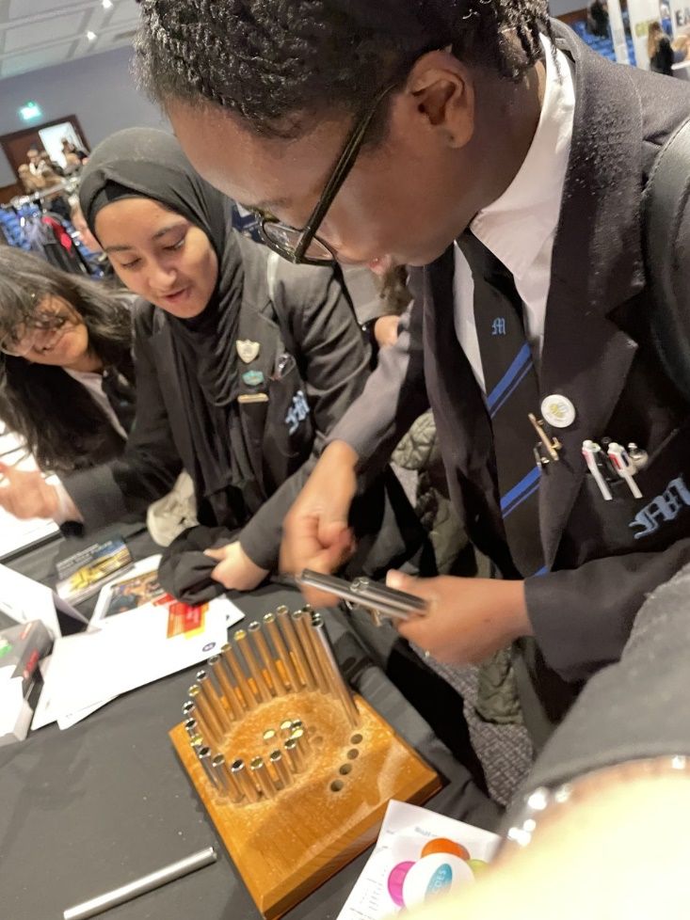
On Wednesday 25th January 30 Year 9 pupils went to visit the Portsmouth Guildhall for an event called ‘Get Inspired’. Pupils had the opportunity to go around and interact with a variety of employers and ask questions, try activities to investigate and develop their employability skills. The pupils were resilient talking to employers about their future choices they could consider. The employers and event organiser said how polite and respectful our pupils were at the event.
