HT Message – Mr. David Jeapes

Please be aware that all sections of the school are closed on Monday 24th January for staff training. The school will reopen, at the usual times, on Tuesday 25th.

Work on our Main Entrance is nearing completion. We expect to take possession of this early next week. Once we have undertaken our own Health and Safety checks, we will bring this gate into action. Please be aware that we will keep the temporary reception on Kensington Road open until Friday 28th January – whilst we establish our new routines. Please rest assured that staff members will be on hand to explain new drop off and pick up routines as soon as we are ready to begin these. We expect our new procedures to be fully operational from Monday 31st January. We have taken the decision to keep the Year R gate operational for the rest of this term to ease social distancing.

We are at a difficult juncture with the pandemic. In the coming days and weeks, it will be apparent that much of society will return to normal. However, schools, amongst others, appear to remain impacted by COVID. This, of course, will lead to some unusual circumstances whereby staff and pupils will go about their everyday lives without hindrance, yet within the school environment, more stringent measures will apply. I can only ask for your understanding and support with this – please do take some time to explain to your child the unique circumstances that school’s operate in.

We, of course, hope to further ease restrictions, in line with any guidance – I am acutely aware that COVID fatigue has set in, and we all look forward to a mask free life! However, for now, it remains recommended that pupils and staff:

- Wear a face covering when in communal areas;
- Socially distance – where this is possible;
- Regularly and thoroughly wash, or sanitise, your hands;
- Take LFTs twice weekly or as per guidance.

Updated Self-Isolation Guidance
The self-isolation period for pupils who record a positive test result for COVID-19 has been reduced to 5 days in most circumstances, unless they cannot test for any reason. Pupils may now take LFT tests early on day 5 and day 6 of their self-isolation period and return to school on the 6th day. Tests must be taken 24 hours apart. If both these test results are negative, and your child does not have a high temperature, they may end their self-isolation after the second negative test result and return to Mayfield.
If a child is positive on day 5, then a negative test is required on day 6 and day 7 to release them from isolation. Anyone who is unable to take LFT tests will need to complete the full 10 day period of self-isolation.

Further information, including examples of when to end self-isolation if you have had COVID-19 symptoms, is available in the https://www.gov.uk/government/news/self-isolation-for-those-with-covid-19-can-end-after-five-full-days-following-two-negative-lfd-tests
Home Learning
If your child is missing school for COVID, or for any other reason, there is work available to support them in maintaining their education when they are absent. This work can be found in the Home Learning section of our website: Home Working | Mayfield School
If your child is well enough, please ensure that your child keeps in touch with their learning, it then makes their return to lessons so much easier for them.
LFD Testing
Following a sharp increase in cases in Key Stage 2 and advice from the Public Health Team at PCC, each child in Year 3 to 5 has been issued with a pack of Lateral Flow Tests and asked to take these daily for seven days.
Pupils in the Senior Section were issued with packs of tests at the start of term and it is strongly recommended that they take a test every Monday and Thursday before coming to school. The next round of packs for senior section pupils will be distributed to pupils next week.
We have a good supply of lateral flow tests in school and additional packs can be collected from the Medical Room or Pupil Services.

Covid Vaccinations at Mayfield School on Wednesday 16th February 2022

Second dose covid vaccinations can now being offered to 12–15 year olds and therefore Mayfield School will be hosting the School Immunisation Team on Wednesday 16th February 2022. The team would like to offer an opportunity for eligible young people to have their second dose vaccination in school on the above date.

There are also a number of young people in this age group who have not had their first dose and this could be for a number of reasons. They will also offer a first dose vaccination to this group on the above date for those who missed out previously.

Since the last vaccination date in school earlier this year, there will be some young people who have since turned 12 years of age and are now eligible for their first dose – vaccinations will now be offered to this group on the above date.

Parents still have the option of making appointments for their eligible young people via the National Booking System, if they prefer.

The benefits of the vaccine are clear:

- It is estimated that a 60% vaccine uptake among healthy 12- to 15-year-olds will reduce confirmed cases of COVID-19 in this group in the period up to 31 March 2022 by 33%. This equates to a reduction of 110,000 school days absent in this age group due to confirmed COVID-19 cases.
- Research shows that those who do become infected 3 weeks after receiving one dose of the vaccine are between 38% and 49% less likely to pass the virus on to their household contacts than those who are unvaccinated.

Consent forms will be given to students on Thursday 10th February and must be returned to Pupil Services by Monday 14th February 3pm.

Guidance for administering paracetamol in school

A reminder to parents/carers that paracetamol can only be given out from the medical room between 10.45am-2pm. This is to reduce the risk of children having too much paracetamol within the correct timescales.

Head of Seniors – Miss Louise Hillier

This week Year 10 have completed their first set of formal school exams. We look forward to seeing their results and we will then use the information gained to target areas for focus in the coming weeks.

Year 7 Parents evening is on Thursday 27th January from 4pm to 7pm. This event is being run virtually and can be booked on our website using the following link:

SchoolCloud - Mayfield School

We are very much looking forward to sharing with you the progress your child has made since September.

Here is a look at what your children are studying in Science this half-term to stimulate your discussions with them at home.

Year 7 will be studying two topics. In the first topic they will be learning about the forces involved in speed and gravity and in the second topic they will be learning about variation in species and reproduction.
Year 8 will be focusing on the principle that everything in the universe is made of atoms and our periodic table of elements, put together by the great scientist Dimitri Mendeleev.
Year 9 will be studying two topics. In the first topic they will be looking at the periodic table, how it is structured and delve deeper into the physical and chemical properties of elements in different groups. In the second topic they will be trying to understand how cells divide, the issues surrounding uncontrolled cell division and the use of stem cells in medicine whilst debating the ethical implications of this.
Year 10 will be studying two topics. The first is about the different ways atoms bond to form new compounds and the useful structures they form. The second is about the properties of materials which includes the specific heat capacity of different materials and density.
Year 11 will be studying two topics. The first involves variation within species, how we inherit characteristics from our parents, natural selection and the theory of evolution proposed by Charles Darwin in his publication, 'The Origin of Species'. The second topic is looking at waves and in particular the electromagnetic spectrum of light.

We are very proud of how smart our pupils look in their school uniform. A reminder that our basic school uniform requirements are:

- Mayfield blazer
- White shirt
- Mayfield tie
- Black trousers
- Black “polishable” shoes

Please can you remind your child of these requirements. It is very cold at the moment, so it is very sensible for your child to wear a coat to school! Outside garments- coats, gloves, hats and scarves- need to be removed inside the building.

Head of Primary – Mrs Fiona Rogers
The children have been very resilient this week and have really shown how adaptable they can be when things have changed quickly around them! We are very proud of them all.

The weather for next week looks to be cold again so please can the children make sure that they have a named, warm coat with them every day.

It is great to see so many children arriving to school on their bikes and scooters each day. Pupils must wear a helmet if they wish to bring their bike or scooter onto the school site.

If you are bringing your child to school in a vehicle, please can you ensure that you are considerate of our pupils, neighbours and other drivers and not park on the double yellow or zigzag lines.

We are very proud of how smart our pupils look in their school uniform. A reminder that our basic school uniform requirements are:

- Mayfield blazer
- White shirt
- Mayfield tie
- Black trousers
- Black “polishable” shoes

Our pre-loved uniform shop is open every Wednesday and has a wide range of pre-loved and brand-new items available. If you are in receipt of pupil premium, we can support you with the provision of uniform. Please email Mrs. Erika Anders anderse@mayfield.portsmouth.sch.uk It is essential that all items are named so that they can be returned to their owner should they go astray.

Year R have been exploring numbers to 5 this week! They have looked at the bonds that make up 5, matching values to numbers up to 5 and taking away from 5.
They have also enjoyed learning more digraphs in Letters and Sounds - oo, oo, ar and or. They have been practising writing words with digraphs in and reading words that contain digraphs.

This week, Year 1 have been looking at toys and putting these into categories such as 'old' and 'new'.

In Maths we have looked at representing numbers to 50 using dienes and ten frames. We have been recognising patterns in numbers when counting forwards and backwards.
We are working hard in English to help Dave find his missing toy, Dogger. Keep an eye out for some lost posters next week!

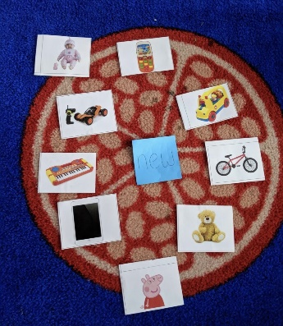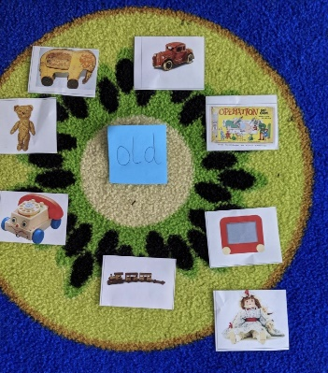

Year 2 have been learning how to create phrases and sentences using exclamation marks linked to a shocked character in our new English text. We have also been acting as police officers asking questions to try and find out what happened to a truck belonging to The Queen.
In maths we have been linking our understanding of doubling numbers to the two times table and solving word problems.

In PSHE we have learnt what bullying is and have talked about ways we can all show kindness outside to others. We have created our own kindness monsters to display in the classroom.

This week in Year 3, we have continued our learning about plants and identified different parts of a plant. In our reading, we acted out what we thought would happen next in The Wild Robot.
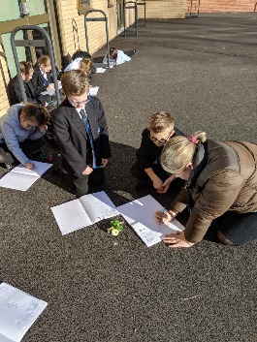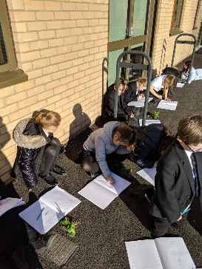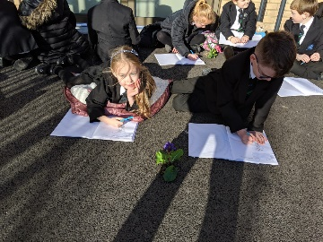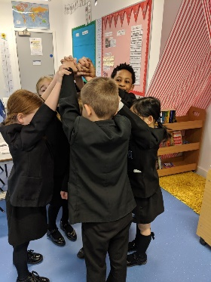
Year 4 have been very resilient this week with learning their time topic, learning how to convert from analogue to digital time. They have done extremely well and hopefully feel much more confident in telling the time.
The children have really enjoyed their topic lessons where in science they have explored sound. This week, they explored how to change the pitch by making different length straw trumpets!

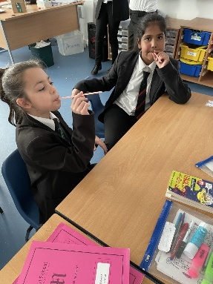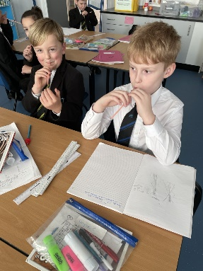

Year 5 have been writing their explanations on how to use a gadget. They have enjoyed creating a fictional gadget that spies can use!
In maths, Year 5 have started to learn how to use formal methods for division.

In Science, they have been learning about insulators and conductors. This included experimenting with different materials and warm water, to find out which materials are the best insulators.
We are very excited about Bikeability, which is coming up very soon! Please remember to sign up to this by following the link in your email. All parents have already been sent this email, but if you are struggling to locate it then please contact your class teacher.

Year 6 have had a fantastic week, exploring electrical circuits in science. They've been able to solve problems with broken circuits, discuss how to make circuits dimmer and brighter and measure the voltage. In maths they have continued to increase their mastery of fractions, looking at adding and subtracting fractions with different denominators. In English, they have enjoyed exploring the characters in the book: Tin. They are working towards writing a narrative on the book, exploring the themes of friendship and love.
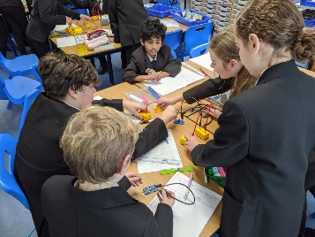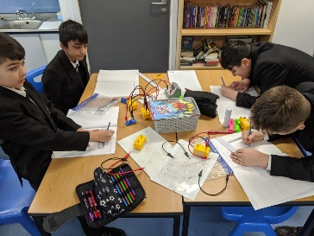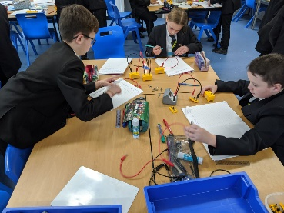

Finally, we are hopeful that the new main entrance will be ready for us to use very soon. Thank you for your patience with this and please do keep your eyes out for more information regarding the upcoming changes to our morning and afternoon routines.

