Independent Home Learning
Whilst you are unable to be learning in school, please complete the following tasks and online activities. Completed work can be emailed to your class teacher for feedback.
Year Group: | 2
English  LO: I can write in the past tense.  LO: I can write for different purposes. |  | Outcome 1: To write a diary entry  Context: Titanic passenger  Use the helpful hints document below to write a diary entry from the perspective of a passenger on board the Titanic. You will need to plan and record three separate entries. Your first entry should recount the day the passenger saw the Titanic for the very first time. The second entry should describe what it was like boarding the Titanic and what it was like on board the vessel. The final entry should retell the key events that happened on the night the Titanic struck the iceberg.  Diary entries should include evidence of fact and opinion - so when writing your three entries, you must research key facts and information. Use the following links to help you:  Titanic facts and figures - BBC Bitesize  Titanic facts for kids | History | National Geographic Kids (natgeokids.com)  Titanic Facts • 1,000+ Fascinating Facts and Figures
Outcome 2: Newspaper Report
Context: Sinking of the Titanic
Begin by watching a short video clip on the BBC Bitesize website about ‘Features of a Newspaper article.’ What are the features of a newspaper? - BBC Bitesize
Using the links above find the information to help you form your 5 W’s introductory paragraph:
- When did the Titanic sink?
- Why did it sink?
- Where did it sink?
- Who was affected by the sinking ship?
- What happened to the Titanic?
Use and copy out the template below to help you form your report. You will need to think of a short, snappy headline and then write out your 5 W’s paragraph to form your introduction. Once you have written your introduction, you will need to write about what happened in more detail and include quotes from surviving passengers.
Phonics |  | Outcome: To revise phase 5 sounds.  Year 2 Phonics Screening Check Revision - Letters and Sounds  Revise each phase 5 sound.  How many words can you think of that contain each sound?  Put these words into context – write sentences.  Identify alternative ways of spelling the sounds e.g. ou/ow  Phase 5 sound hunt – can you find examples of each sound within reading books at home.
Maths |  | LO: I can find ½ and ¼ of a shape and quantity.  Context: Fractions  Unit - Oak National Academy (thenational.academy)  Follow the link above and complete the five fraction lessons.  Other useful arithmetic websites to visit:  - Times tables games - Learn them all here!  - Times tables collection - BBC Teach  - Times Tables Games (topmarks.co.uk)  - Hit the Button - Quick fire maths practise for 6-11 year olds (topmarks.co.uk)
Topic –  Tragic Titanic  Pick a minimum of 3/4 tasks from the grid to complete at home. |  | Use recycled items from around your home to create a Titanic model.  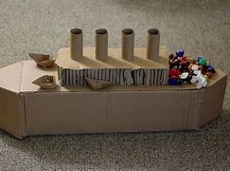 | Write an acrostic poem about the Titanic.  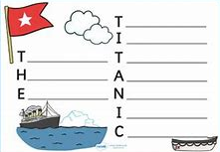 | Use Google Earth to locate the Titanic’s journey, starting from Southampton Dock.  Google Earth
 |  | Imagine that you are about the pack your suitcase to board the Titanic. What would you take with you? Why?  Draw a picture of the items you would take and explain why you would take them.  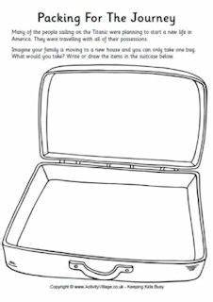 | Build a model of the Titanic out of Lego. | Design and create your own Titanic quiz, using facts from the following websites:  Titanic facts and figures - BBC Bitesize  Titanic facts for kids | History | National Geographic Kids (natgeokids.com)  Titanic Facts • 1,000+ Fascinating Facts and Figures
 |  | Create a Titanic timeline – you will need to record the key dates and events of the Titanic’s maiden voyage.  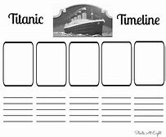 | Design your own – ‘Through the Porthole, I see…’ piece of art. | Use the website link to research the types of food served on the Titanic.  Titanic Menu • Titanic Facts  Design your own first, second and third class menu.
If you have any questions, please email your class teacher:
gray-cathya@mayfield.portsmouth.sch.uk(Dolphins)
hatton-sophie@mayfield.portsmouth.sch.uk(Seals)

