**USEFUL WEBSITES AND APPS**

**PIXL**

**Year 11 and Year 9**

School Id: MF2916

Login : Surnames and initial (Joe Bloggs = BloggsJ)

Password: PASSWORD

**Year 10**

School ID: MF2916

Login: usual school username eg 18SBloggsj

Password: PASSWORD

****Lit App Maths App

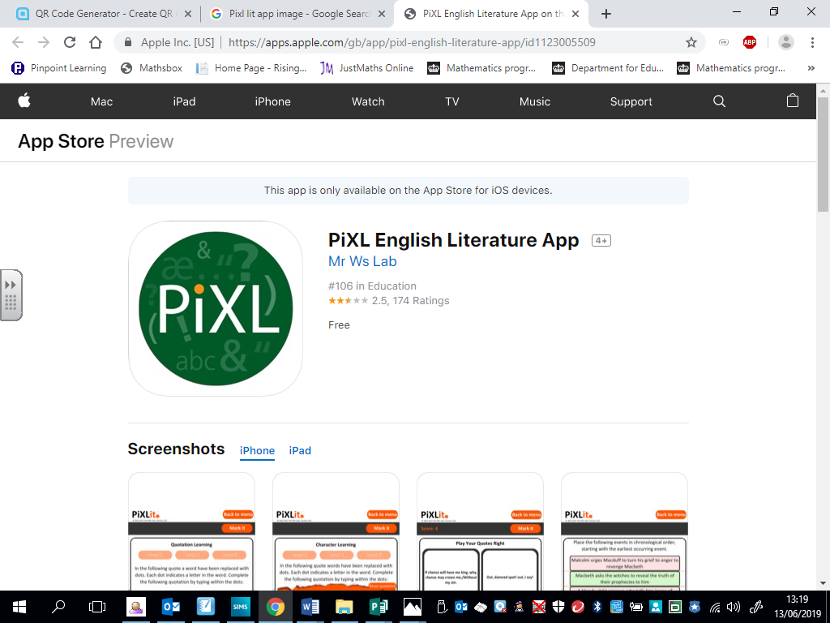

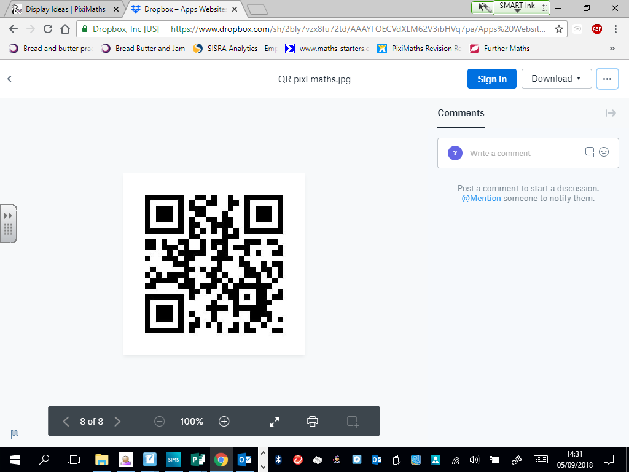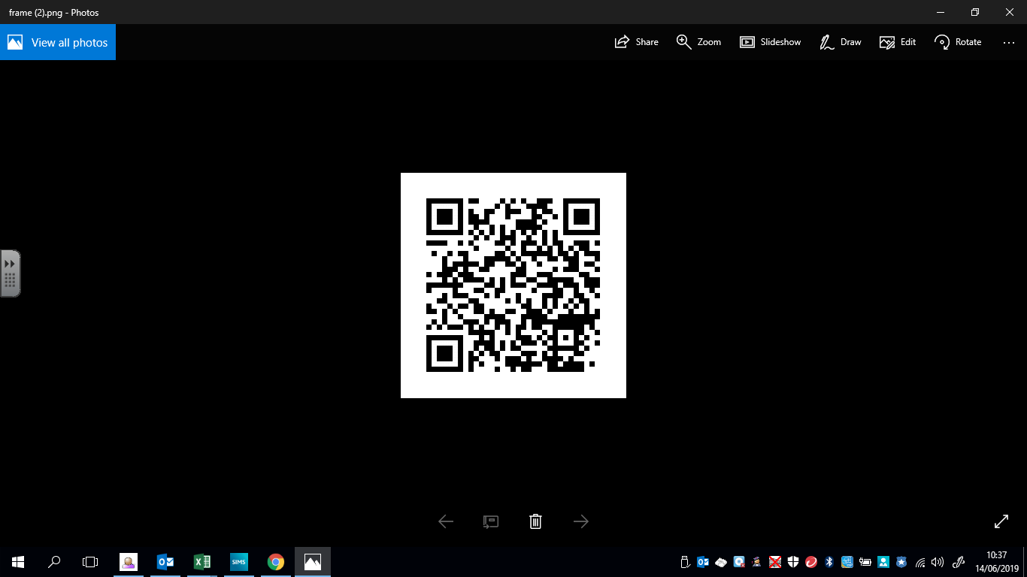

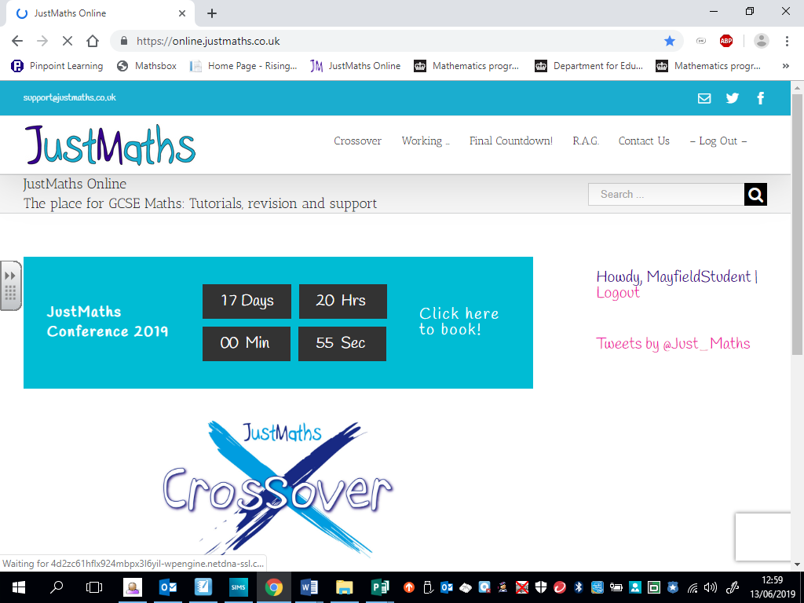

www. Justmathsonline.co.uk

Login: MayfieldStudent

Password: Mayfield

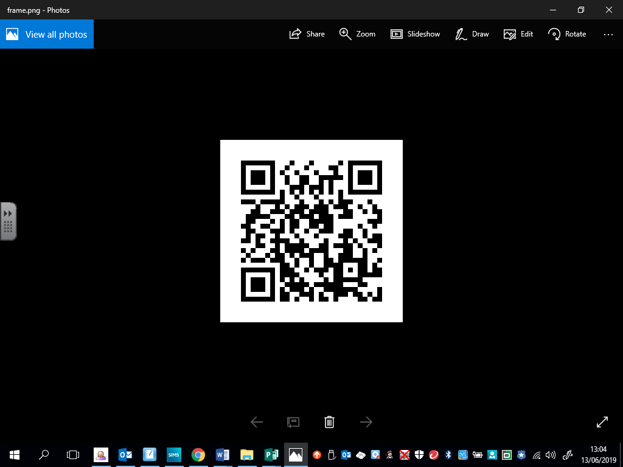



[www.pinpointlearning.co.uk](http://www.pinpointlearning.co.uk)

Login: see your pinpoint booklet

Password: ppl



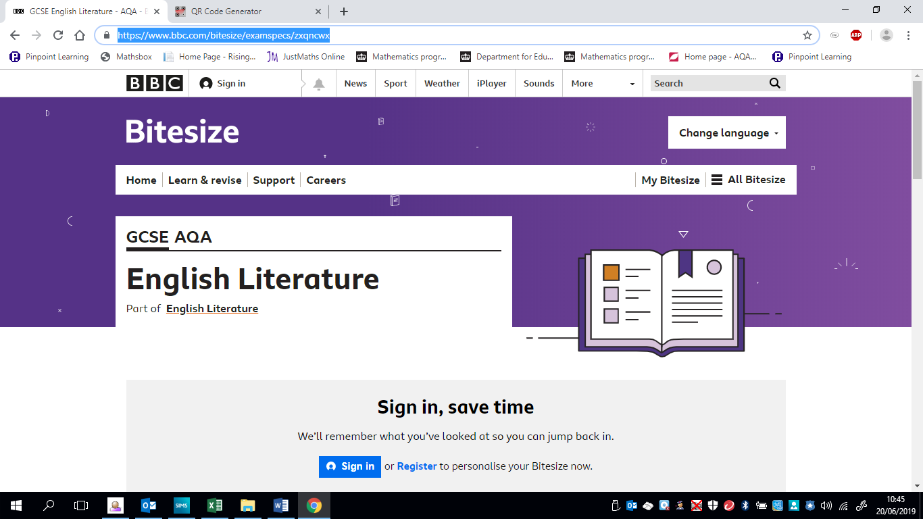

<https://www.bbc.com/bitesize/levels/z98jmp3>

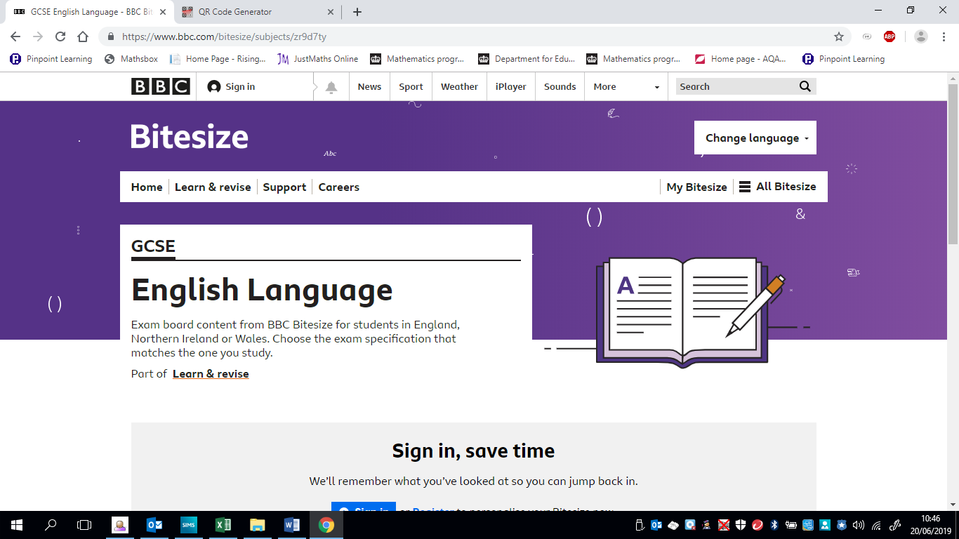







**Science**

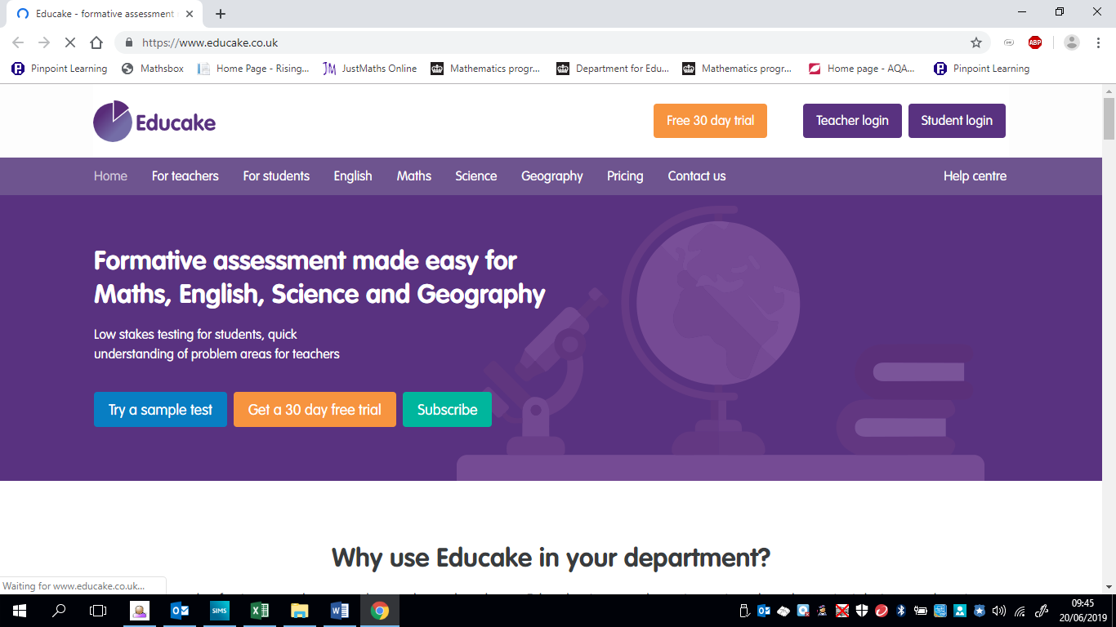[**www.educake.co.uk**](http://www.educake.co.uk)



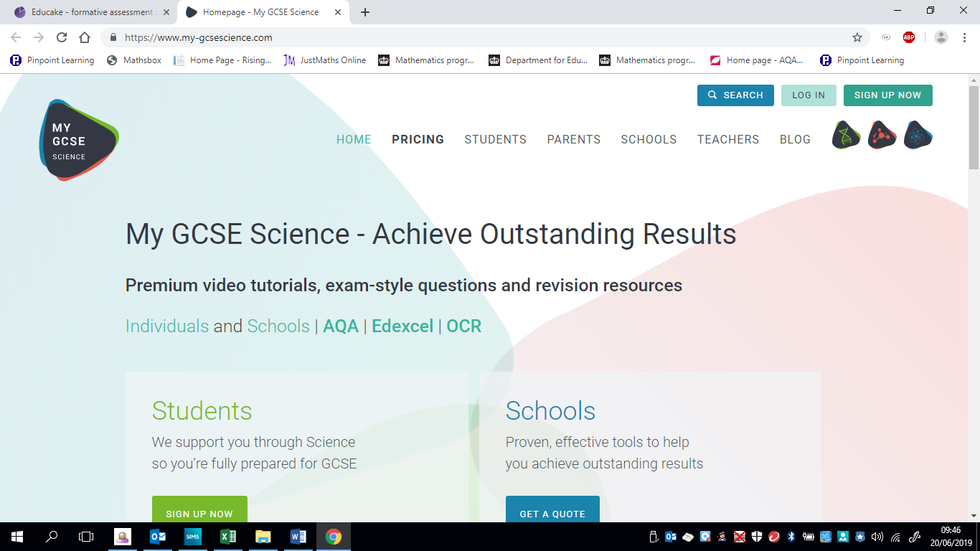

[www.my-gcsescience.com](http://www.my-gcsescience.com)

Login : Your school email address

                              Password: MS

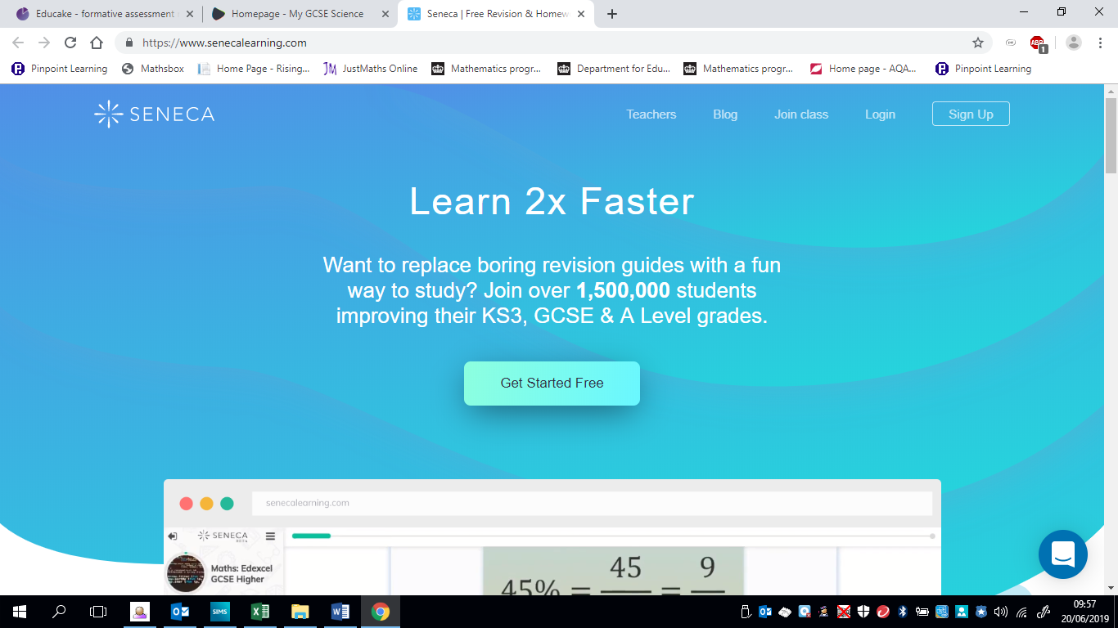

[www.senecalearning.com](http://www.senecalearning.com)